CSE 1310 How to save programs from NetBeans to make your zipped documents

There are two primary ways to save things out of NetBeans – either saving entire projects or saving individual files. Saving entire projects grabs everything and is bigger while saving individual files takes a couple of more steps but saves only the specific stuff that is needed. I’d prefer you to save individual files for the assignment but at the beginning of the semester you will not be penalized for saving the whole project. Later I may change this so be aware of this. Here are the two approaches.

Saving individual .java files:
In NetBeans, look at the .java file you want to save, i.e. have the file open in the NetBeans editor. When you are ready to save the .java file to put in the folder, go to the File menu and select Save As.
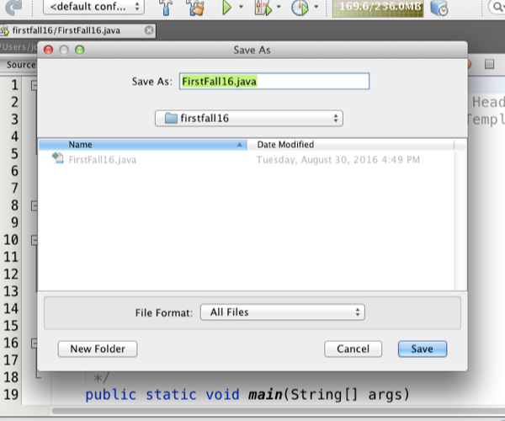

This will bring up a pop-up window that shows the directory/folder (firstfall16) where the .java files are stored by NetBeans. What you want to do now is to change the folder where this copy of the .java file is saved. When you select the directory bar, you’ll see the directory structure where the folder firstfall16 is.

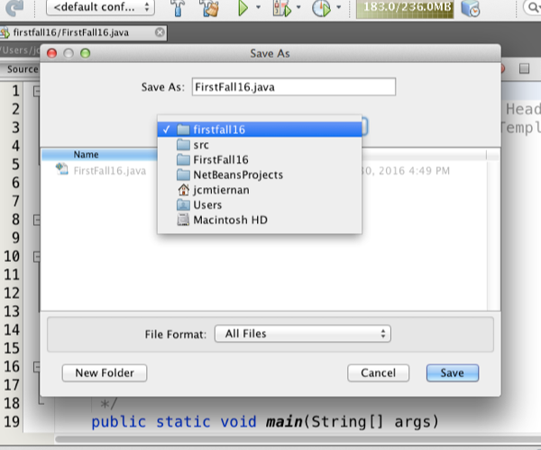

Now go through the directory structure and find the folder where you want to store this file and save it there. If you haven’t created a folder for this lab yet, you can find the right location and create the New Folder to store the .java file into.

Once you have saved this .java file into your folder, close the .java file and go on to the next .java file. (Make sure to close each .java after it is saved. )

When you have saved all the files into your lab folder, including your answers file, then you take the entire folder and zip the folder. The zipped folder is then submitted on Blackboard.

Exporting NetBeans projects:
In NetBeans, look in the Projects menu on the left at the project you want to save. Highlight the project and go to the File Menu and choose Export Project then to ZIP. This brings up another pop-up to now let you select the directory to store the exported project. If you Browse at the Build ZIP line this lets you select the

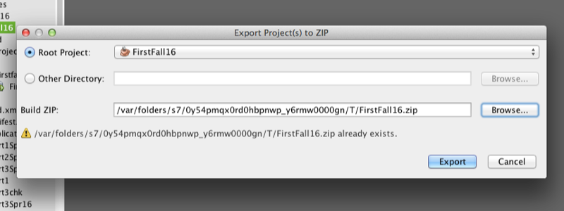

directory. When you get to that menu browser, find your directory and then Save As the project with the name you want for the exported project. If you haven’t created a folder for this lab yet, you can find the right location and create the New Folder to store the zipped project into.

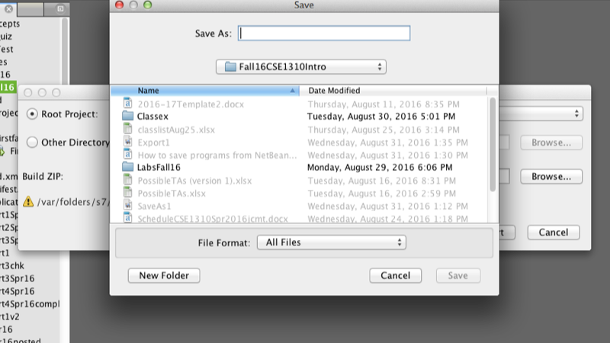
When you have saved all the files into your lab folder, including your answers file, then you take the entire folder and zip the folder. The zipped folder is then submitted on Blackboard.

