CSE 6324 – Advanced Topics in Software Engineering
Agile Methodologies – Spring 2016

Source: https://www.atlassian.com/agile/delivery-vehicles/
- In an agile framework, user stories are the smallest units of work. The goal of a user story is to deliver a particular value back to the customer.
- In scrum, teams forecast to complete a set of user stories during a fixed time period, known as a sprint. Generally speaking, sprints are one, two, or four weeks long. It's up to the team to determine the length of a sprint–we recommend starting with two weeks.
- Once a team forecasts a set of user stories for the sprint, and the sprint is started, the scrum master is in charge of fending off changes to the user stories. This keeps the team focused and combats "scope creep" (when a team adds work to the sprint after the sprint starts). Adding work mid-sprint compromises the team's ability to forecast and estimate accurately.
- At the end of each sprint, the team is required to deliver a working piece of software. In scrum, that's called a potentially shippable increment (PSI). The product owner ultimately decides when the PSI gets released to customers, but the work should be complete enough to be suitable for release at the end of the sprint.
- Epics are significantly larger bodies of work. Epics are feature-level work that encompasses many user stories.
- A great tool for any scrum team are burndown charts. They clearly track progress throughout the sprint with "work remaining" on the Y axis, and "time" on the X axis. Burndown charts are a powerful motivator for the team, and they keep everyone focused during a sprint. Above all, these charts provide supporting data in discussions about the progress of a sprint.
- Stand-up meetings are an integral part of the Scrum process and is a key discipline of Scrum, when they are done properly. This meeting is a coordinating mechanism of a self-organizing team where each member states:
  - What have they finished
  - What are they working on
  - What external issues do they need help on
- Backlog: is the list of all stories left to do

- A great tool for any scrum team are burndown charts. They clearly track progress throughout the sprint with "work remaining" on the Y axis, and "time" on the X axis. Burndown charts are a powerful motivator for the team, and they keep everyone focused during a sprint. Above all, these charts provide supporting data in discussions about the progress of a sprint.

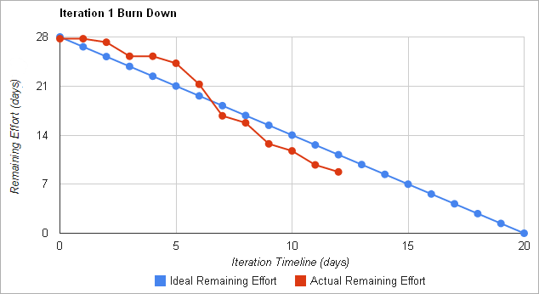

- Scrum planning:
  - Project Initiation (define sprints, and which stories in each sprint)
  - Complete the following for each sprint
    - Sprint Planning
    - Daily Scrum
    - Print Retrospective
    - Demo
    - Release
