CSE 2320 Notes 4: Recurrences

(Last updated 11/24/26 3:32 AM)

CLRS 4.3, 4.4

4.A. Bounding Recurrences Asymptotically

Goal: Take a function 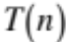 that is defined recursively and find 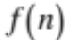 such that 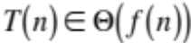.

Need to establish both 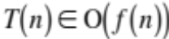 and 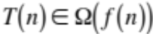 (without using the limit theorems).

4.B. Recurrences, Constants, and Evaluating by Brute Expansion

Consider the recurrence:

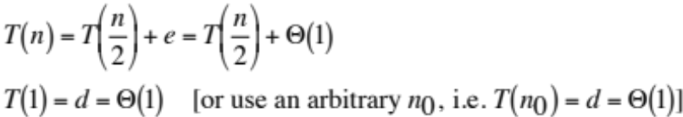

Suppose 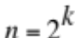:

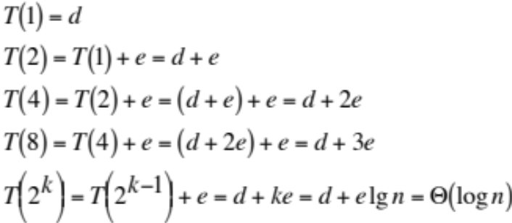

Consider the recurrence:

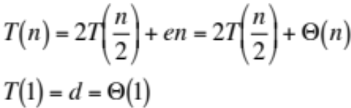

Suppose :

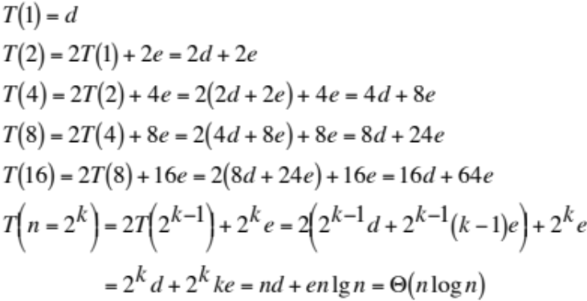

(see http://ranger.uta.edu/~weems/NOTES2320/notes04.c for examples of expansion)

Constants d and e rarely matter . . . certainly not for 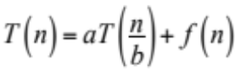 recurrences

4.C. The Substitution Method for Bounding Recurrences

Method

Guess bound (lower Ω and/or upper Ο) [On exams the guess will be given to you]

Verify by math induction (solve for constants for some function in asymptotic set)

i) Assume bounding hypothesis works for k < n

ii) Show bounding hypothesis works for n in exactly the same form as (i).

Refine bound

Example: Binary search recurrence (number of probes)

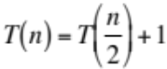

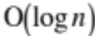

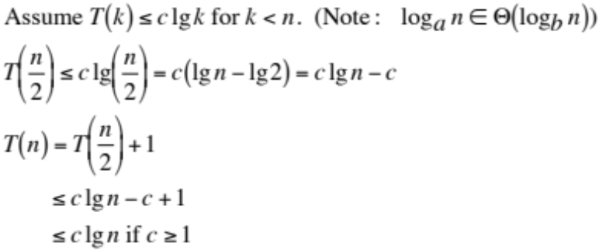
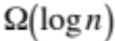

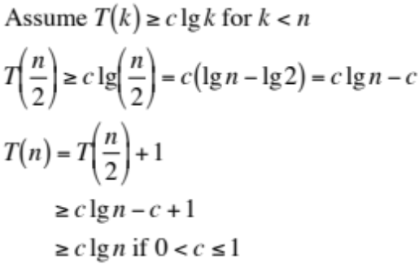

Example: 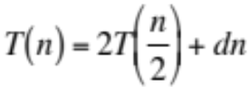

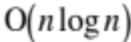

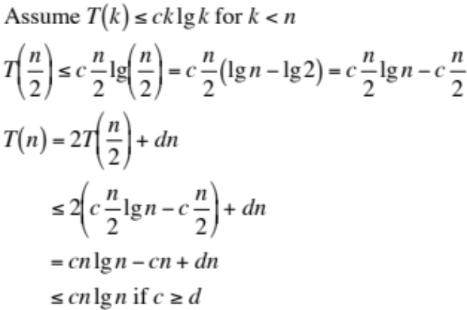

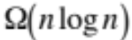

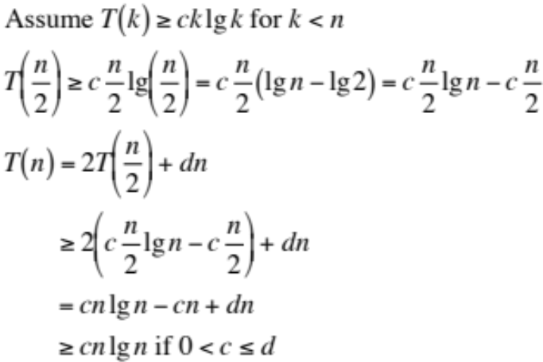

Why is there no basis step for the math induction in these two examples?
Example: 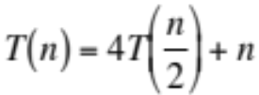

Try 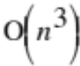 and confirm by math induction:

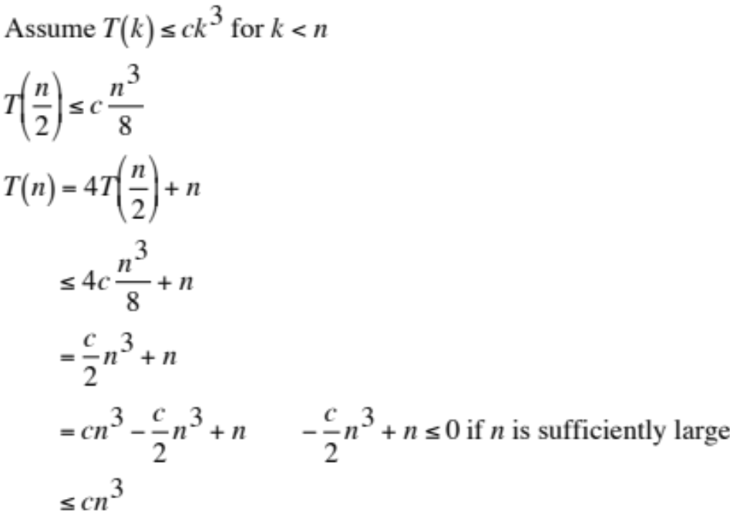

Improve bound to 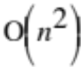 and confirm:

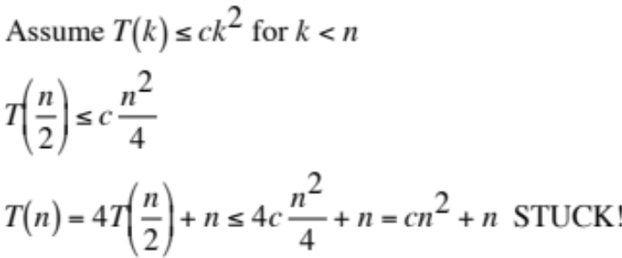

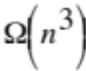 as lower bound:

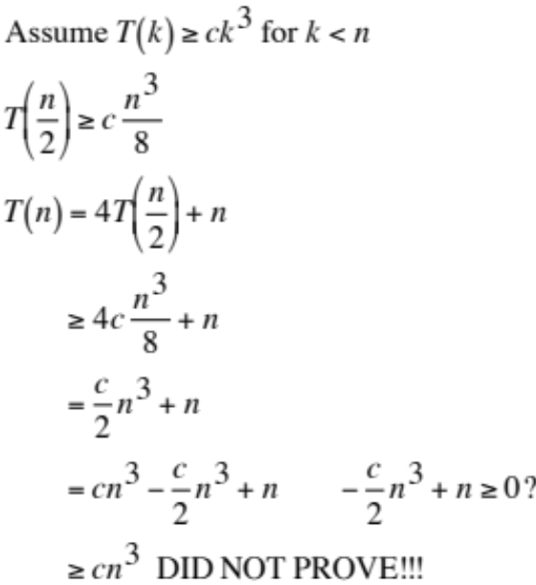

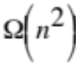 as lower bound:

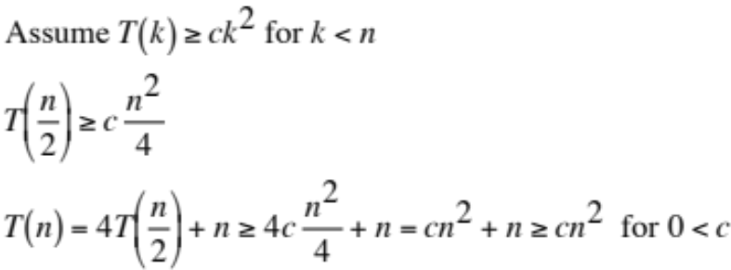

What’s going on? May use either brute expansion (or a recursion tree, see 4.D)

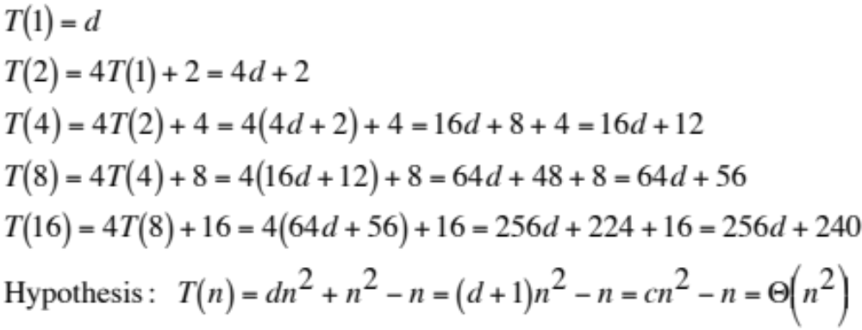
:

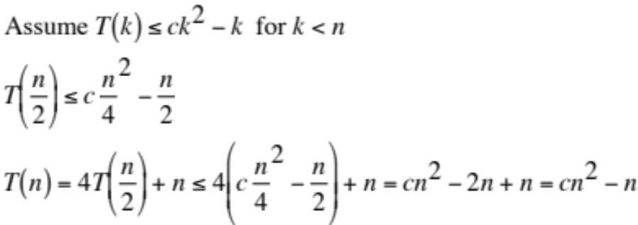

: [This bound was already proven.]

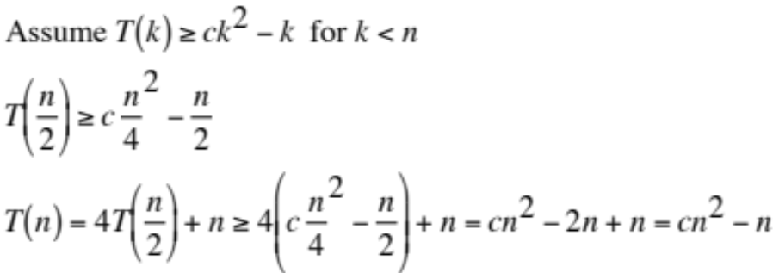

Example: 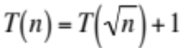

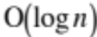:

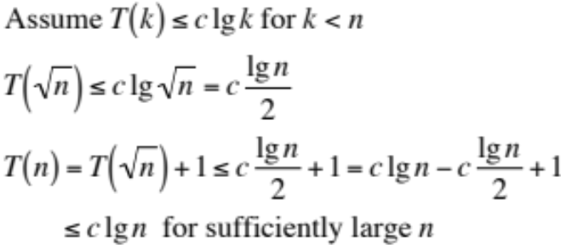

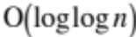:

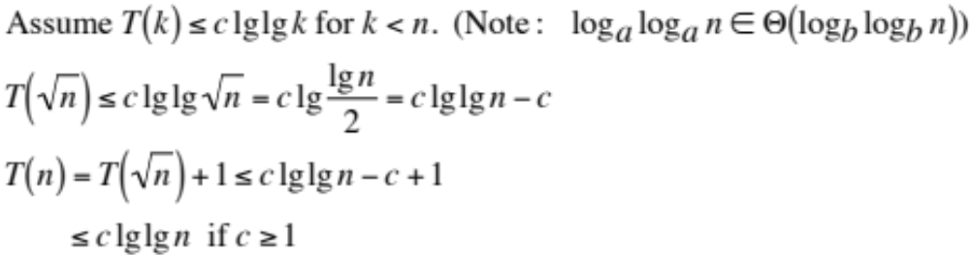

Achieving 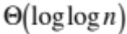 seems irrelevant, but . . .

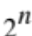 is to as is to 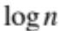 . . . and as is to 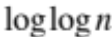.

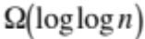:

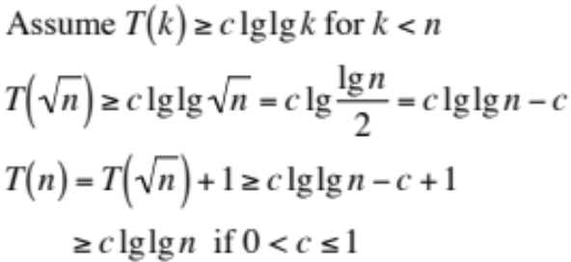

Example: 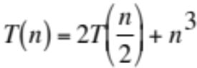

:

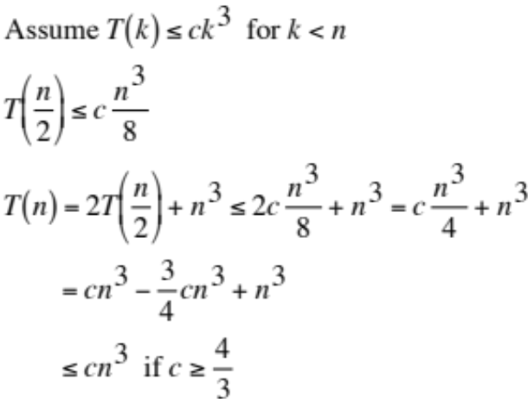

:

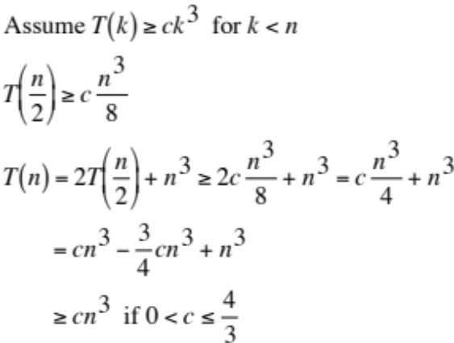

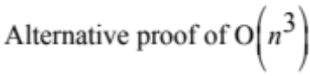:

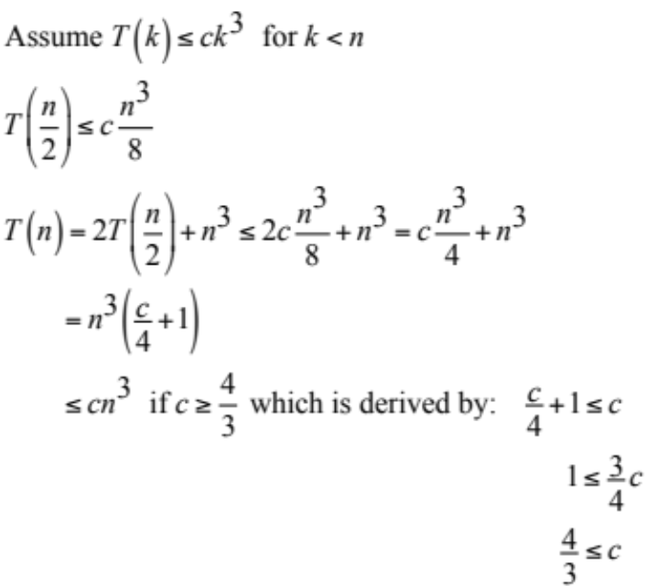
Example: 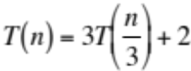

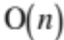:

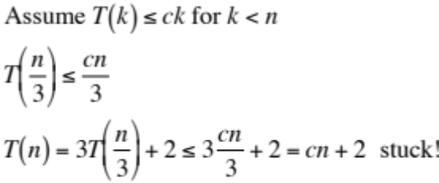

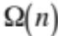:

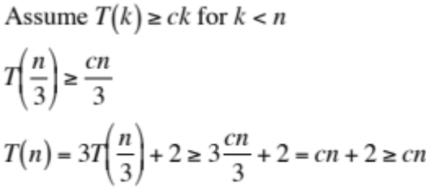

Examine a few cases:

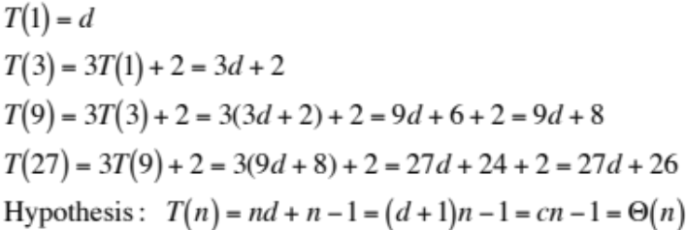

New try for :

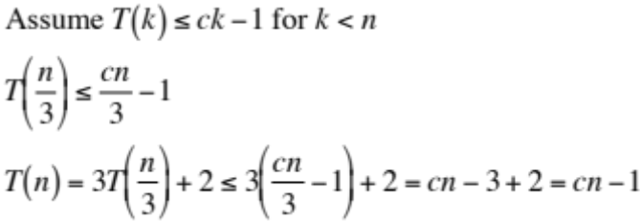

4.D. Recursion Tree Method

Concepts

Draw tree – either for a particular n or for general case

Fan-out

Sub-problem sizes

Number of levels in tree

Number of leaves

(Analysis at parents-of-leaves level is OPTIONAL!)

Assign (non-recursive) contribution of a node (sub-problem) in each level

Compute total (non-recursive) contribution across each level [ different from brute expansion ]

Usually complete by evaluating a summation – Go directly for Θ bound, not separate Ο and Ω.
Example: 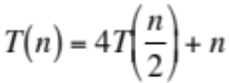

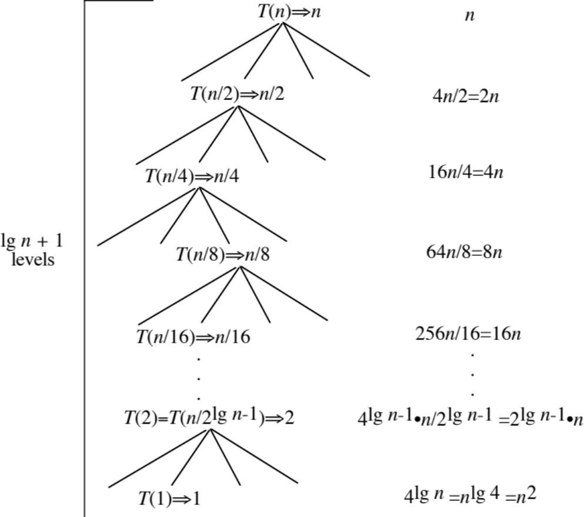

Note use of the identity 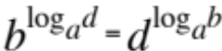. (CLRS, p. 56)

Using definite geometric sum formula:

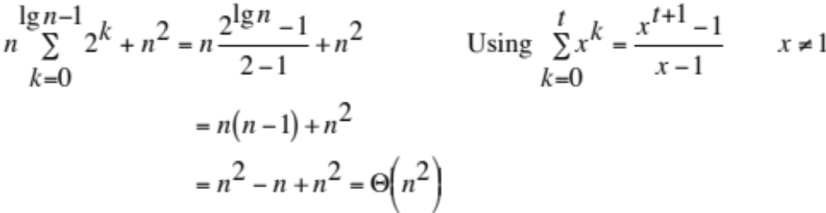

Example:

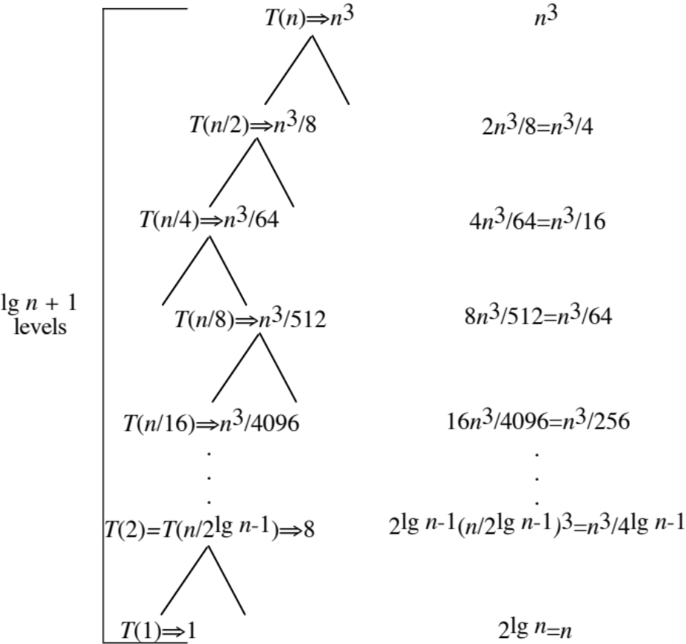

Using indefinite geometric sum formula:

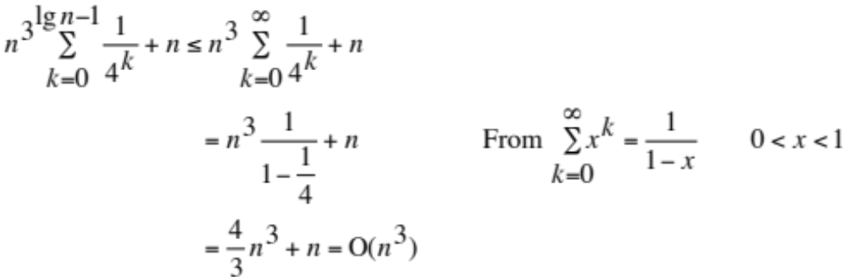

Using definite geometric sum formula:

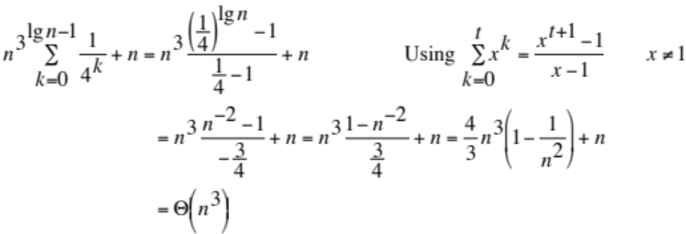

Example: 

