CSE 5311 Notes 15: Sequences

(Last updated 11/22/26 11:23 PM)

Pattern-Based Preprocessing

Simple Rescanning

Pattern - m symbols Text - n symbols

0 1 2 3
Example: Pattern: A B A C
Text: A B A B A B A C A B A B A C A B A
0 1 2 3
0
0 1 2 3
0
0 1 2 3
0
0 1
0
0 1 2 3
0
0 1 2 3
0
0 1
Worst-Case: Θ(mn)
0 1 2 3
Pattern: 0 0 0 1
Text: 0 0 0 0 0 0 0 0 0 0 1
0 1 2 3
0 1 2 3
0 1 2 3
0 1 2 3
0 1 2 3
0 1 2 3
0 1 2 3
0 1 2 3

Rabin-Karp Algorithm

Concept:

1. Compute signature of all m symbols of pattern. (Taking θ(m) time.)

2. Compute signature of each m contiguous symbols of text. (Taking overall θ(n) time.)

If function values for 1. and 2. are ever equal, then do symbol-by-symbol test.

#include <stdio.h>
#include <string.h>

#define B 131
#define EOS 0
#define TRUE 1
#define FALSE 0

void search(pat,text)
char *pat,*text;
{

int hpat,htext,Bm,j,m;

if (pat[0]==EOS) return;
Bm=1;
hpat=htext=0;

for (m=0;text[m]!=EOS && pat[m]!=EOS;m++)
{
Bm*=B;
hpat=hpat*B+pat[m];
htext=htext*B+text[m];
printf("%c ",text[m]);
if (pat[m+1]==EOS)
printf("%d",htext);
else
printf("\n");
}

if (text[m]==EOS && pat[m]!=EOS) return;

for (j=m;TRUE;j++)
{
if (hpat==htext && strncmp(text+j-m,pat,m)==0)
printf("<<<\n");
else
printf("\n");
if (text[j]==EOS) return;
htext=htext*B-text[j-m]*Bm+text[j];
printf("%c %d ",text[j],htext);
}
}

main()
{
char pat[80],text[80],*pos,*work;

printf("Enter pattern & text\n");
while (scanf("%s %s",pat,text)!=EOF)
{
search(pat,text);
printf("Enter pattern & text\n");
}
}

Knuth-Morris-Pratt Scan Technique

Takes O(m + n) time

Uses two tables for matcher

Pattern
Fail links

Matcher properties

Never backs up in the text
May use fail links to back up in pattern

Pattern Fail 1 Fail 2
0 A -1 -1
1 A 0 -1
2 A 1 -1
3 A 2 -1
4 B 3 3

Text: A A C A A A A A B A A A
States (1): 0 1 2 0 1 2 3 4 4
1 3
0
-1

Text: A A C A A A A A B A A A
States (2): 0 1 2 0 1 2 3 4 4
-1 3

Pattern Fail 1 Fail 2
0 A -1 -1
1 A 0 -1
2 B 1 1
3 A 0 -1
4 A 1 -1
5 B 2 1
6 A 3 -1
7 A 4 -1
8 A 5 5
9 B 2 1

Text: A A B A A B A A B A A A B A A B A A A B
States (1): 0 1 2 3 4 5 6 7 8 6 7 8 9 3 4 5 6 7 8 9
5 2

Text: A A B A A B A A B A A A B A A B A A A B
States (2): 0 1 2 3 4 5 6 7 8 6 7 8 9 0 1 2 3 4 5 2
5 1 1
-1
Knuth-Morris-Pratt Failure Link Construction

Fail link - seeks to reuse largest possible suffix before present position that matches a prefix of pattern.

Style 1: Choose maximum value of k with 0 ≤ k < j such that

for 0 < i ≤ k: pattern[k - i] == pattern[j - i]

Now set fail[j] = k

Style 2: Choose maximum value of k with 0 ≤ k < j such that

pattern[k] != pattern[j], and

for 0 < i ≤ k: pattern[k - i] == pattern[j - i]

Now set fail[j] = k

Direct application of these definitions could take Θ(m³) time!

Either style fail link table may be constructed in Θ(m) time.

For style 1:

Suppose fail links 0 through j have already been set and fail[j] == k.

If, in addition, pattern[j] == pattern[k] then

Set fail[j+1] = k+1

But, what if pattern[j] != pattern[k]?

Move k back to fail[k] and recheck for pattern match

0 b -1
1 a 0
2 b 0
3 b 1
4 a 1
5 b 2
6 a 3
7 b 2
8 b 3
9 a 4
10 b 5
11 b 6
12 a 4
13 b 5
14 a 6
15 b 7
16 b 8
17 a 9
18 b 10
19 a 11
20 b ?

For style 2:

Suppose fail links 0 through j have already been set and k is the required maximum value that was used when setting fail[j].

If, in addition, pattern[j] == pattern[k] then

If pattern[j+1] != pattern[k+1]

Set fail[j+1] = k+1

Else

Set fail[j+1] = fail[k+1]

But, what if pattern[j] != pattern[k]?

Move k back to fail[k] and recheck for pattern match

0 b -1
1 a 0
2 b -1
3 b 1
4 a 0
5 b -1
6 a 3
7 b -1
8 b 1
9 a 0
10 b -1
11 b 6
12 a 0
13 b -1
14 a 3
15 b -1
16 b 1
17 a 0
18 b -1
19 a 11
20 b ?

Fail 1 Pattern Fail 2

0 A

1 A

2 B

3 A

4 A

5 B

6 A

7 A

8 A

9 B

Fail 1 Pattern Fail 2

0 A

1 B

2 A

3 A

4 B

5 A

6 B

7 A

8 A

9 B

10 A

11 A

12 B

KMP.c:

/* Determine all possible occurences of pattern string in text
string using KMP technique*/
#include <stdio.h>
#include <string.h>

#define MAXPATLEN 80
#define EOS 0

void preprocpat1(pat,next)
/* Produces slower failure links, but capable of continuing after
match */
char *pat;
int next[];
{
int i,j;
i=0;
j=next[0]= -1;
do
{
if (j==(-1)||pat[i]==pat[j])
{
i++;
j++;
next[i]=j;
}
else
j=next[j];
} while (pat[i]!=EOS);
printf("Fail link table 1\n");
for (i=0;pat[i]!=EOS;i++)
printf("%d %c %d\n",i,pat[i],next[i]);
}

void preprocpat2(pat,next)
/* Produces faster failure links, but INcapable of continuing after
match */
char *pat;
int next[];
{
int i,j;
i=0;
j=next[0]= -1;
do
{
if (j==(-1)||pat[i]==pat[j])
{
i++;
j++;
next[i]=(pat[j]==pat[i]) ? next[j] : j;
}
else
j=next[j];
} while (pat[i]!=EOS);
printf("Fail link table 2\n");
for (i=0;pat[i]!=EOS;i++)
printf("%d %c %d\n",i,pat[i],next[i]);
}

void match(text1,pat)
char *text1,*pat;
{
int next1[MAXPATLEN],next2[MAXPATLEN],i,j;
char *text;
char printSymbol=' ';

if (*pat==EOS) return;
preprocpat1(pat,next1);
preprocpat2(pat,next2);

printf("%s\n",text1);
text=text1;
for (j=0; *text!=EOS;)
if (j==(-1) || pat[j]== *text)
{
if (pat[j+1]==EOS)
printSymbol='^';
if (pat[j+1]==EOS && *(text+1)!=EOS)
j=next1[j]; /*restart*/
else
{
printf("%c",printSymbol);
printSymbol=' ';
text++;
j++;
}
}
else
j=next2[j];
printf("\n");
}

main()
{
char pat[80],text[80];

printf("Enter text & pattern\n");
/*variable text is string 1, variable pat is string 2*/
while (scanf("%s %s",text,pat)!=EOF)
{
match(text,pat);
printf("Enter text & pattern\n");
}
}

KMP Complexity

m pattern symbols, n text symbols

Matcher - every comparison is preceded by a movement of one or both pointers

Text pointer always moves forward ⇒ 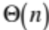

Pattern pointer

Moves forward once for each text symbol ⇒

Total number of backward movements ≤ total number of forward movements
⇒ 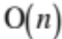 (could set up potential function based on pattern position)

Failure table construction

Lead pointer always moves forward ⇒ 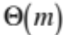

Prefix pointer

Moves forward once for each pattern symbol ⇒

Total number of backward movements ≤ total number of forward movements
⇒ 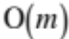 (could set up potential function based on pattern position)

Overall: 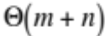

Aside: Worst-case number of comparisons (fail 2 links) when processing a text symbol is bounded by 1 + 1.44 lg m.

Fibonacci strings may be used as difficult cases:

F₁ = “a” F₂ = “b” F_{n} = F_{n-1}F_{n-2}

F₃ = “ba”

F₄ = “bab”

F₅ = “babba”

F₆ = “babbabab”

F₇ = “babbababbabba”

Other Applications

Is W constructed by repetition? i.e. W = X^{k} where X is the smallest such string.

String length must be factorable, then use KMP (either method) and use pointers at end.

Pattern Fail 2 Pattern Fail 2
0 0 -1 0 1 -1
1 0 -1 1 2 0
2 1 1 2 3 0
3 0 -1 3 4 0
4 0 -1 4 1 -1
5 2 2 5 2 0
6 0 -1 6 3 0
7 0 -1 7 4 0
8 1 1 8 1 -1
9 0 -1 9 2 0
10 0 -1
11 2 2

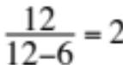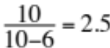

Are two strings (of same length) “circularly equal”?

1. Text = string2 || string 2
2. Pattern = string1
3. Does pattern occur in text?

Aside: CLRS 32.4 Prefix Function

Use Pascal, not C, array conventions:

Pattern Fail 1 Fail 2 π
1 a 0 0 0
2 b 1 1 0
3 a 1 0 1
4 b 2 1 2
5 a 3 0 3
6 b 4 1 4
7 a 5 0 5
8 b 6 1 6
9 c 7 7 0
10 a 1 0 1
11 ? 2

π[i] = Fail1[i+1] - 1

Gusfield’s Z Algorithm (“Fundamental String Preprocessing”)

Alternative to KMP

More straightfoward to apply for new situations.

Instead of failure links, each position of string has the number of positions starting at that
point that match a prefix of entire string.

Trivial to construct Z table in 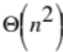 time, but can do in time.

Pattern Z
0 0 8
1 1 0
2 0 1
3 0 3
4 1 0
5 0 3
6 1 0
7 0 1

Applications:

String search: Build Z table for <pattern><text>

Any symbol in <text> with a Z value ≥ |<pattern>| gives a match.

Circularly equal: Build Z table for <string1><string2><string2> (|<string1>| = (|<string2>|)

Any symbol in first copy of <string2> with a Z value ≥ |<string2>| verifies.

Three aspects to Z-table construction:

1. Scanning to match against prefix.

2. Testing whether scanning must be resumed or prefix Z value copying may continue (“Z box” and “countdown”).

3. Modified copying (second phase) when scanning has reached end of input string.

0 1 2 3 4 5 6 7 8 9 10 11 12
0 1 0 0 1 0 1 0 0 1 0 0 1

0 1 2 3 4 5 6 7 8 9 10 11 12 13 14 15 16 17 18 19 20
a b c a b a b c a b c a b a b c a b a b c

0 1 2 3 4 5 6 7 8 9 10 11 12 13 14 15 16 17 18 19 20
0 1 0 0 1 0 1 0 0 1 0 0 1 0 1 0 0 1 0 1 0

21 22 23 24 25 26 27 28 29 30 31 32 33
0 1 0 0 1 0 1 0 0 1 0 0 1
void fundamental() {
int fillPosition,scanPosition,countdown,prefixPosition;

sLength=strlen(S);
if (sLength==0)
return;
Z[0]=sLength;

//Before EOS scanned
countdown=0;
fillPosition=scanPosition=1;
while (scanPosition<sLength)
if (countdown==0 || Z[prefixPosition]>=countdown) {
while (S[scanPosition]==S[countdown]) {
scanPosition++;
countdown++;
}
Z[fillPosition++]=countdown;
if (countdown==0)
scanPosition=fillPosition;
else {
countdown--;
prefixPosition=1;
}
}
else {
Z[fillPosition++]=Z[prefixPosition++];
countdown--;
}

//After EOS scanned
while (fillPosition<sLength)
Z[fillPosition++]=min(countdown--,Z[prefixPosition++]);
}

S. Faro & T. Lecroq, “The Exact Online String Matching Problem: A Review of the Most Recent Results”, ACM Computing Surveys 45 (2), Feb 2013: http://dl.acm.org.ezproxy.uta.edu/citation.cfm?doid=2431211.2431212

Suffix Arrays: Text-Based Preprocessing

Concept: Preprocess text and handle different patterns on-the-fly.

Simpler and more compact than other structures, such as suffix trees.

Sort array (sa) of pointers/subscripts based on corresponding suffixes of a text.

0 1 2 3 4 5 6 7 8 9 10 11
s a b c d a b c d a b c \0

sa 11 8 4 0 9 5 1 10 6 2 7 3

(These notes use null-terminated strings. Other terminators, e.g. $, would change the results . . .)
Key-comparison sorts can construct in 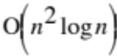 time (expected time for qsort):

int suffixCompare(const void *xVoidPt,const void *yVoidPt) {
// Used in qsort call to generate suffix array.
int *xPt=(int*) xVoidPt,*yPt=(int*) yVoidPt;

return strcmp(&s[*xPt],&s[*yPt]);
}

scanf("%s",s);
n=strlen(s)+1;
for (i=0;i<n;i++)
sa[i]=i;
qsort(sa,n,sizeof(int),suffixCompare);

The rank of a suffix is its position in the suffix array (i.e. these are inverses: rank[sa[i]]==i).

The longest common prefix (lcp[i]) is the number of prefix matches for sa[i-1] and sa[i].

i sa suffix lcp s rank lcp[rank]
0 11 -1 a 3 7
1 8 abc 0 b 6 6
2 4 abcdabc 3 c 9 5
3 0 abcdabcdabc 7 d 11 4
4 9 bc 0 a 2 3
5 5 bcdabc 2 b 5 2
6 1 bcdabcdabc 6 c 8 1
7 10 c 0 d 10 0
8 6 cdabc 1 a 1 0
9 2 cdabcdabc 5 b 4 0
10 7 dabc 0 c 7 0
11 3 dabcdabc 4 0 -1

U. Manber and E. Myers, “Suffix Arrays: A New Method for On-Line String Searches”, SIAM J. on Computing 22, 5 (1993), 935-948. http://epubs.siam.org.ezproxy.uta.edu/doi/pdf/10.1137/0222058

J. Kärkkäinen et.al., “Linear Work Suffix Array Construction”, J. ACM 53, 6 (Nov. 2006), 918-936 achieves linear time. http://dl.acm.org.ezproxy.uta.edu/citation.cfm?doid=1217856.1217858

S.J. Puglisi et.al., “A Taxonomy of Suffix Array Construction Algorithms”, ACM Computing Surveys 39 (2), June 2007. http://dl.acm.org.ezproxy.uta.edu/citation.cfm?doid=1242471.1242472

“Impressive as the progress has been, ingenious as the methods have been, there still remains the challenge to devise a SACA that is lightweight, linear in the worst case, and fast in practice.”

T. Kasai et.al., “Linear-Time Longest-Common-Prefix Computation in Suffix Arrays and Its Applications”, p. 181-192 in A. Amir and G.M. Landau (Eds): CPM 2001: 12th Ann’l Symp. on Combinatorial Pattern Matching, Lecture Notes in Computer Science 2089, Springer-Verlag, 2001.

M.I. Abouelholda, et.al., “Replacing Suffix Trees with Enhanced Suffix Arrays”, J. of Discrete Algorithms 2 (2004), 53-86. http://www.sciencedirect.com.ezproxy.uta.edu/science/journal/15708667/2/1

G.Navarro, “Spaces, Trees, and Colors: The Algorithmic Landscape of Document Retrieval on Sequences”, ACM Computing Surveys 46 (4), March 2014. http://dl.acm.org.ezproxy.uta.edu/citation.cfm?doid=2597757.2535933
Manber/Myers method uses 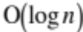 radix sorts each taking time to achieve 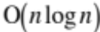 time.

radixsort i=1
POS MSD LSD - start of pass
0 abcdabcdabc 98 99
1 bcdabcdabc 99 100
2 cdabcdabc 100 101
3 dabcdabc 101 98
4 abcdabc 98 99
5 bcdabc 99 100
6 cdabc 100 101
7 dabc 101 98
8 abc 98 99
9 bc 99 100
10 c 100 1
11 1 0

POS MSD LSD - after radix sort
11 1 0
0 abcdabcdabc 98 99
4 abcdabc 98 99
8 abc 98 99
1 bcdabcdabc 99 100
5 bcdabc 99 100
9 bc 99 100
10 c 100 1
2 cdabcdabc 100 101
6 cdabc 100 101
3 dabcdabc 101 98
7 dabc 101 98
6 buckets

POS MSD LSD - after renumbering
11 0
0 abcdabcdabc 1
4 abcdabc 1
8 abc 1
1 bcdabcdabc 2
5 bcdabc 2
9 bc 2
10 c 3
2 cdabcdabc 4
6 cdabc 4
3 dabcdabc 5
7 dabc 5

radixsort i=2
POS MSD LSD - start of pass
0 abcdabcdabc 1 4
1 bcdabcdabc 2 5
2 cdabcdabc 4 1
3 dabcdabc 5 2
4 abcdabc 1 4
5 bcdabc 2 5
6 cdabc 4 1
7 dabc 5 2
8 abc 1 3
9 bc 2 0
10 c 3 0
11 0 0

POS MSD LSD - after radix sort
11 0 0
8 abc 1 3
0 abcdabcdabc 1 4
4 abcdabc 1 4
9 bc 2 0
1 bcdabcdabc 2 5
5 bcdabc 2 5
10 c 3 0
2 cdabcdabc 4 1
6 cdabc 4 1
3 dabcdabc 5 2
7 dabc 5 2
8 buckets
POS MSD LSD - after renumbering
11 0
8 abc 1
0 abcdabcdabc 2
4 abcdabc 2
9 bc 3
1 bcdabcdabc 4
5 bcdabc 4
10 c 5
2 cdabcdabc 6
6 cdabc 6
3 dabcdabc 7
7 dabc 7

radixsort i=4
POS MSD LSD - start of pass
0 abcdabcdabc 2 2
1 bcdabcdabc 4 4
2 cdabcdabc 6 6
3 dabcdabc 7 7
4 abcdabc 2 1
5 bcdabc 4 3
6 cdabc 6 5
7 dabc 7 0
8 abc 1 0
9 bc 3 0
10 c 5 0
11 0 0

POS MSD LSD - after radix sort
11 0 0
8 abc 1 0
4 abcdabc 2 1
0 abcdabcdabc 2 2
9 bc 3 0
5 bcdabc 4 3
1 bcdabcdabc 4 4
10 c 5 0
6 cdabc 6 5
2 cdabcdabc 6 6
7 dabc 7 0
3 dabcdabc 7 7
12 buckets

POS MSD LSD - after renumbering
11 0
8 abc 1
4 abcdabc 2
0 abcdabcdabc 3
9 bc 4
5 bcdabc 5
1 bcdabcdabc 6
10 c 7
6 cdabc 8
2 cdabcdabc 9
7 dabc 10
3 dabcdabc 11

The lcp array may be constructed in time. (LCPdemo.c)

void computeLCP() {
//Kasai et al linear-time construction
int h,i,j,k;

h=0; // Index to support result that lcp[rank[i]]>=lcp[rank[i-1]]-1
for (i=0;i<n;i++) {
k=rank[i];
if (k==0)
lcp[k]=(-1);
else {
j=sa[k-1];
// Attempt to extend lcp
while (i+h<n && j+h<n && s[i+h]==s[j+h])
h++;
lcp[k]=h;
}
if (h>0)
h--; // Decrease according to result
}
}

Accelerating binary searches on sa using lcp:

int slowSearchFirst(char* key) {
// Finds first string >= key assisted by binary search on suffix array,
// but without using lcp.
int low,high,mid;
int i,j;

low=0;
high=n-1;
while (low<=high) {
mid=(low+high)/2;
j=sa[mid]; // Position in s
i=0; // Position in key
// Like strcmp
while (s[j]==key[i] && key[i]) {
j++;
i++;
}
if (key[i]==0 || s[j]>key[i])
high=mid-1;
else
low=mid+1;
}

return low;
}

int fastSearchFirst(char* key) {
// Finds first string >= key assisted by binary search on suffix array.
// Uses lcp to limit char comparisons.
int low,high,mid;
int i,j;
int keyLength,lowMatches,highMatches,midMatches;

keyLength=strlen(key);
low=0;
lowMatches=0;
high=n-1;
highMatches=0;

while (low<=high) {
mid=(low+high)/2;
// How many strcmp matches can be salvaged?
midMatches=(lowMatches<highMatches) ? lowMatches : highMatches;

if (midMatches==keyLength) {
high=mid-1;
highMatches=(lcp[mid]<midMatches) ? lcp[mid] : midMatches;
}

j=sa[mid]+midMatches; // Position in s
i=midMatches; // Position in key
while (s[j]==key[i] && key[i]) {
midMatches++;
j++;
i++;
}
if (key[i]==0 || s[j]>key[i]) {
high=mid-1;
highMatches=(lcp[mid]<midMatches) ? lcp[mid] : midMatches;
}
else {
low=mid+1;
lowMatches=(lcp[low]<midMatches) ? lcp[low] : midMatches;
}
}

return low;
}

slowSearchFirst uses 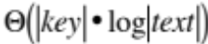 time, fastSearchFirst uses 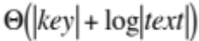 time.

Longest Common Substring Using Suffix Array & LCP

1. Construct text as <string1>$<string2>, then build SA and LCP arrays.

2. Scan LCP array for maximum entry for two adjacent SA entries from different strings.

i sa suffix lcp s rank lcp[rank]
0 30 -1 0 13 8
1 11 $010010100101001001 0 1 24 7
2 10 0$010010100101001001 0 0 5 6
3 27 001 1 0 14 6
4 24 001001 3 1 25 5
5 2 001001010$010010100101001001 6 0 6 4
6 5 001010$010010100101001001 4 0 17 3
7 19 00101001001 6 1 28 2
8 14 0010100101001001 9 0 10 2
9 28 01 1 1 21 1
10 8 010$010010100101001001 2 0 2 0
11 25 01001 3 $ 1 0
12 22 01001001 5 0 16 11
13 0 01001001010$010010100101001001 8 1 27 10
14 3 01001010$010010100101001001 6 0 8 9
15 17 0100101001001 8 0 19 8
16 12 010010100101001001 11 1 30 7
17 6 01010$010010100101001001 3 0 15 8
18 20 0101001001 5 1 26 7
19 15 010100101001001 8 0 7 6
20 29 1 0 0 18 5
21 9 10$010010100101001001 1 1 29 4
22 26 1001 2 0 12 5
23 23 1001001 4 1 23 4
24 1 1001001010$010010100101001001 7 0 4 3
25 4 1001010$010010100101001001 5 0 11 3
26 18 100101001001 7 1 22 2
27 13 10010100101001001 10 0 3 1
28 7 1010$010010100101001001 2 0 9 1
29 21 101001001 4 1 20 0
30 16 10100101001001 7 0 -1
Length of longest common substring is 8
01001001

M.A. Babenko and T.A. Starikovskaya, “Computing Longest Common Substrings Via Suffix Arrays”, Proc. 3rd Int’l Computer Science Symp. in Russia, CSR 2008, LNCS 5010, Springer, 64-75.

Aside: Kärkkäinen et.al. linear-time suffix array construction (DC3)

0 1 2 3 4 5 6 7 8 9 10 11 12 13 14 15 16 17 18 19 20 21
c d e a b c d e c d e a b c d e a b c d e (called t in the paper)

Step 1: Sort Sample Suffixes

R₁=[dea][bcd][ecd][eab][cde][abc][de0] (Sample triples starting at position 1)

R₂=[eab][cde][cde][abc][dea][bcd][e00] (Sample triples starting at position 2)

Concatenate to give the “samples”:

R=[dea][bcd][ecd][eab][cde][abc][de0][eab][cde][cde][abc][dea][bcd][e00]

LSD Radix sort the “characters” of R and rank:

[000] 1
[abc] 2 (appears 2 times)
[bcd] 3 (appears 2 times)
[cde] 4 (appears 3 times)
[de0] 5
[dea] 6 (appears 2 times)
[e00] 7
[eab] 8 (appears 2 times)
[ecd] 9

R’ is the result of substituting the rank for each character in R:

0 1 2 3 4 5 6 7 8 9 10 11 12 13 14
6 3 9 8 4 2 5 1 8 4 4 2 6 3 7

Since the symbols in R’ are not unique, DC3 is called recursively to produce the suffix array SA_{R’}. Note that 15 is the empty suffix.

0 1 2 3 4 5 6 7 8 9 10 11 12 13 14
7 5 11 13 1 4 10 9 6 12 0 14 3 8 2

From Kärkkäinen et.al., “Once the sample suffixes are sorted, assign a rank to each suffix. . . .”. Each value appearing in SA_{R’} gets mapped as below according to how R was constructed from the triples:

0 1 2 3 4 5 6 7 8 9 10 11 12 13 14 (Positions of sample)
1 4 7 10 13 16 19 22 2 5 8 11 14 17 20 (Positions of original Fibonacci string)

to give the following when substituted into SA_{R’}:

0 1 2 3 4 5 6 7 8 9 10 11 12 13 14
7 5 11 13 1 4 10 9 6 12 0 14 3 8 2 (Positions of sample)
22 16 11 17 4 13 8 5 19 14 1 20 10 2 7 (Positions of original Fibonacci string)
1 2 3 4 5 6 7 8 9 10 11 12 13 14 15 (Ranks)

Now “invert” to give ranks for sampled positions of original Fibonacci string:

0 1 2 3 4 5 6 7 8 9 10 11 12 13 14 15 16 17 18 19 20 21 22 23
c d e a b c d e c d e a b c d e a b c d e
? 11 14 ? 5 8 ? 15 7 ? 13 3 ? 6 10 ? 2 4 ? 9 12 ? 1

Step 2: Sort Nonsample Suffixes

Nonsample suffixes are indicated in the immediately preceding table by “?”. Use LSD radix sort to sort pairs (t_{i}, rank(S_{i+1}) for these positions:

Sort input:

0: (c, 11)
3: (a, 5)
6: (d, 15)
9: (d, 13)
12: (b, 6)
15: (e, 2)
18: (c, 9)
21: (0, 1)

Sort output

21: (0, 1)
3: (a, 5)
12: (b, 6)
18: (c, 9)
0: (c, 11)
9: (d, 13)
6: (d, 15)
15: (e, 2)

Step 3: Merge

16: (a, 4)
11: (a, b, 6)

17: (b, c, 9)

4: (b, 8)

13: (c, 10)
8: (c, d, 13)

5: (c, d, 15)
19: (d, 12)
14: (d, e, 2)

1: (d, 14)

20: (e, 0, 1)

10: (e, 3)
2: (e, a, 5)
7: (e, 7)

21: (0, 1) (0, 0, 0)

3: (a, 5) (a, b, 8)

12: (b, 6) (b, c, 10)

18: (c, 9) (c, d, 12)

0: (c, 11) (c, d, 14)

9: (d, 13) (d, e, 3)

6: (d, 15) (d, e, 7)

15: (e, 2) (e, a, 4)

Final Result

0 1 2 3 4 5 6 7 8 9 10 11 12 13 14 15 16 17 18 19 20 21
21 16 11 3 17 12 4 18 13 8 0 5 19 14 9 1 6 20 15 10 2 7 Suffix Array
-1 0 5 5 0 4 4 0 3 8 8 3 0 2 7 7 2 0 1 6 6 1 LCP

Longest Common Subsequences

Dynamic Programming - review

Has important applications in genetics research.

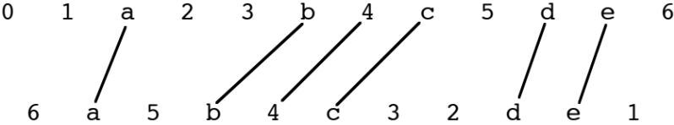

1. Describe problem input.

Two sequences:

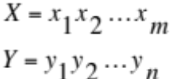

2. Determine cost function and base case.

C(i, j) = length of LCS for 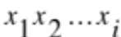 and 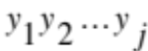

C(i, j) = 0 if i = 0 or j = 0

3. Determine general case.

Suppose 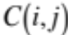 has

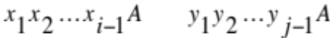

Since 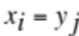, 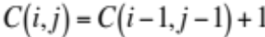

Now suppose 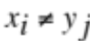:

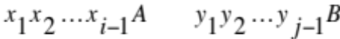

But ‘B’ may appear in 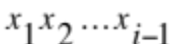 or ‘A’ may appear in 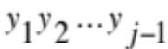:

4. Appropriate ordering of subproblems.

Before computing , must have 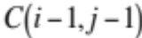, 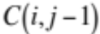, and 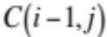 available.

Use (m + 1) × (n + 1) matrix to store C values.

5. Backtrace for solution – either explictly save indication of which of the three cases was used or recheck C values.

Takes 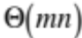 time.

Example:

010101
001100
LCS is 0100, length==4
0 0 1 1 0 0
0 0 0 0 0 0 0
0 0 1 1 1 1 1 1
1 0 1 1 2 2 2 2
0 0 1 2 2 2 3 3
1 0 1 2 3 3 3 3
0 0 1 2 3 3 4 4
1 0 1 2 3 4 4 4

Compact Version of Dynamic Programming

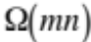 space is not required. 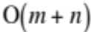 space is attainable using a recursive algorithm.

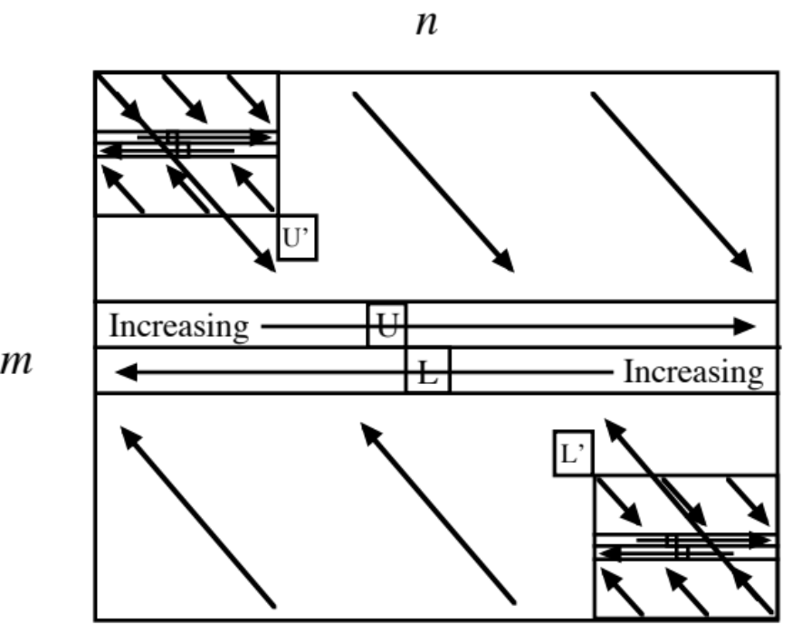

1. Use the usual NW to SE () cost computation to get increasing left-to-right cost row for LCS of the first m/2 elements of the first sequence and the entire second sequence.

2. Perform symmetric (SE to NW, ) cost computation for LCS of the last m/2 elements of the first sequence and the entire second sequence.

3. Scan across the two seams for the diagonal pair (U,L) with the maximum sum. This sum is the length of the LCS.

4. Scan left-to-right across the upper seam for the leftmost entry U’ with the U value. If non-zero, this gives an element for the LCS output array.

5. Scan right-to-left across the lower seam for the rightmost entry L’ with the L value. If non-zero, this gives an element for the LCS output array.

6. The U’ and L’ entries correspond to elements in the second sequence. Two simple scans can be used to find the corresponding elements of the first sequence.

7. Call recursively for each of the two subproblems. (Small subproblems may use O(mn) space version.)

Still runs in time:

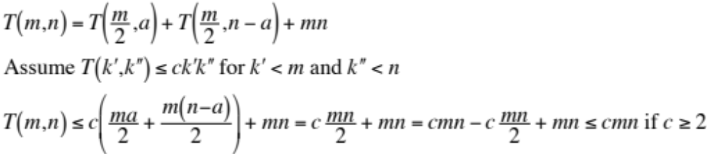

A B C D A B C D

0 0 0 0 0 0 0 0 0

A 0 1 1 1 1 1 1 1 1

A 0 1 1 1 1 2 2 2 2

B 0 1 2 2 2 2 3 3 3

B 0 1 2 2 2 2 3 3 3

C 3 3 3 2 2 2 2 1 0

C 3 3 3 2 2 2 2 1 0

D 2 2 2 2 1 1 1 1 0

D 1 1 1 1 1 1 1 1 0

0 0 0 0 0 0 0 0 0

Four Russians’ Method and LCS (aside, details in Gusfield)

When the LCS involves a small alphabet, the following properties allow Kronrod’s technique to be applied:

1. Going across a row of the 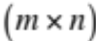 LCS matrix, 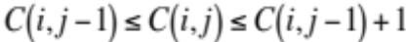.

2. Going down a column of the LCS matrix, 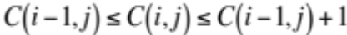.

(3. Going down a diagonal of the LCS matrix, .)

A template is used to a) preprocess for all possible situations and b) tile the LCS matrix:

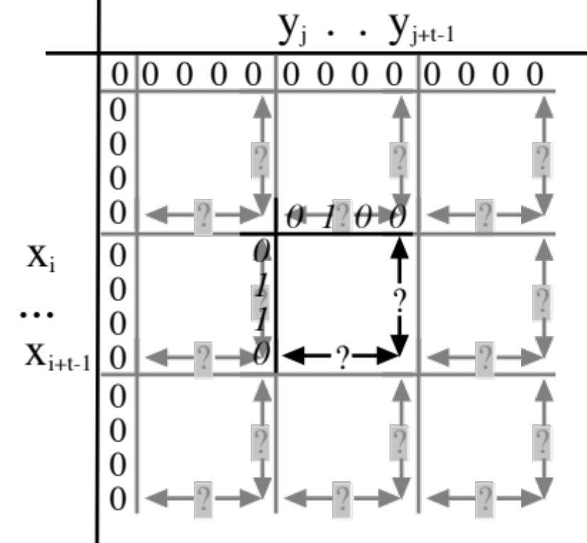

0 = value same as predecessor 1 = value is one more than predecessor

x_{i} = position in first sequence y_{j} = position in second sequence

? = offset values supplied by preprocessing

Typically, 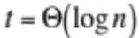 and runs in 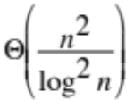.

Longest Increasing Subsequence

Equivalent to LCS:

Monotone: Sort input sequence A to obtain sequence A’ in ascending order.

Compute LCS of A and A’.

Strict (LSIS): Remove duplicates from A’ before computing LCS.

Dynamic Programming:

Concept: For each possible subsequence length, determine the smallest possible last
element.

Algorithm: Process A left-to-right.

Maintain table of current smallest elements for the subsequence lengths.

This table is non-decreasing.

Each element is processed by a binary search and then linking to predecessor.

Monotone: Find last table element ≤ current sequence element.

Strict: Similar, but current sequence element is ignored if already in table.

Monotone: 0 1 2 3 4 5 6 7 8 9
3 2 1 1 2 3 3 2 1 2
(predecessors)

Strict: 0 1 2 3 4 5 6 7 8 9
3 2 1 1 2 3 3 2 1 2
(predecessors)

Sparse LCS Using LSIS

Suppose an LCS for the following sequences is desired:

0 1 2 3 4 5 6 7

sequence 1: A B C D A B C D

sequence 2: A A B B C C D D

1. Replace each occurence of a symbol in sequence 1 by the positions of that symbol in sequence 2, but in descending order.

sequence 1: A B C D A B C D
0 1 2 3 4 5 6 7 8 9 10 11 12 13 14 15
sequence 2 positions 1 0 3 2 5 4 7 6 1 0 3 2 5 4 7 6
(predecessors)

2. Solve LSIS using dynamic programming.

Output gives positions in sequence 2 (0 1 2 4 6) for LCS elements: A A B C D

Takes time in O(r log r) where r is the length of the constructed LSIS instance.

Binary search table may be replaced by van Emde Boas tree.

