CSE 5311 Name _______________________________________
Test 1 - Closed Book
Summer 2014 Student ID # ____________________________________
Multiple Choice. Write your answer to the LEFT of each problem. 3 points each
1. During which operation on a leftist heap may subtree swaps be needed?
A. Decrease-Key B. Extract-Min
C. Union D. All of A., B., and C.
2. Which of the following is not true regarding the amortized analysis of binary tree traversals?
A. Init had an amortized cost of 1.
B. Succ had an actual cost determined by the number of edges followed.
C. Succ had an amortized cost of 2.
D. The potential was defined with regard to the type of traversal being performed.
3. Suppose you already have 10 different coupons when there are 20 coupon types. What is the expected number of boxes for obtaining a coupon different from the 10 you already have?
A. 2 B. 3 C. 4 D. 5
4. When is path compression used?
A. After an insertion into a splay tree.
B. With a Find operation.
C. After an insertion into any type of balanced binary search tree.
D. With a Union operation.
5. Which of the following data structures offers similar capabilities and performance characteristics to skip lists?
A. AVL trees B. Splay trees C. Treap D. Union-find with path compression
6. If a Fibonacci tree appears as a subtree of an AVL tree, which nodes would be assigned a balance factor of 0?
A. none of them B. only the leaves
C. only the root D. the leaves and the root
7. How many inversions are there for the lists 1, 2, 5, 4, 3 and 1, 2, 3, 4, 5?
A. 2 B. 3 C. 4 D. 5
8. Which of the following is not a legal leftist heap?
A. 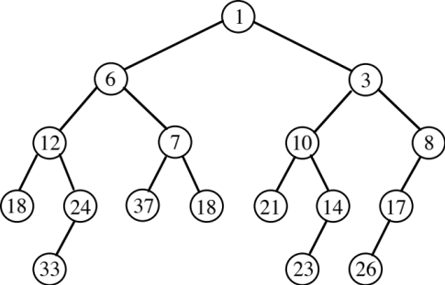 B. 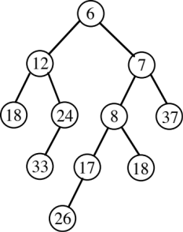
C. 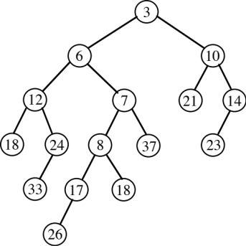 D. 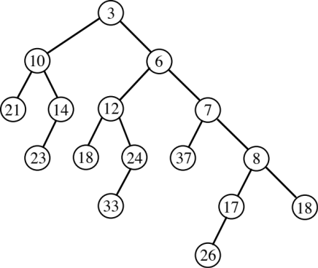
9. Which situation is true regarding a cascading cut that produces c trees for a Fibonacci heap?
A. Both the actual and amortized costs are O(1).
B. The actual cost is O(c). The amortized cost is O(1).
C. The actual cost is O(1). The amortized cost is O(c).
D. The potential can become negative.
10. Which property does not hold for binomial heaps?
A. Minimum takes O(1) time.
B. Performing n Insert operations into an empty heap will take O(n) time.
C. The number of trees is based on the binary representation of the number of stored items.
D. Decrease-Key takes O(log n) time.
11. When using Brent’s rehash, the number of previously inserted keys that may move is:
A. 1 B. 2 C. 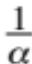 D. 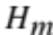, where m is the number of stored keys
12. Which priority queue implementation generalizes binary heaps by increasing the branching?
A. Binomial heaps B. d-heaps C. Fibonacci heaps D. Leftist heaps
13. What is minimized in the dynamic programming solution to the subset sum problem?
A. The number of input values used to sum to each 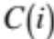 B. 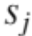
C. m D. The index stored for each
14. What is the worst-case number of rotations when performing deletion on an AVL tree?
A. 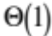 B. 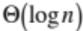 C. 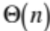 D. No rotations are ever used
15. If the universe size at the root of a van Emde Boas tree is u, then the number of children is:
A. lg u B. log u C. log log u D. 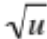
16. Give the binomial min-heap that results from inserting 1, 2, 3, 4, 5, 6, 7, 8 (in that order) into an empty heap. (5 points)
CSE 5311 Name _______________________________________
Test 1 - Open Book
Summer 2014 Student ID # ____________________________________
1. “During Disney’s biggest celebration, find one of 50 character Wobblers inside specially-marked Kellogg’s® cereals!”.
a. Assuming all Wobblers are equally likely to be the one that occurs in a box, what is the expected number of boxes to obtain all 50 Wobblers? (3 points. You may leave your answer as an expression.)
b. Under the same assumption as a., what is the expected number of boxes to obtain just 25 different Wobblers (of the available 50)? (7 points. You may leave your answer as an expression.)
2. Evaluate the following recurrences using the master method. Indicate the case that is used for each.
(10 points)
a. 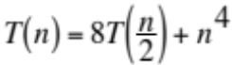
b. 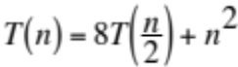
c. 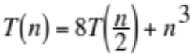
3. Construct the final optimal binary search tree (using Knuth’s root trick) and give its cost. SHOW YOUR WORK. (10 points)

n=6;
q[0]=0.12;
key[1]=10;
p[1]=0.12;
q[1]=0.09;
key[2]=20;
p[2]=0.2;
q[2]=0.03;
key[3]=30;
p[3]=0.1;
q[3]=0.04;
key[4]=40;
p[4]=0.2;
q[4]=0.0;
key[5]=50;
p[5]=0.01;
q[5]=0.04;
key[6]=60;
p[6]=0.03;
q[6]=0.02;
w[0][0]=0.120000
w[0][1]=0.330000
w[0][2]=0.560000
w[0][3]=0.700000
w[0][4]=0.900000
w[0][5]=0.950000
w[0][6]=1.000000
w[1][1]=0.090000
w[1][2]=0.320000
w[1][3]=0.460000
w[1][4]=0.660000
w[1][5]=0.710000
w[1][6]=0.760000
w[2][2]=0.030000
w[2][3]=0.170000
w[2][4]=0.370000
w[2][5]=0.420000
w[2][6]=0.470000
w[3][3]=0.040000
w[3][4]=0.240000
w[3][5]=0.290000
w[3][6]=0.340000
w[4][4]=0.000000
w[4][5]=0.050000
w[4][6]=0.100000
w[5][5]=0.040000
w[5][6]=0.090000
w[6][6]=0.020000
Building c(0,2) using roots 1 thru 2
Building c(1,3) using roots 2 thru 3
Building c(2,4) using roots 3 thru 4
Building c(3,5) using roots 4 thru 5
Building c(4,6) using roots 5 thru 6
Building c(0,3) using roots 1 thru 2
Building c(1,4) using roots 2 thru 4
Building c(2,5) using roots 4 thru 4
Building c(3,6) using roots 4 thru 6
Building c(0,4) using roots 2 thru 2
Building c(1,5) using roots 2 thru 4
Building c(2,6) using roots 4 thru 4
Building c(0,5) using roots 2 thru 2
Building c(1,6) using roots 2 thru 4
Building c(0,6) using roots ? thru ?
Counts - root trick 31 without root trick 50
Average probe length is ???
trees in parenthesized prefix
c(0,0) cost 0.000000
c(1,1) cost 0.000000
c(2,2) cost 0.000000
c(3,3) cost 0.000000
c(4,4) cost 0.000000
c(5,5) cost 0.000000
c(6,6) cost 0.000000
c(0,1) cost 0.330000 10
c(1,2) cost 0.320000 20
c(2,3) cost 0.170000 30
c(3,4) cost 0.240000 40
c(4,5) cost 0.050000 50
c(5,6) cost 0.090000 60
c(0,2) cost 0.880000 10(,20)
c(1,3) cost 0.630000 20(,30)
c(2,4) cost 0.540000 40(30,)
c(3,5) cost 0.340000 40(,50)
c(4,6) cost 0.150000 60(50,)
c(0,3) cost 1.200000 20(10,30)
c(1,4) cost 1.200000 20(,40(30,))
c(2,5) cost 0.640000 40(30,50)
c(3,6) cost 0.490000 40(,60(50,))
c(0,4) cost 1.770000 20(10,40(30,))
c(1,5) cost 1.350000 20(,40(30,50))
c(2,6) cost 0.790000 40(30,60(50,))
c(0,5) cost 1.920000 20(10,40(30,50))
c(1,6) cost 1.540000 40(20(,30),60(50,))
c(0,6) cost ??? ??????????????????

4. Fill in the min and max blanks for the following instance of a van Emde Boas tree for the set {1, 3, 5, 6, 7, 13, 14, 15}. You should give these as values in the local universe (0..u-1). Instead of using the symbol “/” for nil, use the symbol “∅”. (10 points)
root (base 0) u 16 min _______ max _______
summary (base 0) u 4 min _______ max _______
summary (base 0) u 2 min _______ max _______
cluster[0] (base 0) u 2 min _______ max _______
cluster[1] (base 2) u 2 min _______ max _______
cluster[0] (base 0) u 4 min _______ max _______
summary (base 0) u 2 min _______ max _______
cluster[0] (base 0) u 2 min _______ max _______
cluster[1] (base 2) u 2 min _______ max _______
cluster[1] (base 4) u 4 min _______ max _______
summary (base 0) u 2 min _______ max _______
cluster[0] (base 4) u 2 min _______ max _______
cluster[1] (base 6) u 2 min _______ max _______
cluster[2] (base 8) u 4 min _______ max _______
summary (base 0) u 2 min _______ max _______
cluster[0] (base 8) u 2 min _______ max _______
cluster[1] (base 10) u 2 min _______ max _______
cluster[3] (base 12) u 4 min _______ max _______
summary (base 0) u 2 min _______ max _______
cluster[0] (base 12) u 2 min _______ max _______
cluster[1] (base 14) u 2 min _______ max _______
5. The hash table below was created using double hashing with Brent’s rehash. The initial slot (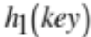) and rehashing increment (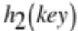) are given for each key. Show the result from inserting 1300 using Brent’s rehash when 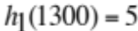 and 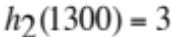. (10 points)
key
0
1 1000 6 2
2
3 1200 3 3
4 500 3 1
5 12 5 1
6 27 6 3

key
0
1
2
3
4
5
6
CSE 5311 Name ________________________________
Test 2 - Closed Book
Summer 2014
Multiple Choice. Write your answer to the LEFT of each problem. 3 points each
1. What is the nature of the signature function for the Karp-Rabin method?
A. it is similar to the KMP failure links
B. the remainder by discarding the overflow for a polynomial
C. a polynomial of arbitrary precision implemented using a bignum package
D. similar to a double hash function for string keys
2. When performing selection in worst-cast linear time for n numbers, roughly how many column medians are computed in the first round?
A. 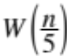 B. m, the median-of-medians C. 0.7n D.
3. While constructing a suffix array for a sequence with n symbols by using radix sorts, sequence symbols are used in which of the radix sorts?
A. All of them B. None of them C. The last one D. The first one
4. Which of the following is a deficiency of the maximum capacity path technique?
A. Augmenting paths will be discovered in descending incremental flow increase order.
B. Flow decomposition must be applied.
C. An augmenting path is blocked if it introduces a cycle of flow.
D. The maximum number of potential augmenting paths depends on the achievable flow, in addition to the number of vertices and edges.
5. In a maximum flow problem, the number of augmenting paths in a flow decomposition is bounded by:
A. V B. 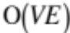 C. f D. E
6. Which of the following is not true regarding Strassen’s algorithm?
A. It is not possible to have an asymptotically faster algorithm.
B. It requires more space than the everyday method.
C. It uses 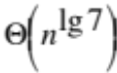 scalar additions when multiplying two n x n matrices.
D. It uses scalar multiplications when multiplying two n x n matrices.
7. The four russians’ concept is to:
A. Implement longest common subsequences using linear space
B. Pack bits into an efficient storage unit
C. Trade-off between enumerating situations and referencing these situations
D. Trade-off between scalar additions and multiplications
8. Which is not true regarding the first-fit decreasing method for bin packing?
A. Each object is placed by going left-to-right until it fits in a bin or a new bin is allocated.
B. Objects placed in bins beyond the optimal number have sizes no larger than ½.
C. The number of objects placed in bins beyond the optimal number is arbitrary.
D. The number of objects with sizes larger than ½ is a lower bound on the optimal number of bins.
9. Which of the following is NOT required when showing that problem B is NP-complete by a reduction from problem A?
A. The reduction has an inverse that takes each instance of problem B to an instance of problem A.
B. The reduction takes polynomial time.
C. The reduction must be consistent for the decision results for each instance of problem A and and the corresponding instance of problem B.
D. Problem A is NP-complete.
10. The algorithm for finding a maximum capacity path for network flows is most similar to which algorithm?
A. Breadth-first search
B. Decomposition of a flow into E augmenting paths
C. Dijkstra
D. Floyd-Warshall
11. Which minimum spanning tree algorithm is the slowest?
A. Boruvka B. Kruskal C. Prim D. Warshall
12. The reduction from 3-sat to 3-colorability will give a graph requiring four colors when:
A. Removing one clause from the 3-sat instance will leave a satisifiable set of clauses.
B. The 3-sat instance is unsatisfiable.
C. The 3-sat instance is satisfiable.
D. The 3-sat instance is a tautology.
13. Which of the following is not required before relabeling (“lifting”) a vertex to a new height?
A. Both breadth-first searches have been done.
B. The vertex is overflowing.
C. Any eligible edges for the present height have been saturated.
D. The vertex is not the source or sink.
14. Which of the following does not have a polynomial-time approximation algorithm?
A. Bin packing
B. Edge coloring
C. Traveling salesperson with triangle inequality
D. Vertex coloring
15. How many times will -1 occur in the style 2 fail link table for the pattern acaababc?
A. 1 B. 2 C. 3 D. 4
16. Suppose you have a set of points in Euclidean 2-d space. Give an algorithm for finding a ρ-approximation for the minimum traveling salesperson path. Be sure to give the value of ρ. (5 points)

CSE 5311 Name ________________________________
Test 2 - Open Book
Summer 2014
1. Demonstrate Boruvka’s algorithm on the following graph. Be sure to indicate the edges that are inserted into the MST in each phase. (10 points)
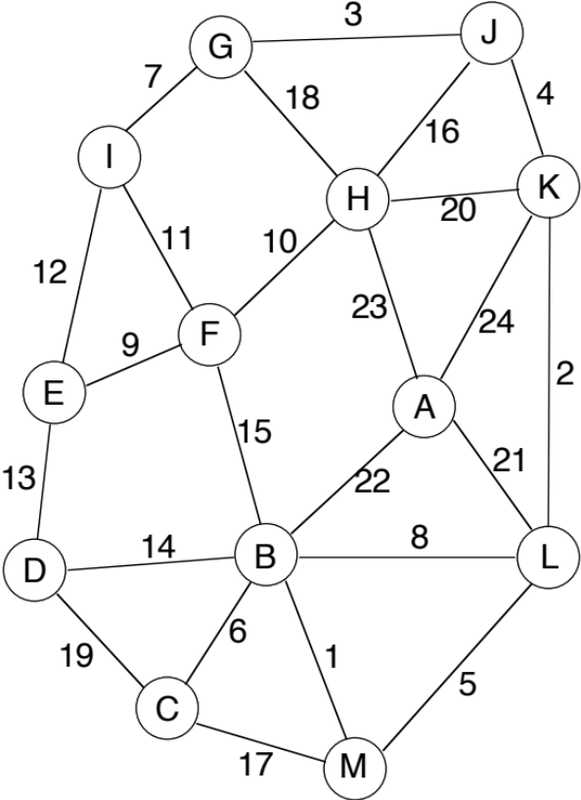
2. Give both types of KMP failure link tables and the table produced by the Z algorithm for the following string: (15 points)
0 a
1 c
2 a
3 b
4 a
5 c
6 a
7 c
8 a
9 b
10 a
11 c
12 a
13 b
14 a
15 c
16 a
17 c
18 a
19 b
20 a
21 c
22 a
23 c
24 a
3. List the remaining operations to complete this instance of network flows by push-relabel. In addition, give a minimum cut. (15 points)
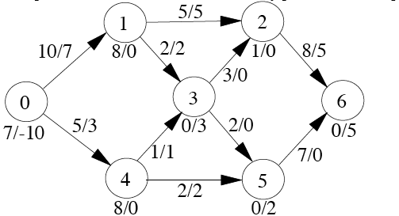
4. Use dynamic programming, either with a table or lists, to determine a subset that sums to 20. DO NOT SOLVE BY INSPECTION! (10 points)
2 3 5 7 11 13 17

