Asymptotic Bounds

**Review:**

Use ratio and limit to infinity to compare function growth. Examples:

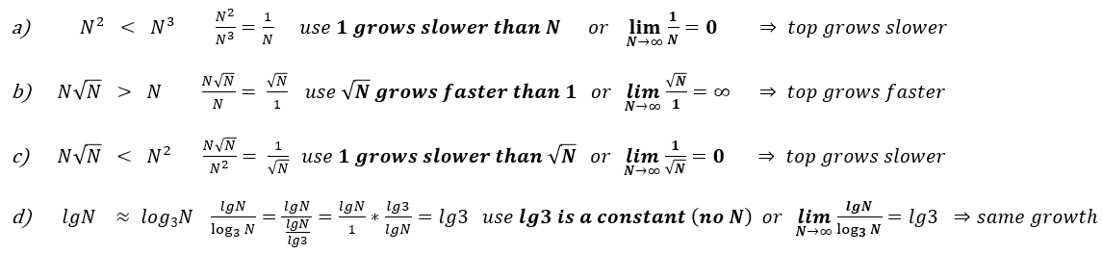

Examples of functions that have N2 growth:

Speed of Growth:

____<____<____<____<____<____<____<____<____<____<____<____<____

Fill in each column functions that have the same growth as the column label.

|  |  |  |  |  |  |  |
| --- | --- | --- | --- | --- | --- | --- |
| 1 | lgN | N | NlgN | N2 | N3 | 2N |
|  |  |  |  |  |  |  |

The functions listed in a column are ____ of the function that labels the column. E.g. _________ = ___( N2)

From ordering by growth to asymptotic notation

…………………………………………………………………………………………………………………………………………………………………………………

…………………………………………………………………………………………………………………………………………………………………………………

Symbol: Θ O o Ω ⍵

Meaning:

Examples: N3/10 – 500N2 -1000 = O(N3) True/False Solution: find dominant term(s) and compare their growth

Notation abuse: = instead of $∈$

Finding Θ , O , Ω for an algorithm.

|  |  |
| --- | --- |
| Worst case is Θ(___) then the algorithm is ___ ( ______)  Best case is Θ(___) then the algorithm is ___ ( ______) | Insertion sort:  Worst case is Θ(___) then insertion sort is ___ ( ______)  Best case is Θ(___) then insertion sort is ___ ( ______) |

An algorithm is Θ(_____) iff best case and worst case have __________________ TC.

Exercise: Assume:

* Alg 1 is O(N2) ……can be: ……………………………………………………….. cannot be: ………………………………………………………..
* Alg 2 is Θ(NlgN) can be: ……………………………………………………….. cannot be: ………………………………………………………..
* Alg 3 is Ω(N) …… can be: ……………………………………………………….. cannot be: ………………………………………………………..
* what could be the TC function in each case?
* which one is “better”? (define better)

|  |  |  |  |  |  |
| --- | --- | --- | --- | --- | --- |
| Symbol | Name | Meaning | Notation | Examples | Limit theorem |
| ⍵ |  |  |  |  |  |
| Ω |  |  |  |  |  |
| Θ |  |  |  |  |  |
| O |  |  |  |  |  |
| o |  |  |  |  |  |

Ex: Fill in s.t the statements are correct

TC = Θ(log3(N)) => TC = o(______) , TC = O(______), TC = Ω(______), TC = ⍵(______)

⍵: ____________________ Ο: _____________________ Ω: ___________________ ο: ______________________

TC = Θ(N2) => TC = o(______) , TC = O(______), TC = Ω(______), TC = ⍵(______)

⍵: ____________________ Ο: _____________________ Ω: ___________________ ο: ______________________

TC = O(N2)

⍵: ____________________ Ο: _____________________ Ω: ___________________ ο: ______________________

Asymptotic Bounds as Limits:

f(n) = ω(g(n)) ⇔ $\lim_{n→∞}{\frac{f(n)}{g(n)}}=∞$

English Translation:

 f(n) = Ω(g(n)) ⇔ $\lim_{n→∞}{\frac{f(n)}{g(n)}}=∞ or c≠0$

English Translation:

f(n) = Θ(g(n)) ⇔ $\lim_{n→∞}{\frac{f(n)}{g(n)}}=c≠0$  (limit is a non-zero constant)

English Translation:

 f(n) = O(g(n)) ⇔ $\lim_{n→∞}{\frac{f(n)}{g(n)}}=0 or c$

English Translation:

 f(n) = o(g(n)) ⇔ $\lim_{n→∞}{\frac{f(n)}{g(n)}}=0$

English Translation:

Properties:

1.

2.

3.

4.

5.

*** Transitivity (From Discrete Structures): If a > b and b > c, then a > c. This concept can be applied to TC bounds as well.

6.

7.