*BFS-Visit(G,s) // search graph G starting from vertex s.*



* 1. *For each vertex u of G*



* + 1. *color[u] = WHITE // undiscovered*
    2. *dist[u] = inf // distance from s to u*

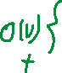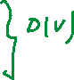

* + 1. *pred[u] = NIL // predecessor of u on the path from s to u*



* 1. *color[s] = GRAY // s is being processed*



* 1. *dist[s] = 0*



* 1. *pred[s] = NIL*



* 1. *Initialize empty queue Q*



* 1. *put(Q,s) // s goes to the end of Q*



* 1. *While Q is not empty*



* + 1. *u = get(Q) // removes u from the front of Q*



* + 1. *For each v adjacent to u //explore edge (u,v) // in increasing order*



* + - 1. *If color[v] == WHITE*



* + - * 1. *color[v] = GRAY*

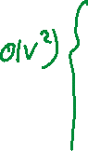

* + - * 1. *dist[v] = dist[u]+1*

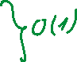

* + - * 1. *pred[v] = u*



* + - * 1. *put(Q,v)*



* + 1. *color[u] = BLACK*

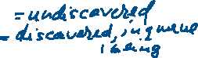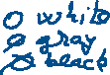

|  |  |  |
| --- | --- | --- |
| *Representation* | *BFS time complexity* | *BFS space complexity* |
| *Adj LIST* | *O(______)* |  |
| *Adj MATRIX* | *O(______)* |  |



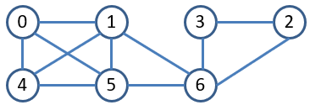



|  |  |  |  |  |  |  |  |
| --- | --- | --- | --- | --- | --- | --- | --- |
| *Vertex* | *0* | *1* | *2* | *3* | *4* | *5* | *6* |
| *Work*  *(dist and parent updates for nodes)* |  |  |  |  |  |  |  |

*MST_Prim(G,w,s)* // N = |V|

1. *int d[N], p[N]*
2. *For v =0 -> N-1*
3. *d[v]=inf //min weight of edge connecting v to MST*
4. *p[v]=-1 //MST vertex, s.t. w(p[v],v) =d[v]*
5. *d[s]=0*
6. *Q = PriorityQueue(G.V, d)*
7. *While notEmpty(Q)*
8. *u = removeMin(Q,d)*



1. *for each v adjacent to u*



1. *if v in Q and w(u,v)<d[v] {*



1. *p[v]=u*



1. *d[v] = w(u,v);*
2. *decreasedKeyFix(Q,v,d)* //v is neither index nor key
3. }
4. }

Assume adjacency list representation. TC: SC:

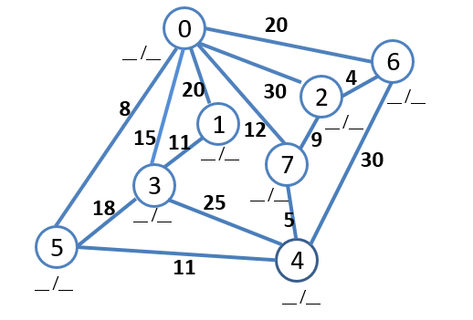

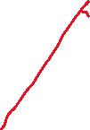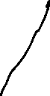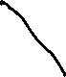

|  |  |  |  |  |  |  |  |  |
| --- | --- | --- | --- | --- | --- | --- | --- | --- |
| Vertex | 0 | 1 | 2 | 3 | 4 | 5 | 6 | 7 |
| Work  (dist and parent updates for nodes) |  |  |  |  |  |  |  |  |



*Dijkstra(G,w,s)* // N = |V|

1. *int d[N], p[N]*
2. *For v =0 -> N-1*
3. *d[v]=inf //total weight from s to v*
4. *p[v]=-1 //v’s predecessor on path s to v*
5. *d[s]=0*
6. *Q = PriorityQueue(d)*
7. *While notEmpty(Q) {*
8. *u = removeMin(Q,w)*
9. *for each v adjacent to u*
10. *if v in Q and (d[u]+w(u,v))<d[v]{*
11. *p[v]=u*
12. *d[v] = d[u]+w(u,v);*
13. *decreasedKeyFix(Q,v,d)*
14. *}*

*15 }*



|  |  |  |  |  |  |  |  |  |
| --- | --- | --- | --- | --- | --- | --- | --- | --- |
| Vertex | 0 | 1 | 2 | 3 | 4 | 5 | 6 | 7 |
| Work  (dist and parent updates for nodes) |  |  |  |  |  |  |  |  |