|  |  |  |  |  |  |
| --- | --- | --- | --- | --- | --- |
| Vertex | 0 | 4 | 5 | 1 | 7 |
| In-degree |  |  |  |  |  |
| Out-degree |  |  |  |  |  |

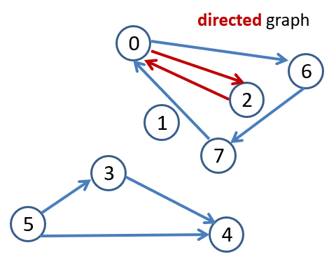

Give the adjacency matrix and adjacency list

representation for the above graph.

Fill in the matrix representation.

Use row as source and column as destination for edges.

|  |  |  |  |  |  |  |  |
| --- | --- | --- | --- | --- | --- | --- | --- |
|  |  |  |  |  |  |  |  |
|  |  |  |  |  |  |  |  |
|  |  |  |  |  |  |  |  |
|  |  |  |  |  |  |  |  |
|  |  |  |  |  |  |  |  |
|  |  |  |  |  |  |  |  |
|  |  |  |  |  |  |  |  |
|  |  |  |  |  |  |  |  |

Give the Adjacency list representation.

Size __ array of _____________ (array items)

|  |
| --- |
|  |
|  |
|  |
|  |
|  |
|  |
|  |
|  |

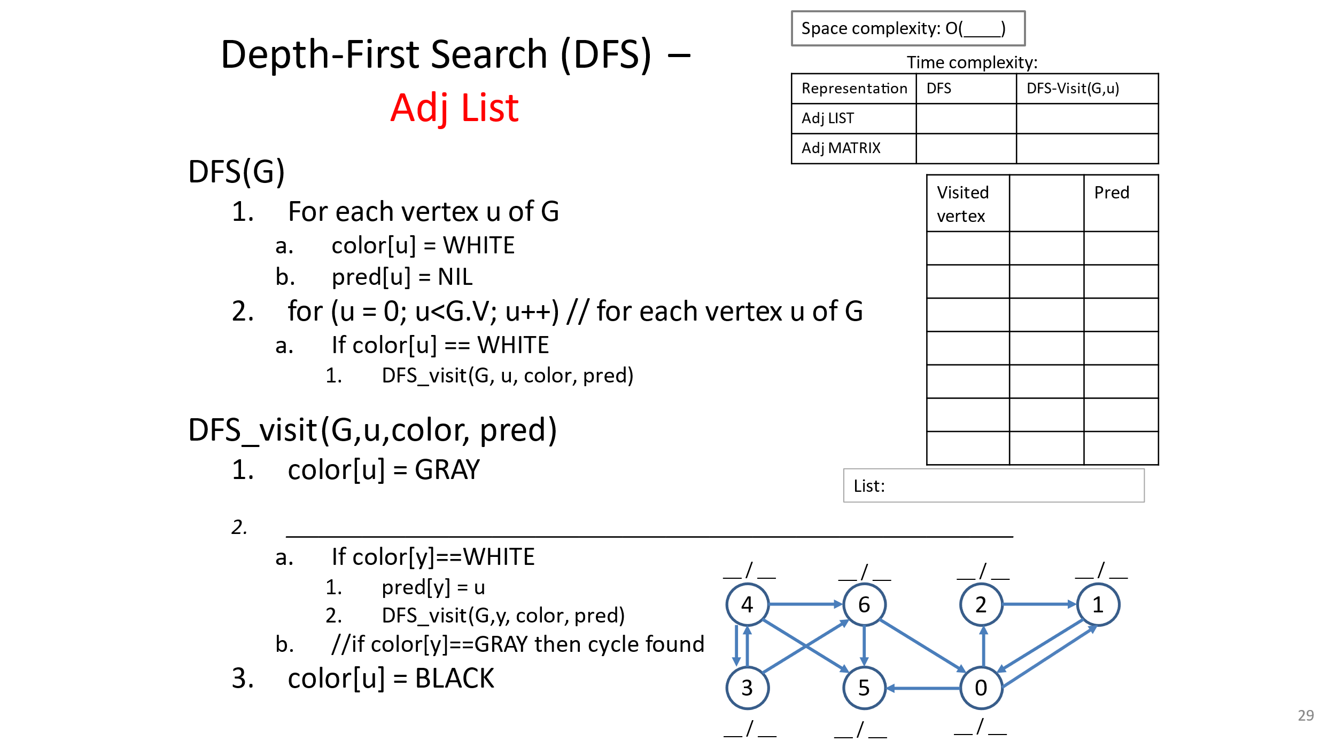

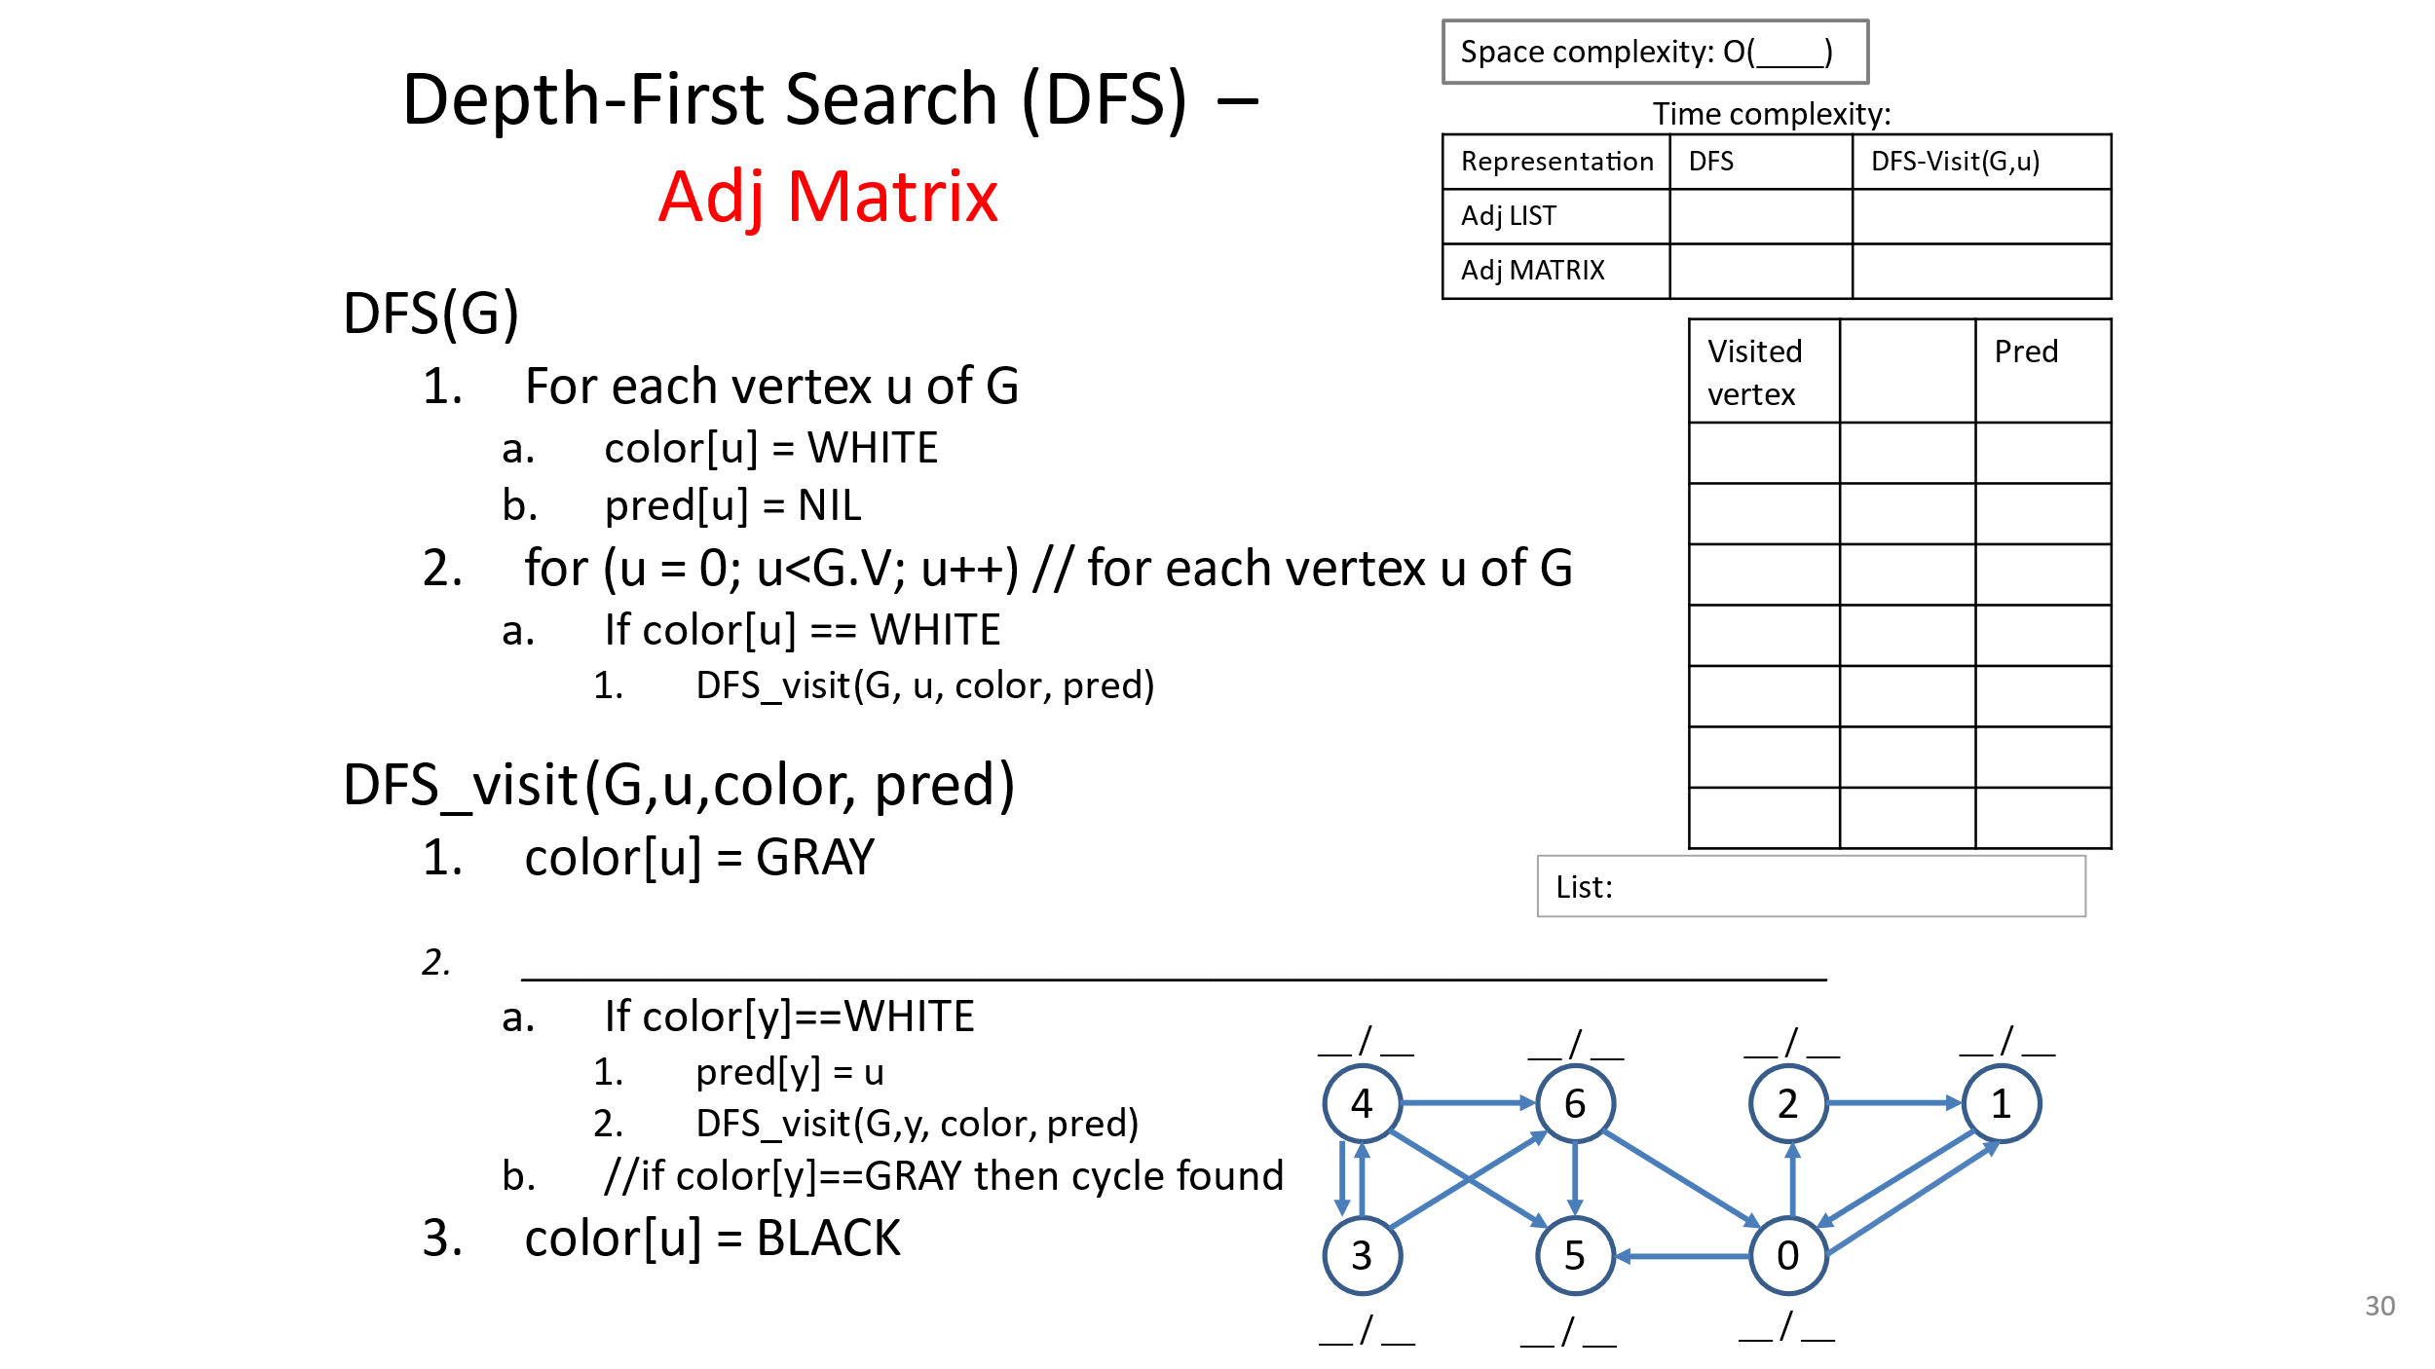

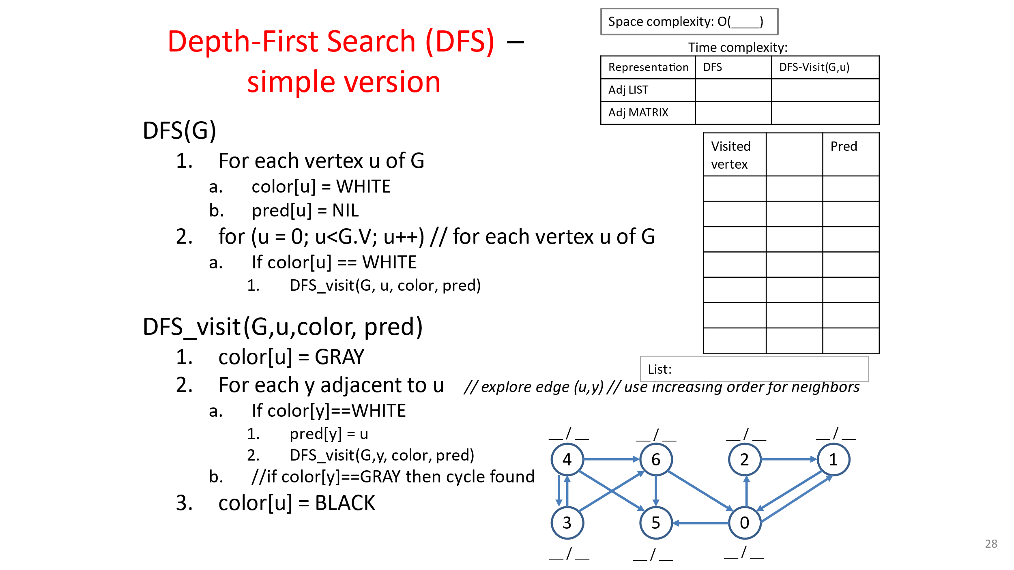

|  |  |  |  |  |  |  |  |  |
| --- | --- | --- | --- | --- | --- | --- | --- | --- |
|  | 0 | 1 | 2 | 3 | 4 | 5 | 6 | 7 |
| 0 | 0 | **1** | **1** | 0 | 0 | **1** | **1** | **1** |
| 1 | **1** | 0 | 0 | 0 | 0 | 0 | 0 | 0 |
| 2 | **1** | 0 | 0 | 0 | 0 | 0 | 0 | 0 |
| 3 | 0 | 0 | 0 | 0 | **1** | **1** | 0 | 0 |
| 4 | 0 | 0 | 0 | **1** | 0 | **1** | **1** | **1** |
| 5 | **1** | 0 | 0 | **1** | **1** | 0 | 0 | 0 |
| 6 | **1** | 0 | 0 | 0 | **1** | 0 | 0 | 0 |
| 7 | **1** | 0 | 0 | 0 | **1** | 0 | 0 | 0 |

1

0

3

2

5

7

4

6

1

2

5

6

7

0

0

4

5

3

5

6

7

0

0

0

3

4

4

4

**A**

