CSE 3302 Notes 4: Semantic Analysis

(Last updated 11/24/26 4:02 AM)

Syntax vs. Semantics

Σ σ Σ σ

Well-formed vs. meaningful

Context-free vs. context-sensitive

Static Semantics

Names declared, typechecking

switch statement cases are independent

Value assigned before use

Dynamic Semantics

What the generated code must do

Language definition . . .

C allowed pointer values and loops

4.1. The Role of the Semantic Analyzer

Assertions = Additional properties to be assured at specific execution points

C/C++ - can be disabled

Dynamic checks - Either built into interpreter or part of generated code

Static analysis

Detects errors

Can avoid some dynamic checking

Can reduce method dispatch costs

4.2. Attribute Grammars

General method for defining semantics

Alternatives:

Prototype language implementation (first Ada implementation in SETL, Pascal in Pascal)

Two-level grammar (Algol 68)

Denotational semantics (functional/logic languages)

Natural language . . .

Initially, just a formal method for semantics (Knuth, 1968)

Cornell Program Synthesizer (PL/I, 1981)

Compiler-compilers

E, T, F grammar in book - synthesized attributes (bottom-up)

From http://homepage.cs.uiowa.edu/~slonnegr/plf/Book/, chapter 3

Strings of form are the only ones acceptable.

Start with grammar:

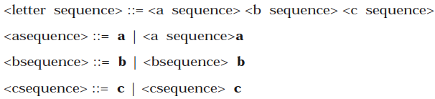
Accepted string:

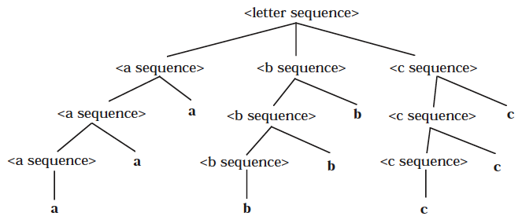

Also accepted (?)

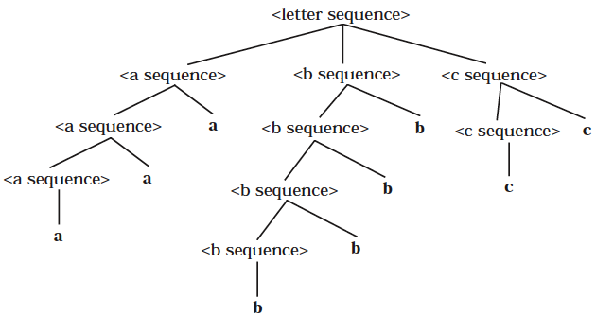

Attribute grammar to capture context-sensitivity with synthesized attributes:

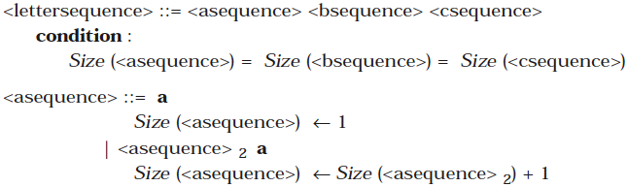

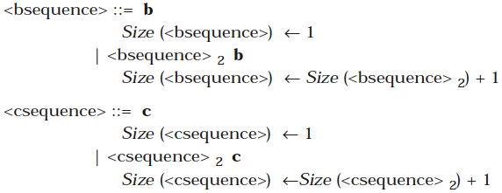

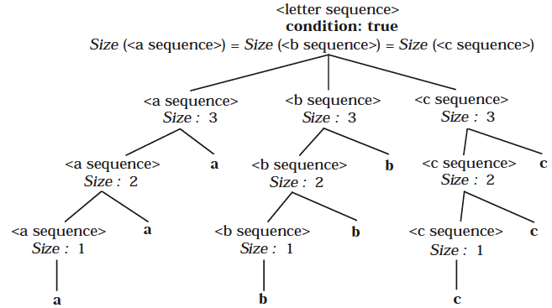

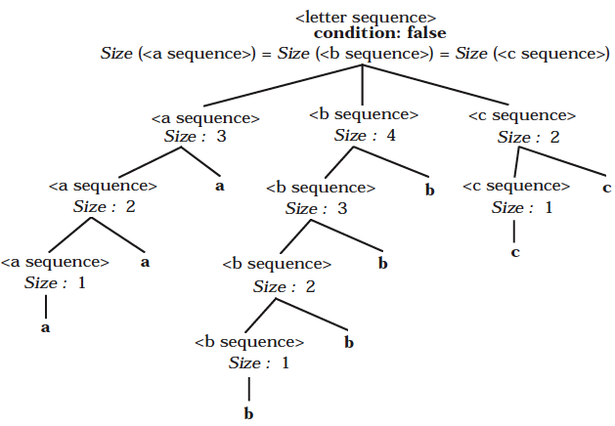

Same example, but taking advantage of inherited attributes:

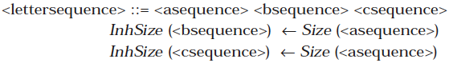

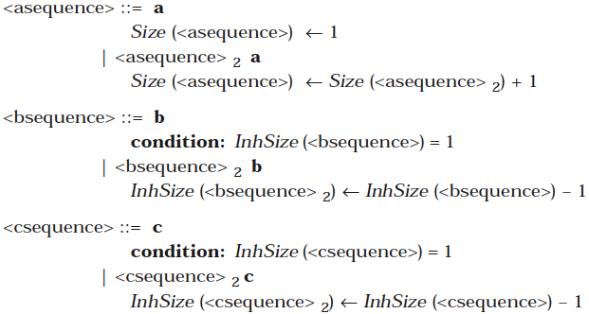

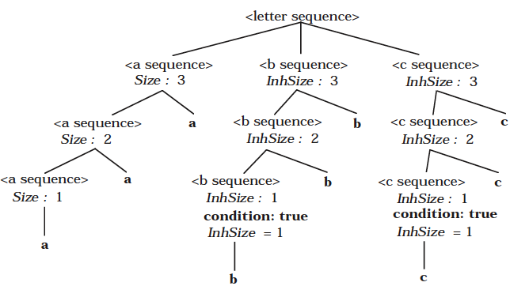

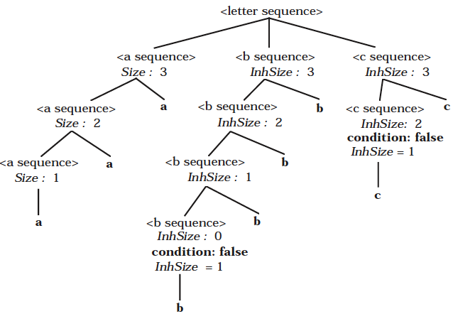
Meaning of binary numbers using synthesized attributes:

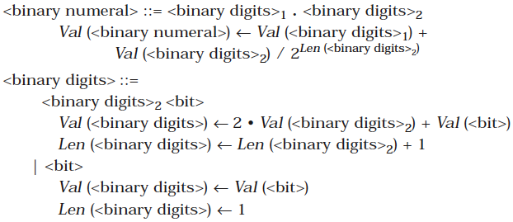

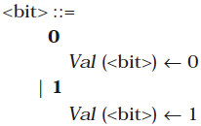

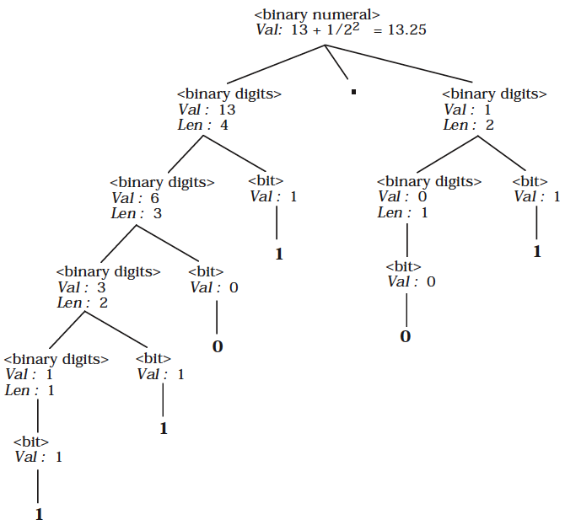

But only the value of the entire number is computed. What about each bit’s contribution?
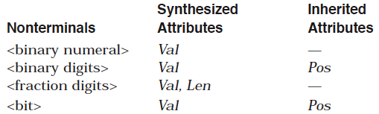

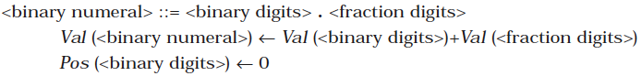

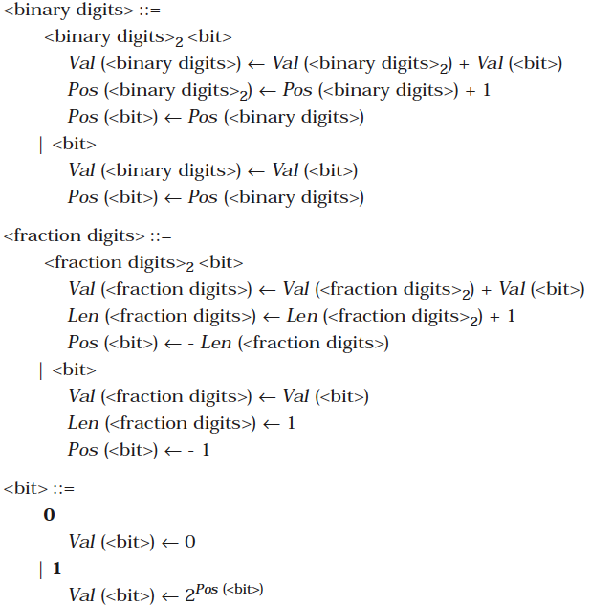

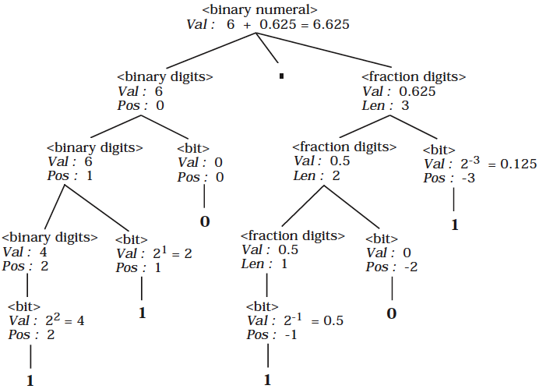

Small programming language (Wren) and its context sensitivities

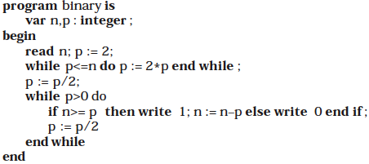

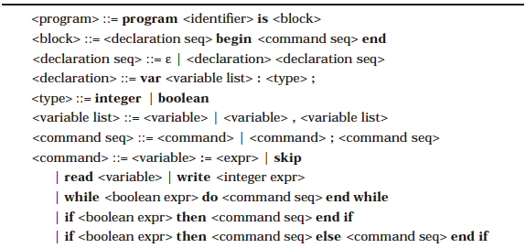
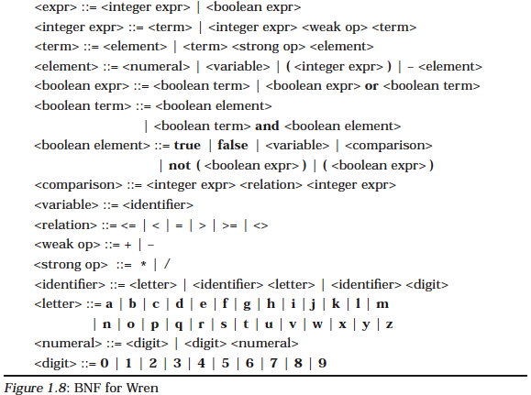

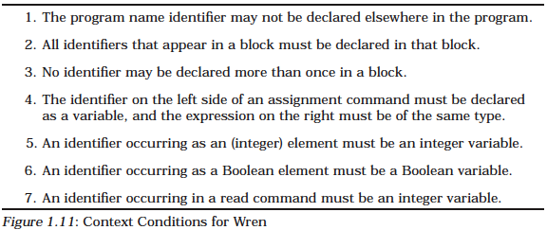

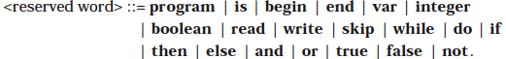

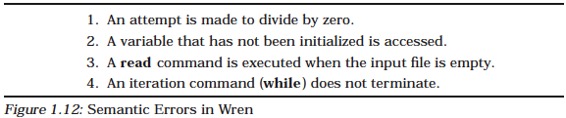

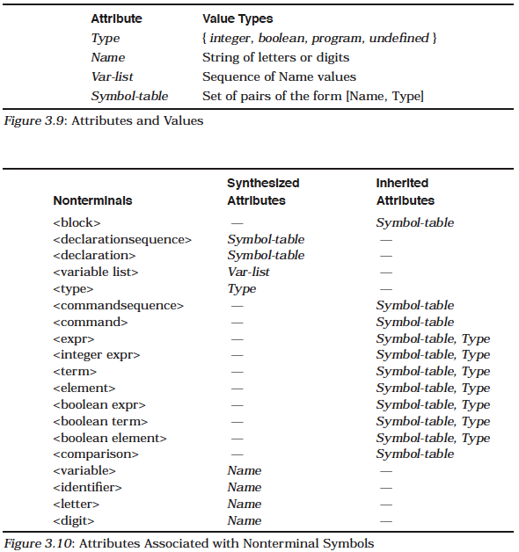

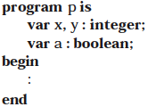

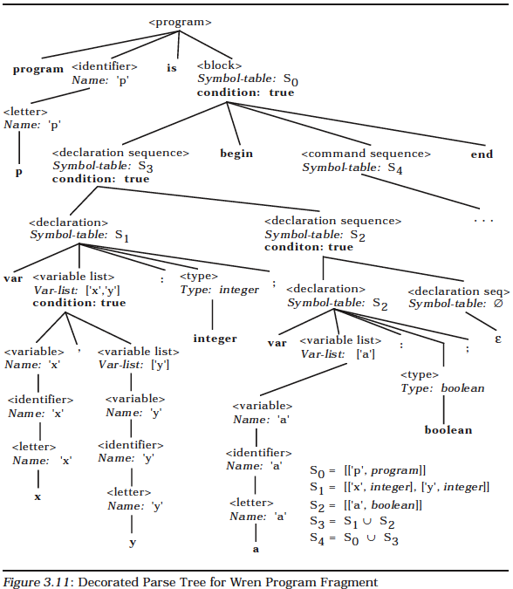

Application: Structure Editor

Goal: Editor based on moving among program constructs

Various formatting possibilities - including highlighting, indenting

Use window dimensions in decisions

Eliding of “uninteresting code”

Simple formatting:

if (x>y) { temp=x; x=y; y=temp; }

if (x>y)
{
temp=x;
x=y;
y=temp;
}

Synthesized attributes - space needed for construct

Inherited attributes - position of construct in display

Application: Connecting Defs to Uses for Data Flow Analysis

Def: Assigning value to a variable, e.g. (identifier, line#/token#)

Use: Value of variable is used in an expression

Basic block: Straight-line code, no branching

Historic approach: Treat program as flowchart (graph)

Construct-based approach:

INPUT(x) set: defs with some path to construct x without an intervening def
KILL(x) set: defs always invalidated before leaving construct x
GEN(x) set: defs in construct x with path to exit
OUTPUT(x): defs getting through or generated in construct x

(INPUT(x) − KILL(x)) ∪ GEN(x) = OUTPUT(x)

Each construct (basic block, control structure, function, etc.) has equations and way to match
defs to uses.

Could integrate def-use information with structure editor
4.3. Evaluating Attributes

Iterative Firing/Propagation/Queue/Petri Net/Data Flow Machine Ideas

Build AST

Initialize obvious values

Initialize queue with non-finalized tree nodes

Iterate with updates to queue until changes stop

Integrate With Parser

OK for static semantics

Not useful for substantial analysis

Avoids storage issues

Circularity of attribute grammar

Does an attribute value at a node depend on itself due to a path of synthesized/inherited
attributes?

