Homework – Notes 8-10
(Solution)
Using Version 2
1. Input String :
E A S Y Q U E S T I O N

QuickSort :-

E A S Y Q U E S T I O N
E A I E N U Y S T S O Q
E A E I

A E

E

O Q S T S U Y

O

S T S U Y

S T S U

S S T

S

T
The Sorting Result is : -

A E E I N O Q S S T U Y

Using Version 1
2. Input String :
E A S Y Q U E S T I O N

QuickSort :-

E A S Y Q U E S T I O N
E A E I N U S S T Y O Q
E A E I

E A E

A E

E

U S S T Y O Q
O Q S T Y U S

O

S T Y U S

S S Y U T

S

Y U T

T U Y

U Y

U Y

The Sorting Result is : -

A E E I N O Q S S T U Y

7.6 Example of 6 files in the case where Quicksort gives worst case performance

Ex -1 9 8 7 6 5 4 3 2 1 10
Ex -2 8 7 6 5 4 3 2 1 9 10

Ex -3 7 6 5 4 3 2 1 8 9 10

Ex -4 6 5 4 3 2 1 7 8 9 10

Ex -5 5 4 3 2 1 6 7 8 9 10

Ex -6 4 3 2 1 5 6 7 8 9 10

Note: ( Quicksort shows worst case behavior when the partitioning element resides on the extreme sides of the list. ) Answer.

6.74 0 1 2 3 4 5 6 7 8 9 10
A B R A C A D A B R A

A B C D R

A->5 0 5 2 1 1
B->2
C->1
D->1 0 5 7 8 9
R->2

0 1 2 3 4 5 6 7 8 9 10
(Location)

A A
B A B
R A B R
A A A B R
C A A C R
A A A A B C R
D A A A D R
A A A A A B C D R
B A A A A B B C D R
R A A A A B B C D R R
A A A A A A B B C D R R

(Sorted)

10.41 LSD Radix Sort

Keywords | 1st Leading Place | 2nd Leading Place
Now | All | Party
is | Aid | People
The | Come | Of
Time | For | The
For | Good | The
All | Is | their
Good | Now | Aid
People | Of | Time
To | People | All
Come | Party | Now
The | The | For
Aid | Time | Good
Of | To | To
Their | The | Come
Party | Their | Is
(Answer)

3.25
Returns no. of nodes in a circular linked list

Method:

int count-node (Node p) /* p is a node type variable having two fields, val & next */

{
int count=0;
Node start=p;
While (p.next != start)
{
count ++;
p = p.next;
}
return count;
}

3.26
Code fragment that determines the number of nodes that are between two given reference x & t

int count-node (Node x, Node t)
{
int count=0;
While (x.next != t)
{
count ++;
x = x.next;
}
return count;
}

3.27

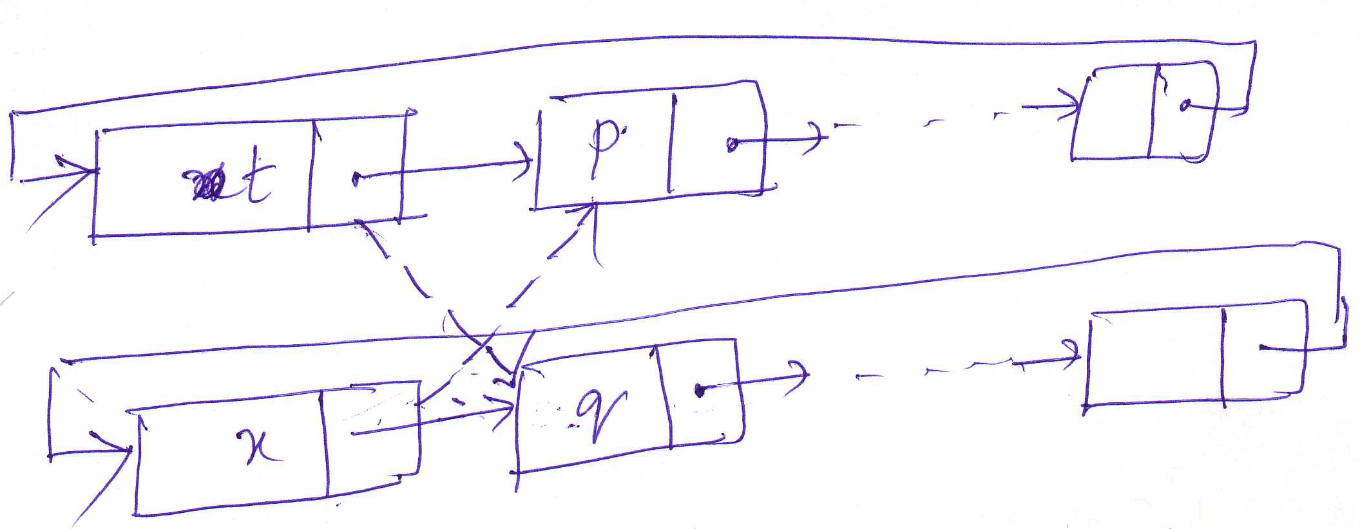

void list-ins(Node t, Node x)
{
Node q = x.next;
Node p = t.next;
x.next = p;
t.next = q;
}
This entire insertion takes O(1) time.

4.5

E

A

S

pop-1 x

Y

(2) x

Q

U

E

(3) x | Pop (1) -> | Returns ->
(4) x | (2) | S
(5) x | (3) | Y
S | (4) | E
T | (5) | U
(6) x | (6) | Q
(7) x | (7) | T
(8) x | (8) | S
I | (9) | A
O | (10) | O
(9) x | (11) | N
N | (12) | I
(10) x |  | E
(11) x
(12) x

4.18 Array Representation

Class intStack
{
private int[] S;
private int[] N;

intStack(int maxN)
{
S=new int [maxN]; N=0;
}
int count() {
return N;
}
void push(int item) {
S[N++] = item;
}
int pop() {
return S[--N];
}
}
(Answer)

Linked List Representation
Class intStack
{
private Node head;
private class Node {
- - - -
- - - -
}
intStack(int maxN)
- - - -
int count() /* Isempty() is replaced by count method */
{
private int count=0;
while (head.next != null) {
head = head.next;
count++;
}
return count;
}
void push(int item) {
- - -
}
int pop() {
- - -
}
}
(Answer)

4.9 Convert to Postfix Expression

( 5 * ( ( 9 * 8 ) + ( 7 * ( 4 + 6) ) ) )

Input | Output | Stack
( | 5
5
* |  | *
( |  | *
( |  | *
9 | 9 | *
* |  | * *
8 | 8 | *
) | * | *
+ |  | * +
( |  | * +
7 | 7
* |  | * + *
( |  | * + *
4 | 4
+ |  | * + * +
6 | 6 | * + * +
) | +
) | *
) | +
) | *
The postfix Expression is : - 5 9 8 * 7 4 6 + * + *

4.10 Postfix Evaluation (showing stack content)

Token | Stack
5 | 5
9 | 5 9
* | 45
8 | 45 8
7 | 45 8 7
4 | 45 8 7 4
6 | 45 8 7 4 6
+ | 45 8 7 10
* | 45 8 70
2 | 45 8 70 2
1 | 45 8 70 2 1
3 | 45 8 70 2 1 3
* | 45 8 70 2 3
+ | 45 8 70 5
* | 45 8 350
+ | 45 358
* | 16110
(Answer)

4.36
E A S * Y * Q U E * * *

S T * * * I O * N * * *

Initially Empty Queue
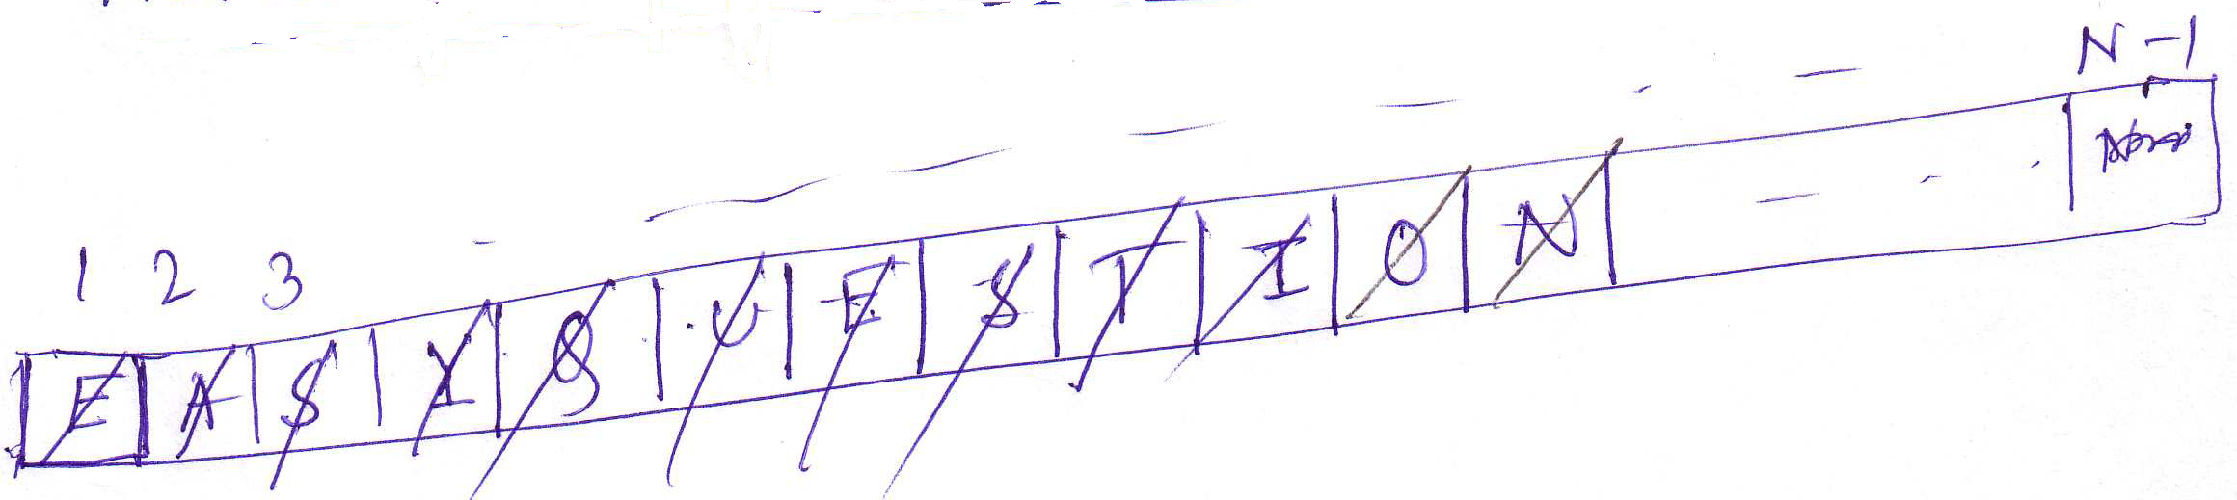

1st get (*) -> Returns E
2nd get (*) -> Returns A
3rd get (*) -> Returns S
4th get (*) -> Returns Y
5th get (*) -> Returns Q
6th get (*) -> Returns U
7th get (*) -> Returns E
8th get (*) -> Returns S
9th get (*) -> Returns T
10th get (*) -> Returns I
11th get (*) -> Returns O
12th get (*) -> Returns N
(Answer)

