CSE 3318 Notes 6: Greedy Algorithms

(Last updated 7/29/26 5:39 AM)

CLRS 16.1-16.3

6.A. Concepts

Commitments are based on local decisions:

NO backtracking (will see in stack rat-in-a-maze - Notes 10)

NO exhaustive search (will observe in dynamic programming - Notes 07)

Approaches:

1. Sort all items, then make decisions on items based on ordering.

2. Items are placed in heap and then processed by loop with delete and priority changes.

MAIN ISSUE: NOT efficiency . . . Quality of Solution instead

Special situations - exact solution (these three path problems are asides for now . . .)

Prim’s Minimum Spanning Tree (Notes 14, min-heap)

n vertices - choose n - 1 edges to give tree with minimum sum of (undirected) edge weights. Path for each vertex is one that minimizes the maximum weight appearing on the path.

Each vertex is labeled with its predecessor on path back to the source (vertex 0).

Each round augments the tree with the minimum weight edge.

So, vertices are finalized in ascending “min of maxes” order (0, 3, 6, 7, 2, 1, 5, 4).

Dijkstra’s ( https://www.cs.utexas.edu/~EWD ) Shortest Path (Notes 15, min-heap)

n vertices - choose n - 1 edges to give tree with a path from source to each vertex that minimizes the sum of (directed) edge weights on the path.

Each vertex is labeled with its shortest path distance from source and its predecessor.

Each round augments the tree with the last edge for the shortest (uncommitted) path.

So, vertices are finalized in ascending shortest-path distance order (0, 3, 7, 2, 1, 5, 4, 6).

Maximum Capacity Path for Network Flow (CSE 5311, CLRS 24, max-heap,
https://dl-acm-org.ezproxy.uta.edu/doi/10.1145/2628036 )

n vertices - choose n - 1 edges to give tree with path from source (0) to each vertex that maximizes the minimum capacity of the (directed) edge weights on the path.

Each vertex is labeled with its maximum capacity from source and its predecessor.

Each round augments the tree with the last edge for the maximum capacity (uncommitted) path.

So, vertices are finalized in descending maximum capacity order (0, 1, 2, 6, 7, 3, 4, 5).

More frequently - heuristic (approximation)

6.B. Example – activity scheduling (unweighted interval scheduling)

n actitivites

Start time (activity starts exactly at time)

Finish time (activity finishes before this time)

One room
Goal: Maximize number of activities. (Unlike weighted interval scheduling in Notes 07)

Greedy Solution:

1. Sort activities in ascending finish time (“right end”) order.

2. Consider each activity according to sorted order:

Include activity in schedule only if it does not overlap with other activities already in schedule

Optimal or heuristic?

Optimality Proof:

1. Suppose there is an alternate (optimal) schedule with a different first activity:

s? . . . f? < rest of schedule >

But s₁ . . . f₁ can replace s? . . . f? since f₁ ≤ f?

2. Same argument applies to replacing other activities in the schedule

Problems that can be solved optimally by a greedy method have a simpler structure than problems requiring dynamic programming.

6.C. Knapsack Problem

Can carry W pounds in your knapsack.

Have n items each with value v_{i} and weight w_{i} (≤ W).

Wish to maximize the amount of revenue for selected items without exceeding weight limit.

Greedy approach: Choose according to descending order of $$$/lb.

Fractional (divisible) version:

$$$/lb for each divisible item.

Example:

W = 10 lbs

Perfume: $500/lb, 1 lb available

Chocolate: $30/lb, 5 lbs available

Beans: $2/lb, 5 lbs available

Rice: $1/lb, 5 lbs available

Optimal or heuristic?

0/1 (indivisible) version:

Example:

W = 10 lbs

Lobster 2 lbs, $42 ($21/lb)

Bottle of wine: 5 lbs, $100 ($20/lb)

Sword: 4 lbs, $76 ($19/lb)

Rare book: 6 lbs, $102 ($17/lb)

Greedy says to choose _______________, but optimal is ___________________.

Observe that applying fractional concept to 0/1 problem gives an upper bound on what may be
achieved optimally (OPT) for 0/1.

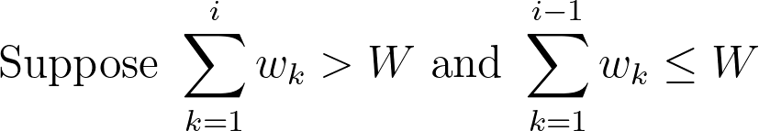

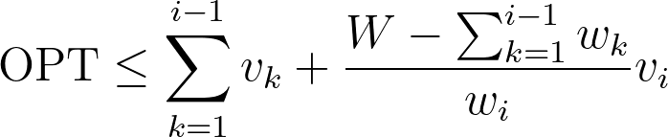

By taking the larger of the revenue for the first i - 1 items or the revenue v_{i} for item i,
at least 1/2 of OPT will be achieved. (Why?)
6.D. Huffman Codes - elementary data compression for a static distribution of symbols in an alphabet.

Prefix Code Tree (not optimal)

Concept: Letters that appear more often (higher probability) should be assigned shorter codes.

Evaluating a particular code tree (even if not optimal)

Symbol Probability Bits Probability•Bits

A .2 2 .4
B .05 3 .15
C .3 4 1.2
D .15 4 .6
E .1 2 .2
F .2 2 .4
=== ===
Σ=1.0 Σ=2.95= Expected bits per symbol

Algorithm: Build up subtrees by pairing trees with lowest probabilities (use min-heap).

Very easy to implement tree using table with 2n - 1 entries ( https://ranger.uta.edu/~weems/NOTES3318/huffman.c ):

i probability left right
0 .2 - -
1 .05 - -
2 .3 - -
3 .15 - -
4 .1 - -
5 .2 - -
6 .15 1 4
7 .3 6 3
8 .4 0 5
9 .6 7 2
10 1.0 8 9

Symbol Probability Bits Probability•Bits

A .2 2 .4
B .05 4 .2
C .3 2 .6
D .15 3 .45
E .1 4 .4
F .2 2 .4
=== ===
Σ=1.0 Σ=2.45= Expected bits per symbol

Optimality: If two minimum-weight trees are not the ones combined in each step, then the expected bits per symbol could be larger than would be computed by the algorithm.

Time: If there are n symbols, then there are n - 1 subtree combining steps to perform. Each step calls heapExtractMin twice and minHeapInsert once. $O\left(n\text{log}n\right)$ overall. (A queue-based implementation appears in Notes 10.)

Observation: For any shape binary tree, there is some probability distribution that has that tree as its result.

Suppose n=8 and all p_{i} are 1/8: Suppose p_{i} are exponentially skewed:

(Aside, more in Notes 07) - Ordinary Huffman coding is not order preserving. The result of comparing two strings, before and after compression, may be different.

Using strcmp() on the strings:

X = A B E \0

Y = A B F \0

Using memcmp() on the bitstrings from the optimal Huffman code tree:

X = 00 1000 1001

Y = 00 1000 01

Under what condition will a Huffman code tree be order preserving?

(Aside: ACM Computing Surveys paper on Huffman coding:
https://dl-acm-org.ezproxy.uta.edu/doi/10.1145/3342555 )

