\textrm{Suppose }\sum_{k=1}^{i}w_{k}>W\textrm{ and }\sum_{k=1}^{i-1}w_{k}\leq W

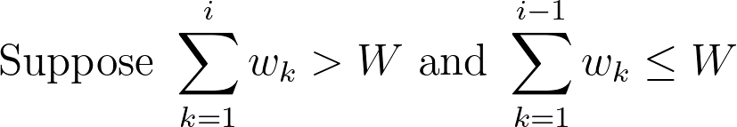

\mathrm{OPT}\leq \sum_{k=1}^{i-1}v_{k}+\frac{W-\sum_{k=1}^{i-1}w_{k}}{w_{i}}v_{i}

