CSE 6319 Notes 3: Mechanism Design (Part 1)

(Last updated 11/23/26 5:04 AM)

Karlin & Peres 10/11/12/13/14/15/16/17

Nisan 9/10/11/12/13/15/28

Roughgarden 2/3/4/5/6/7/8/9/10

3.A. Single-Peaked Preferences Over Policies (N 10.2)

n agents wish to choose a single point in a real-valued interval [0, 1].

Each agent has a single most-preferred point. Decreasing preferences to either side.

Desire a strategy-proof rule (dominant strategy to report truthful preferences) to decide the point.

Possible Rule Properties:

onto = for every point in [0, 1], there is a strategy profile such that rule gives the point.

unanimity = if all agents have the same peak, rule choses it

Pareto-optimal = there is no point more preferred by all agents to the chosen point

Median-Voter Rule: Assume odd number of agents. Use median of their peaks.

Strategy-proof (but so is choosing the kth highest peak)

Weighted average? (not strategy-proof in general, but could be dictatorial in the extreme)

anonymous = rule does not depend on order of input

Aside: 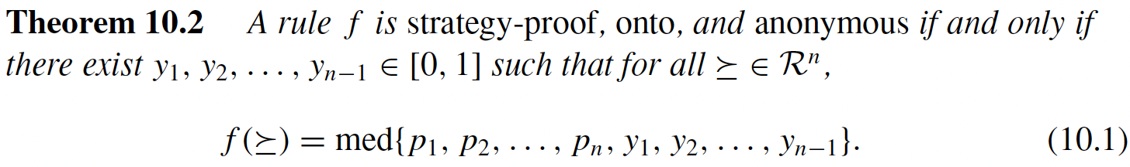

Aside: https://en.wikipedia.org/wiki/The_Vital_Center

Aside: https://en.wikipedia.org/wiki/A_Theory_of_Justice

Stable Matching

Marriages and Gale-Shapley (KP 10.1-10.3; N 10.4; R 10.2-10.3)

Classical Problem Instance:

n men (A, B, C, . . .) with preference lists (ordered from most-preferred to least)

n women (1, 2, 3, . . .) with preference lists

Goal: Produce matching with n stable marriages.

A matching is unstable if there is a blocking pair:

Consider a matching with the pairs (I, k) and (L, j) based on preference lists:

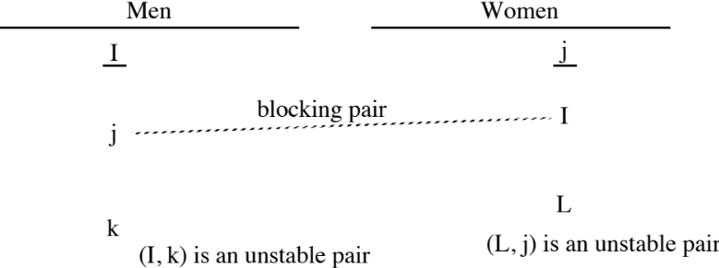

I and j prefer each over their partners in the suggested matching . . . unstable situation

Applications:

Matching new M.D.s to internships (many-to-one, http://www.nrmp.org/ )
Matching lawyers to federal clerkships (one-to-one)
Matching students to classes (many-to-many)
Centralized admissions decisions for universities (many-to-one)

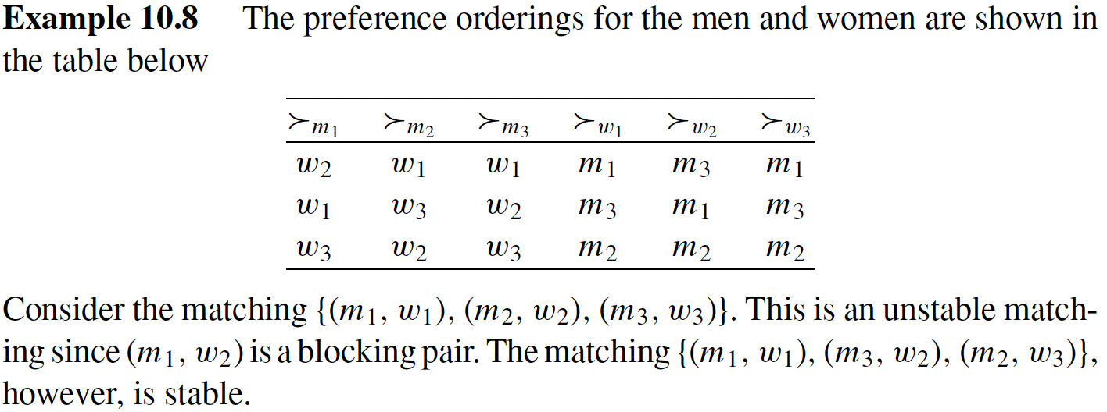

Gale-Shapley (Deferred Acceptance) Algorithm:

Corresponds to most societies. (No https://en.wikipedia.org/wiki/Sadie_Hawkins_Day )

Men propose from the beginning of their lists.

Women always accept the first proposal, but may break the engagement later.

Example (from Sedgewick)

A B C D E 1 2 3 4 5

2 1 2 1 5 E D A C D

5 2 3 3 3 A E D B B

1 3 5 2 2 D B B D C

3 4 4 4 1 B A C A E

4 5 1 5 4 C C E E A

Observations:

1. There is at least one stable solution.

(Once engaged, a woman is always engaged. A man could eventually propose to all women and can’t be rejected by all of them.)

2. The set of currently engaged couples is stable.

3. As stated, Gale-Shapley algorithm gives male-optimal matching. Switching roles in algorithm gives female-optimal matching. (Example of rotations includes female-optimal matching for Sedgewick’s example)

4. Truthfulness?

5. If male-optimal solution is the same as female-optimal solution, the solution is unique.

6. The order of proposals by the available men makes no difference in the outcome . . . leading to:

The “Rural Hospitals” Theorem: When the number of men and women differ (or preference lists may be incomplete), the set of agents included in every stable matching is the same.

Also possible to maintain n² nodes in reduced data structure instead of 2n² nodes (i.e. each node is in two doubly-linked lists) - known as the Extended Gale-Shapley algorithm (MEGS = man-oriented, WEGS = woman-oriented).

Uses node deletion strategy to avoid some pain of rejection! For MEGS:

Man proposes from current beginning of reduced list . . . always accepted!
When woman receives proposal . . . she will always accept and also delete the nodes for all less-preferable men.

For the current set of engagements:

A man is engaged to the woman at the beginning of his list.

A woman is engaged to the man at the end of her list.

A B C D E 1 2 3 4 5

2 1 2 1 5 E D A C D

5 2 3 3 3 A E D B B

1 3 5 2 2 D B B D C

3 4 4 4 1 B A C A E

4 5 1 5 4 C C E E A

Lattice of Stable Matchings:

Given any pair of stable marriage matchings, another stable matching may be found by taking either:

1. The more preferred woman for every man (the “meet”).

2. The less preferred woman for every man (the “join”).

Mathematically, the result is a distributive lattice. (Also, note that any path from the male-optimal matching to the female-optimal matching includes each “rotation” exactly once.)

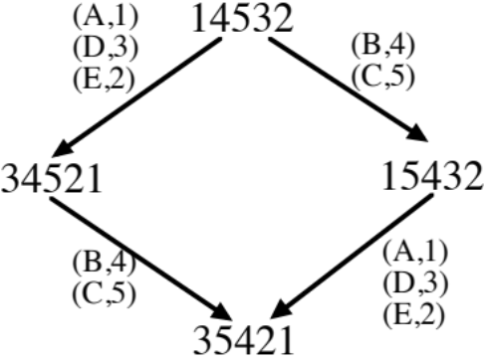

Linear Programming: https://ranger.uta.edu/~weems/NOTES6319/GLPSOL/marriage.*

House Allocation, Kidney Exchange, & Top-Trading Cycles (KP 10.4; N 10.3; R 10.1)

Like Stable Marriages, two types of agents - applicants (with preferences) and houses (without)

No notion of blocking pair

Expects some applicants’ preference lists to be incomplete

Usual solution concept - Pareto optimality, excludes any Pareto improvements:

Matching an unmatched applicant with an acceptable unmatched house

Changing an applicant to a more-preferable house without changing another
applicant to a less-preferable house (or leaving out entirely)

Simplest way to find a Pareto-optimal matching is the Serial Dictatorship Mechanism:

1. Choose an arbitrary order for the applicants.

2. Use the order to have each applicant choose their most-preferred house among the remaining unmatched houses.

Since the method is exhaustive and an early chooser would never trade with a later chooser, must be Pareto-optimal.

Due to different orderings and incomplete preference lists, different size matchings may occur!

Finding a maximum cardinality Pareto-optimal matching:

1. Find a maximum cardinality bipartite matching (e.g. using flow techniques or CLRS problem 26-6, p. 763), but ignore the applicants’ preferences. (The next two phases are constructive proof that a Pareto-optimal matching of this size exists. This phase is the most expensive. It is not worthwhile to clutter it with details of the two later phases.)

2. Make the matching “trade-in free” - iteratively, find a matched applicant having a more-preferred house that is available and promote the applicant.
3. Address “cyclic coalitions” in a manner similar to rotations for S.M. The technique is known as Gale’s Top Trading Cycles algorithm:

a. Delete all unmatched houses.

b. While applicants remain:

1. Iteratively, find applicants matched with their most-preferred house. Make each match permanent and delete the applicant and house from data structures. (This may expose other most-preferred matches in the reduced instance.)

2. Create directed graph:

a. Vertex for each applicant.
b. Edge from vertex for applicant x to the vertex of the applicant who is (tentatively) matched with x’s most-preferred house.

3. Properties of the generated graph:

a. At least one cycle. (Aside: Similar to Boruvka’s MST. https://ranger.uta.edu/~weems/NOTES5311/NEWNOTES/notes08.pdf
https://en.wikipedia.org/wiki/Borůvka's_algorithm )
b. Cycles do not intersect! Simply eliminate each cycle.

Example 1:

After Phase 1

A1: H1 H3 H2

A2: H2 H4 H1

A3: H1 H2 H4

A4: H2 H3 H1
Phase 2 - no changes

Phase 3 graph

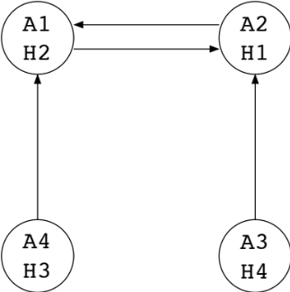
Final Result:

A1: H1

A2: H2

A3: H4

A4: H3

___________________________________________________________________________________

Example 2:

After Phase 1

A1: H3 H5 H1

A2: H1 H3 H4 H2

A3: H1 H4 H2 H3

A4: H1 H2 H3 H4

After Phase 2

A1: H3 H5 H1

A2: H1 H3 H4 H2

A3: H1 H4 H2 H3

A4: H1 H2 H3 H4

After Phase 3a

A1: H3 H1

A2: H1 H3 H4 H2

A3: H1 H4 H2 H3

A4: H1 H2 H3 H4

Phase 3b

The applicants will be deleted in the order: A1 A2 A3 A4

Final Result:

A1: H3

A2: H1

A3: H4

A4: H2

Example 3:

Find all maximum cardinality Pareto-optimal matchings for:

A1: H1 H4 H2

A2: H2 H3 H1

A3: H1 H3 H4

A4: H2 H4 H3

Maximum cardinality matchings (Phase 1) - Pareto-optimal ones are highlighted. The number below the non-Pareto-optimal ones is the number of Pareto-optimal ones that may be reached using later phases.

H1 H1 H1 H2 H2 H2 H4 H4 H4

H2 H2 H3 H1 H1 H3 H1 H2 H3

H3 H4 H4 H3 H4 H1 H3 H1 H1

H4 H3 H2 H4 H3 H4 H2 H3 H2

1 1 1* 1 1

*Situation leading to 3.b iteration:

A1: H1 H4 H2

A2: H2 H3 H1

A3: H1 H3 H4

A4: H2 H4 H3

A1: H1

A2: H2

A3: H3 H4

A4: H4 H3
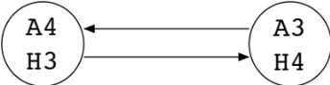
A1: H1

A2: H2

A3: H3

A4: H4

Example 4:

After Phases 1, 2, 3.a, 3.b.1, 3.b.2

A1: H1 H2 H3 H4

A2: H2 H3 H4 H1

A3: H3 H4 H1 H2

A4: H4 H1 H2 H3
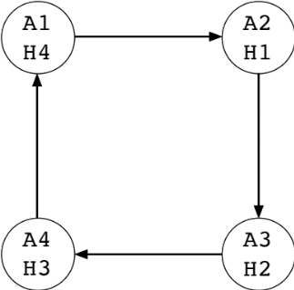

3.B. Fair Division (KP 11)

Aside: https://en.wikipedia.org/wiki/Ham_sandwich_theorem

Cake Cutting (KP 11.1; procaccia.2.pdf; cake.su.pdf)

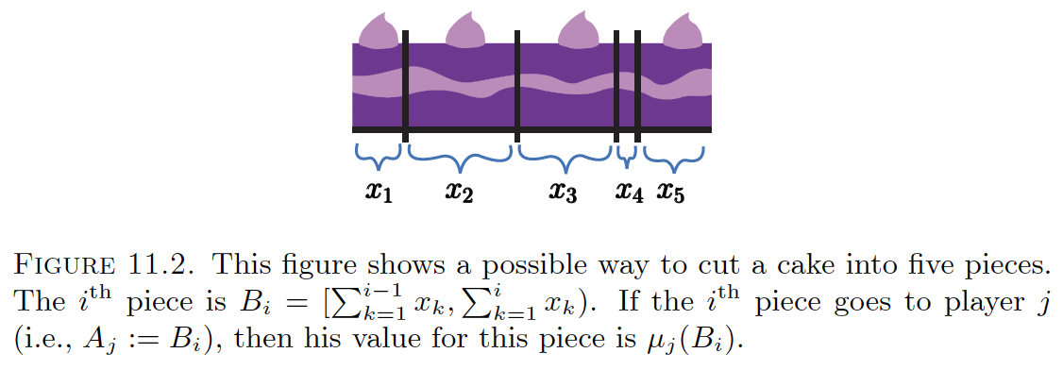

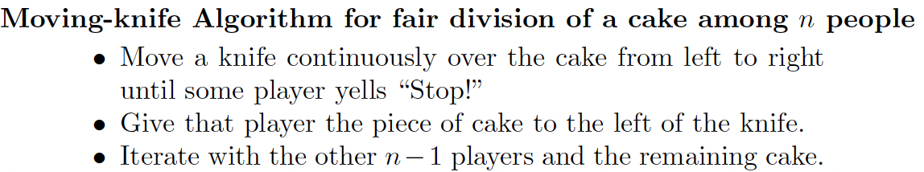

Not envy-free

Simmons’ Method Based on Sperner’s Lemma (KP 11.1.1; cake.su.pdf p. 930-937)

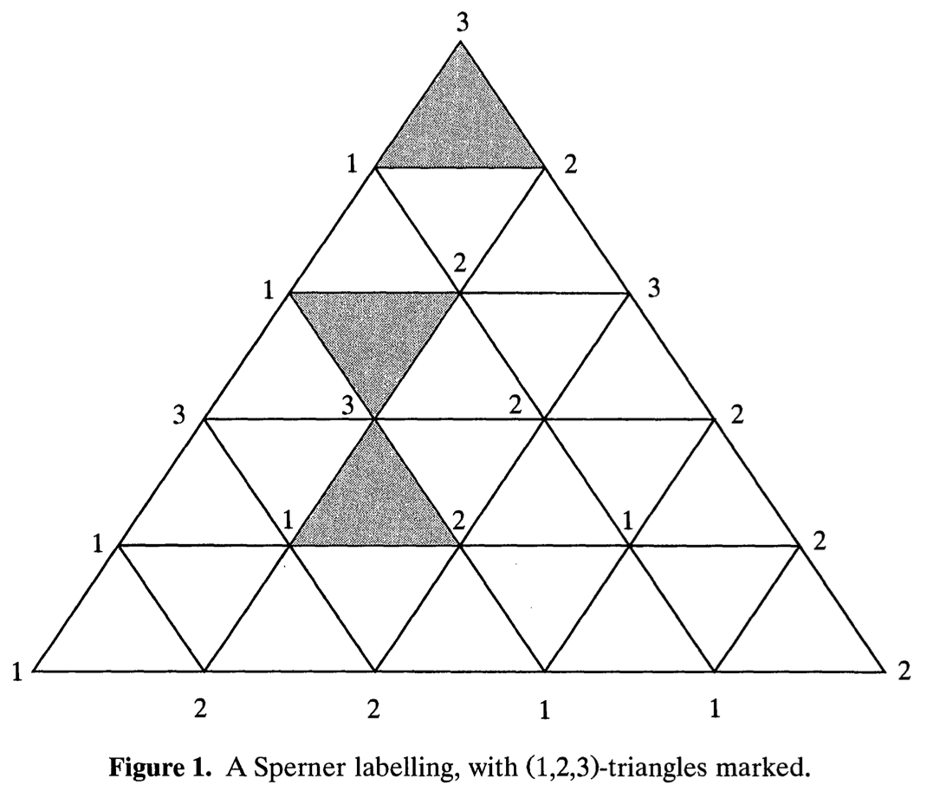

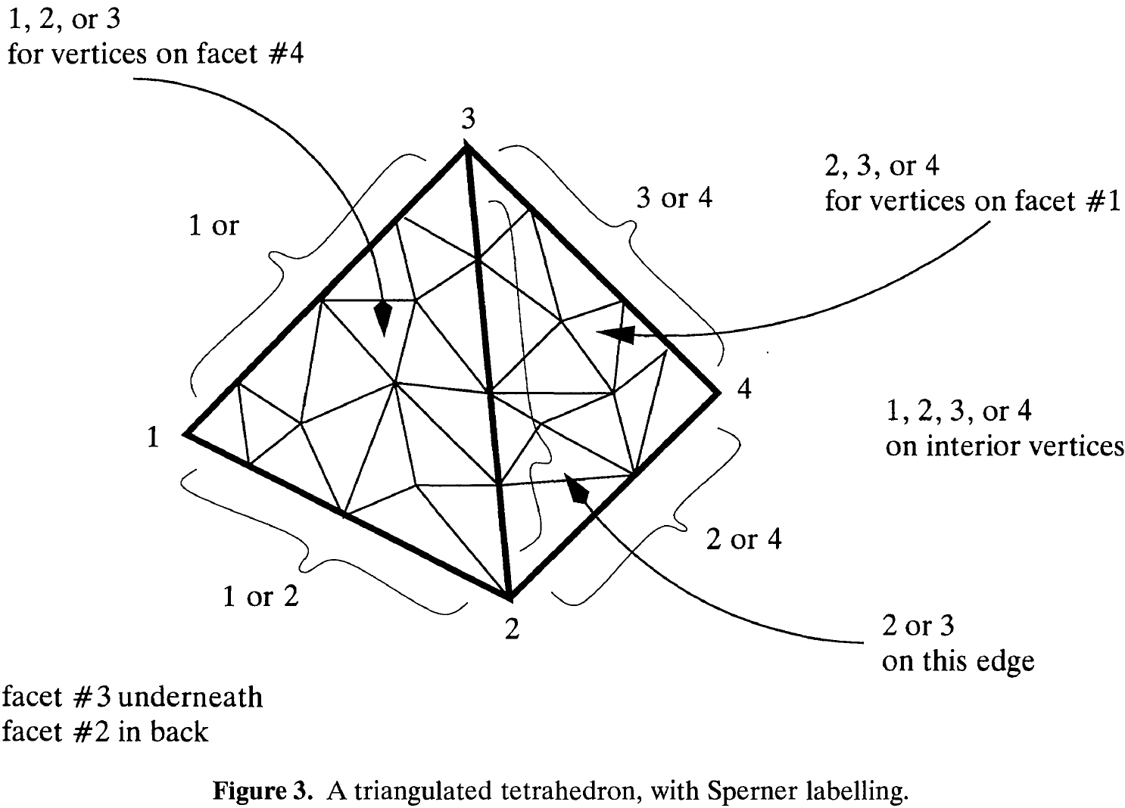

Trap-door walk (https://en.wikipedia.org/wiki/Doubly_connected_edge_list
https://ranger.uta.edu/~weems/dt.html) as constructive proof and as fundamental
procedure:

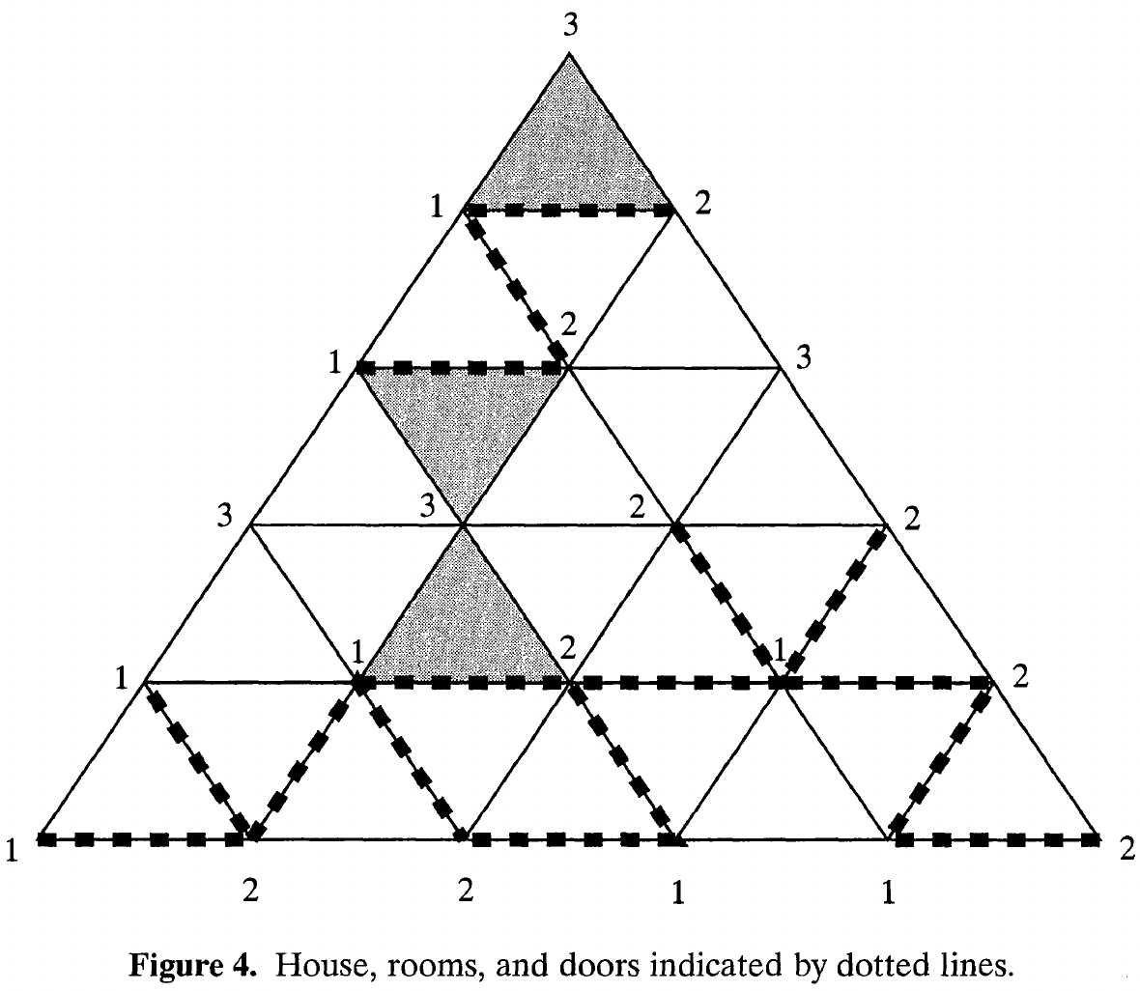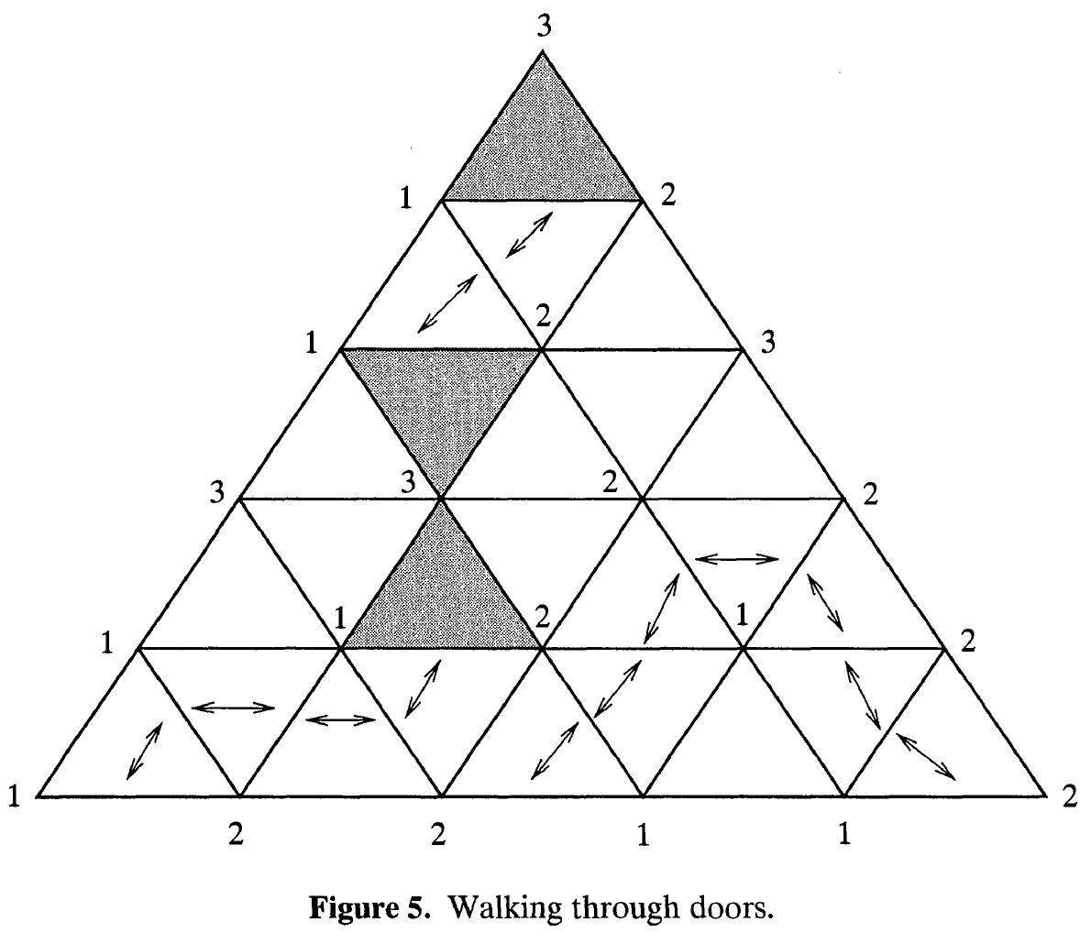

Simmons’ Algorithm:

Construct initial triangulation (∈ and η issue for diameters with KP?)

Repeat until happy:

Properly color (“fully label”) small triangles/tetrahedrons/simplices
(vertex ownership, not Sperner)

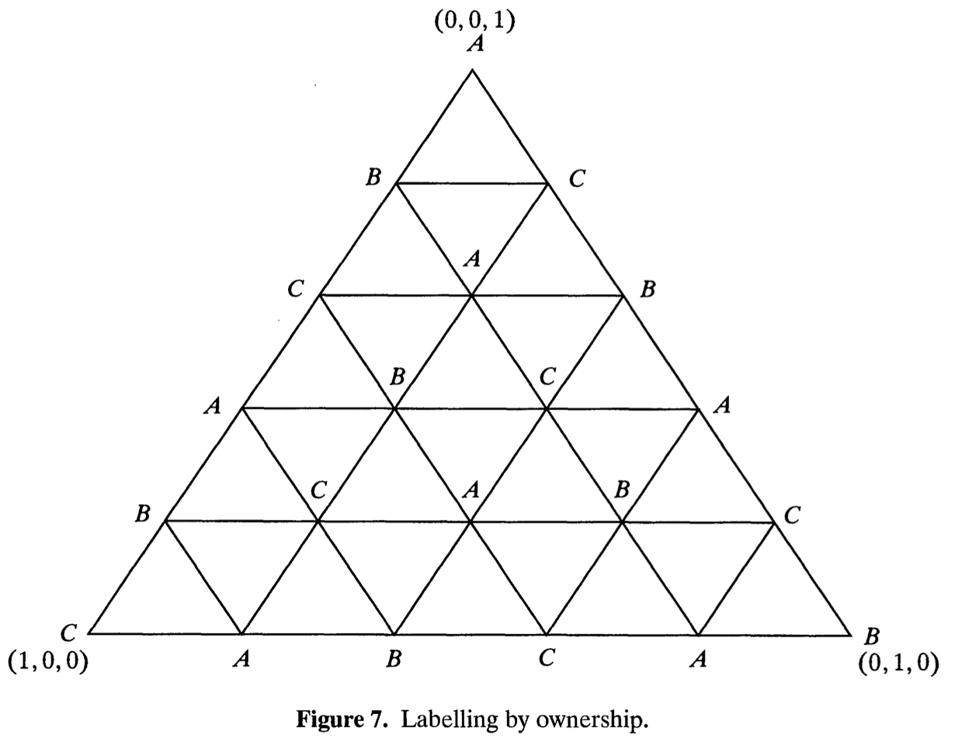

Determine the preferred slice for the owner of each vertex
(This is a Sperner labeling. Consider segment between (0, 0, 1) and (0, 1, 0).)

Find “fully labeled” simplices to use in happiness check

Refine triangulation using “barycentric subdivision”

Fair division of rent (indivisible objects) later

Bankruptcy (or divorce settlement or inheritance)

Chapter 4 of https://ebookcentral.proquest.com/lib/utarl/detail.action?docID=377897
(https://www.amazon.com/dp/0521696925) is useful.

Four Laws are presented:

1. Contested-Garment Principle (p. 5). Also has “physical interpretation” diagrams for equivalent Rule of Linked Vessels.

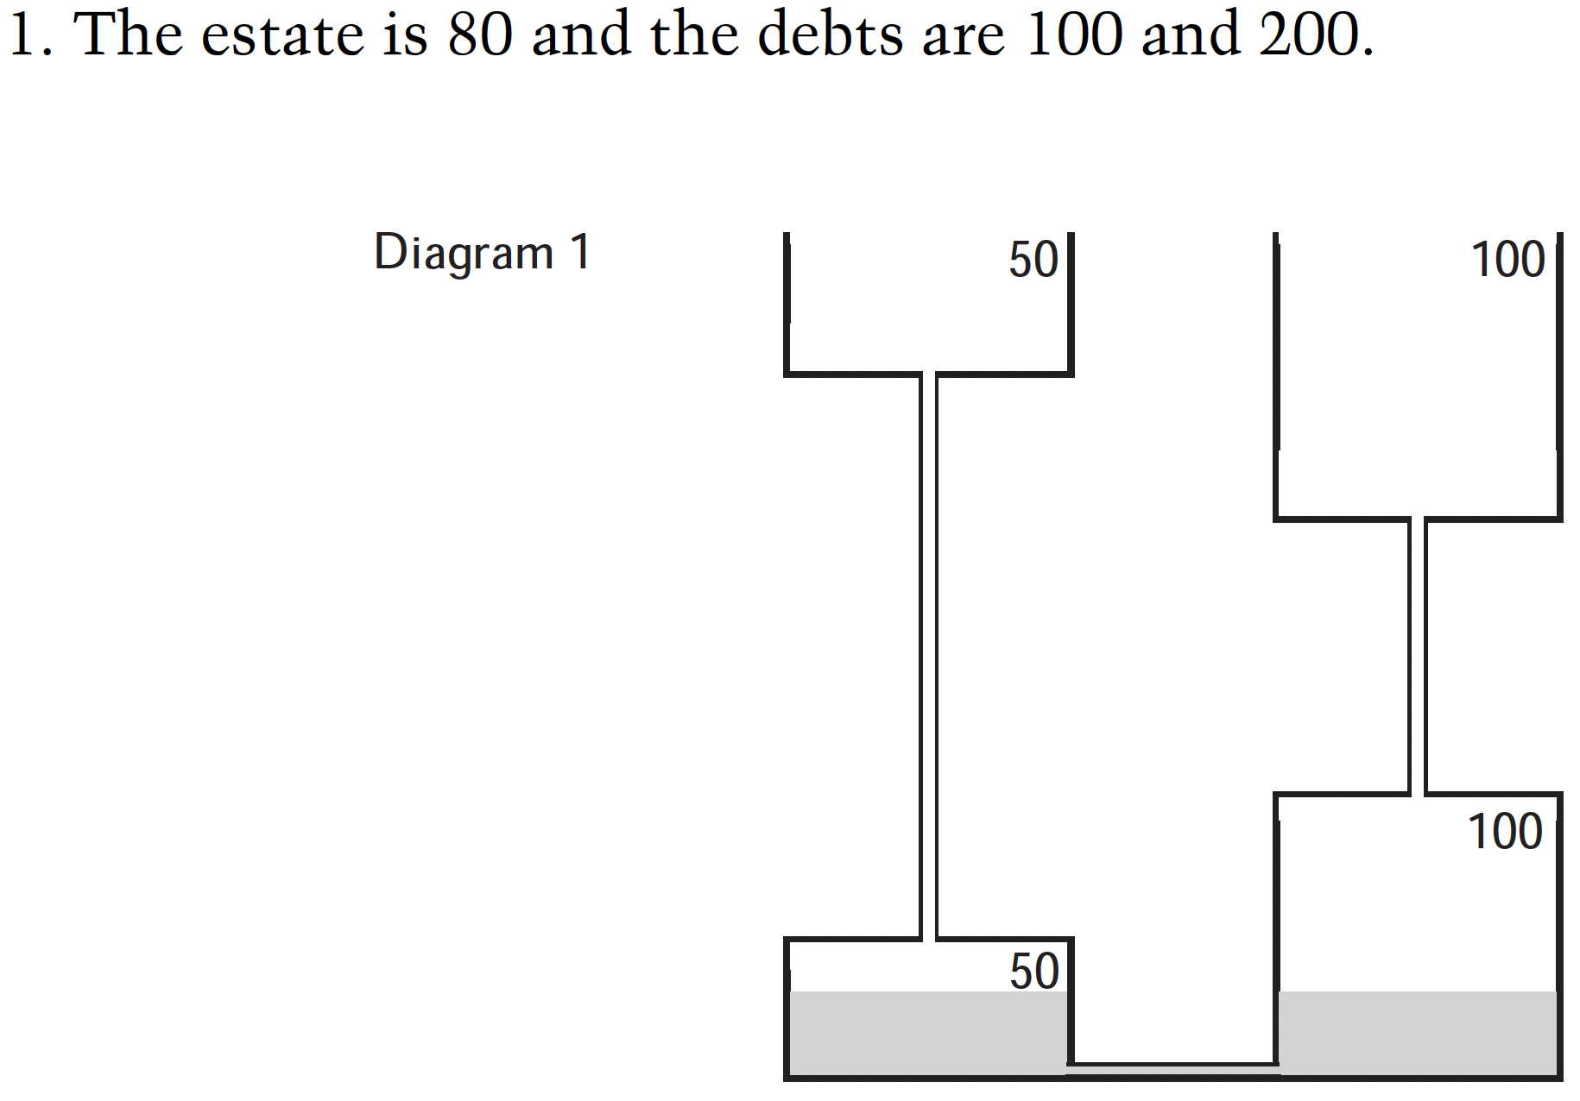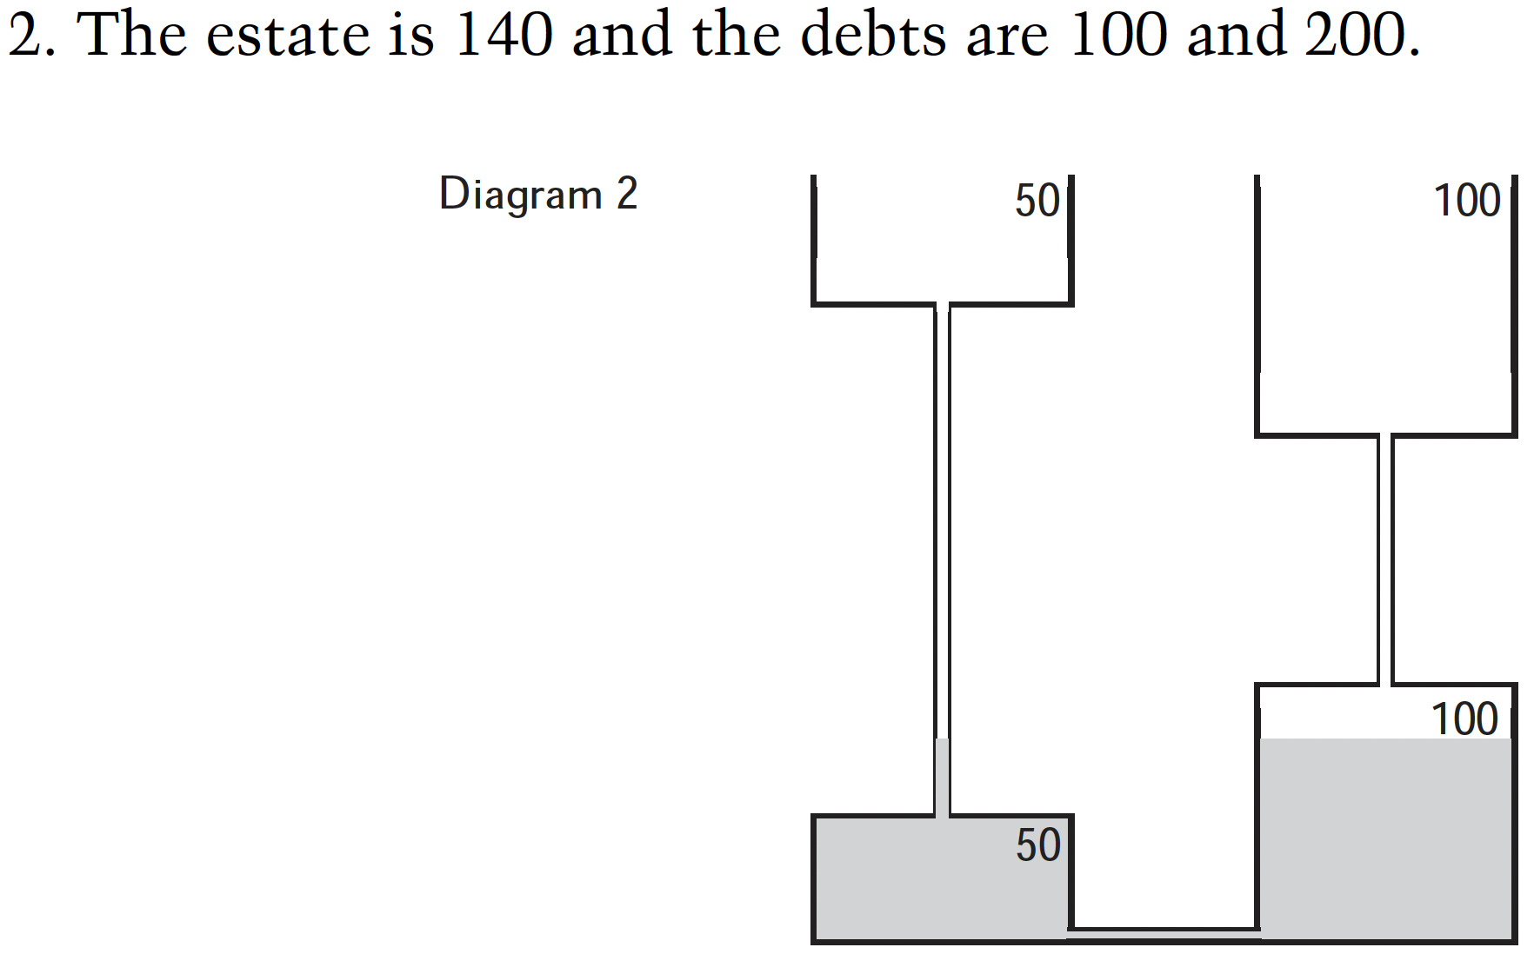

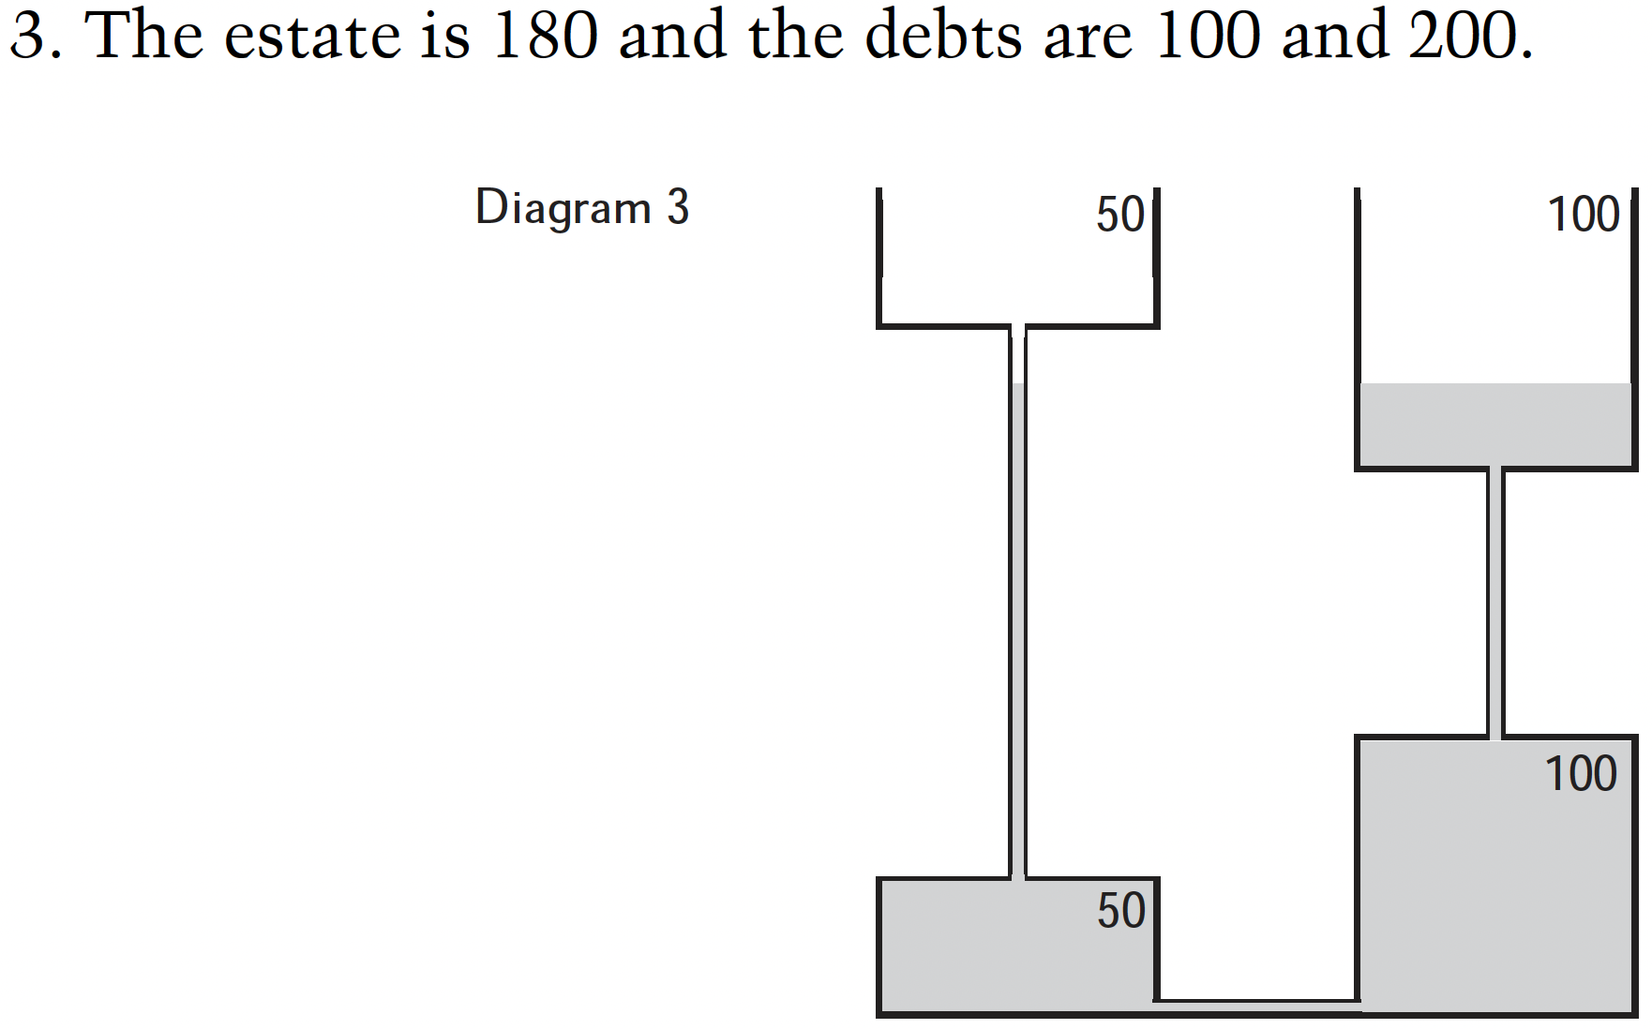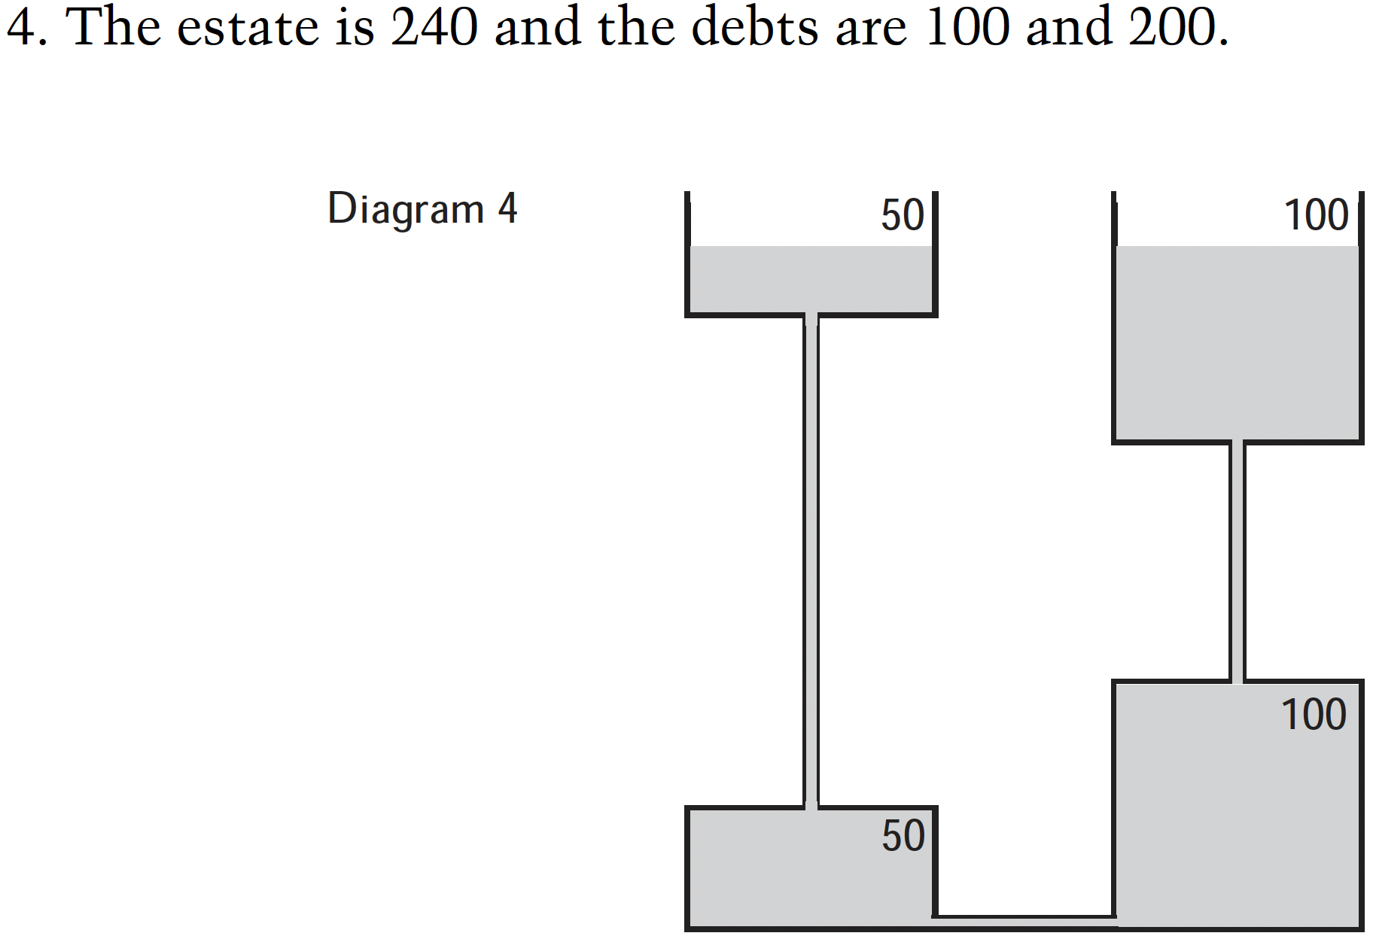
70 170

2. Rif’s Law - order claimants in ascending order, then proceed evenly in levels

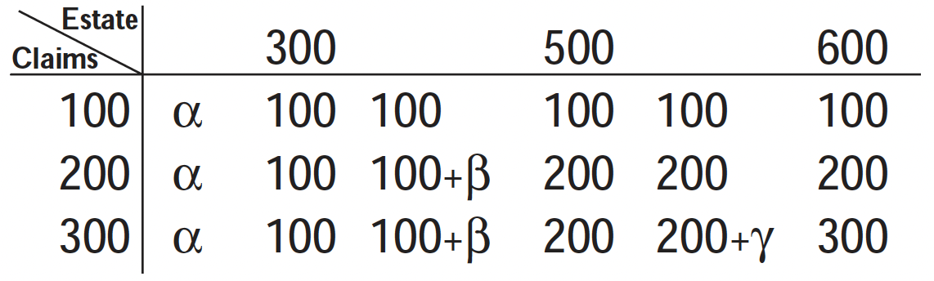

3. Proportional division - proportion of investment determines proportion of proceeds

4. O’Neill’s law - race to the bank (Shapley value)

Cooperative Games (KP 12; N 15.6)

Cooperative Game with Transferable Utility

Glove Market

Player 1 has a left glove. Player 2 has a right glove, so does Player 3.

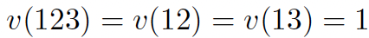

Characteristic Function on subsets of n players: 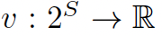

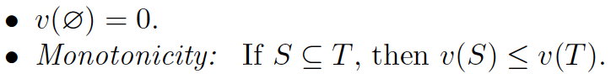

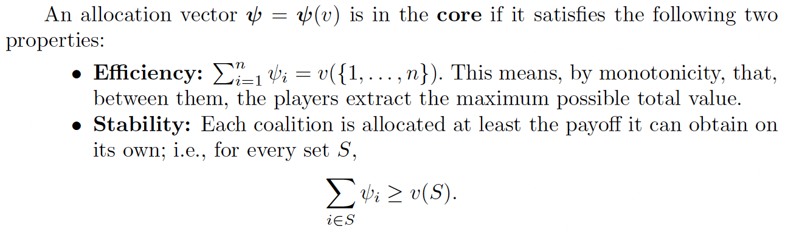
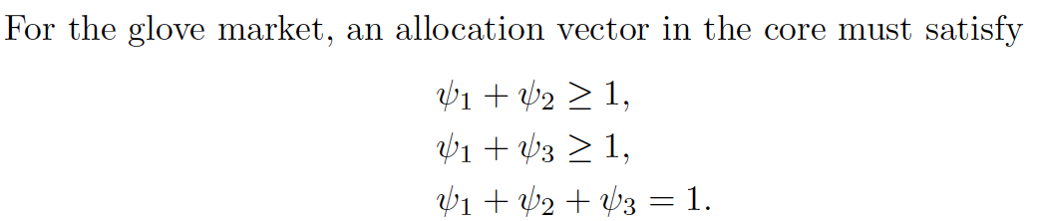

Miners carrying gold bars in pairs. Core solution iff number of miners is even.

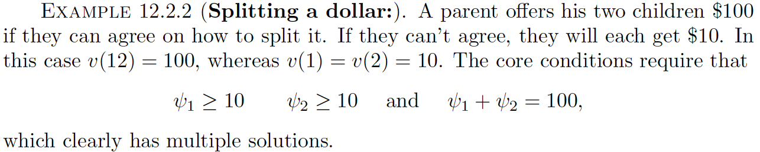

Shapley Value

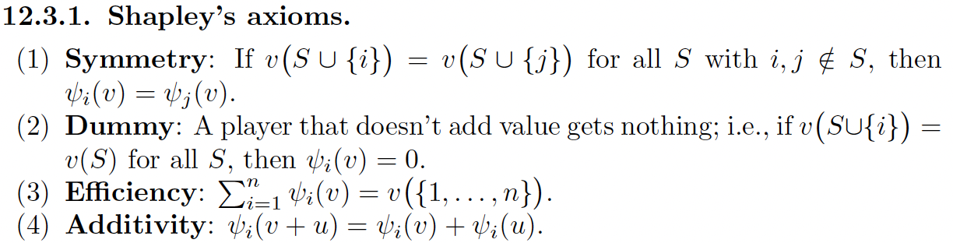
S-Veto Game:

Controlling coalition S. Characteristic function w_{S}(•) = 1 when subset includes S.

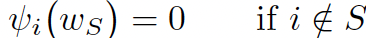

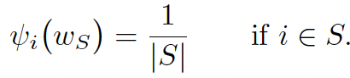

Shapley Value Solution to Glove Market:

Player 1 gets ψ₁(v) = 2/3. ψ₂(v) = ψ₃(v) = 1/6.

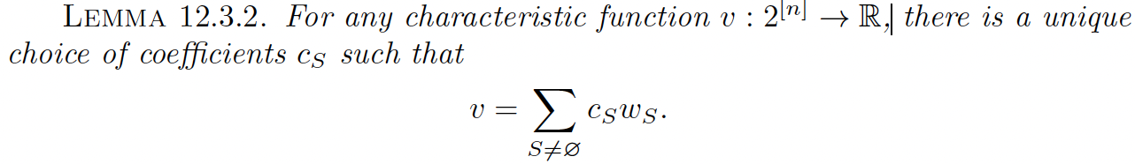

Four Stockholders and Shapley-Shubik Power Index (KP p. 208)

Shapley’s Theorem

Define allocation by marginal contribution based on a permutation π:

satisfies the last three of Shapley’s axioms. To satisfy symmetry, determine the expected value:

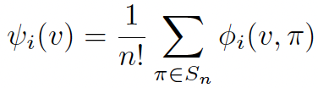

https://en.wikipedia.org/wiki/Airport_problem

(Nash) Bargaining . . . skip

3.C. Social Choice (KP 13; N 9.2)

“Every nation gets the government it deserves” (https://en.wikiquote.org/wiki/Joseph_de_Maistre#Quotes)

“If . . . voters . . . knew the distribution . . .”

“Vote early and vote often”

https://en.wikipedia.org/wiki/Ross_Perot

https://en.wikipedia.org/wiki/Electronic_voting_in_Estonia

https://www.amazon.com/Gödels-Proof-Ernest-Nagel/dp/0814758371/

https://en.wikipedia.org/wiki/Gödel%2C_Escher%2C_Bach

https://en.wikipedia.org/wiki/Proofs_and_Refutations

https://en.wikipedia.org/wiki/Order_dimension

F. Brandl, et.al. “Proving the Incompatibility of Efficiency and Strategyproofness via SMT Solving”. J. ACM 65, 2, Article 6 (January 2018), 28 pages. https://dl.acm.org/doi/10.1145/3125642

Condorcet Paradox - order of pairwise contests can make a difference

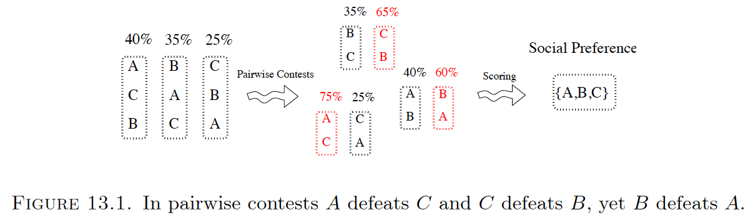

Mechanisms

Plurality voting (KP p. 217, figures 13.2 and 13.3)

Runoff elections (KP p. 217, figures 13.4 and 13.5)

Voting rule - produces a single winner from preference profile

Ranking rule - produces a total order from preference profile

Arrow's Properties

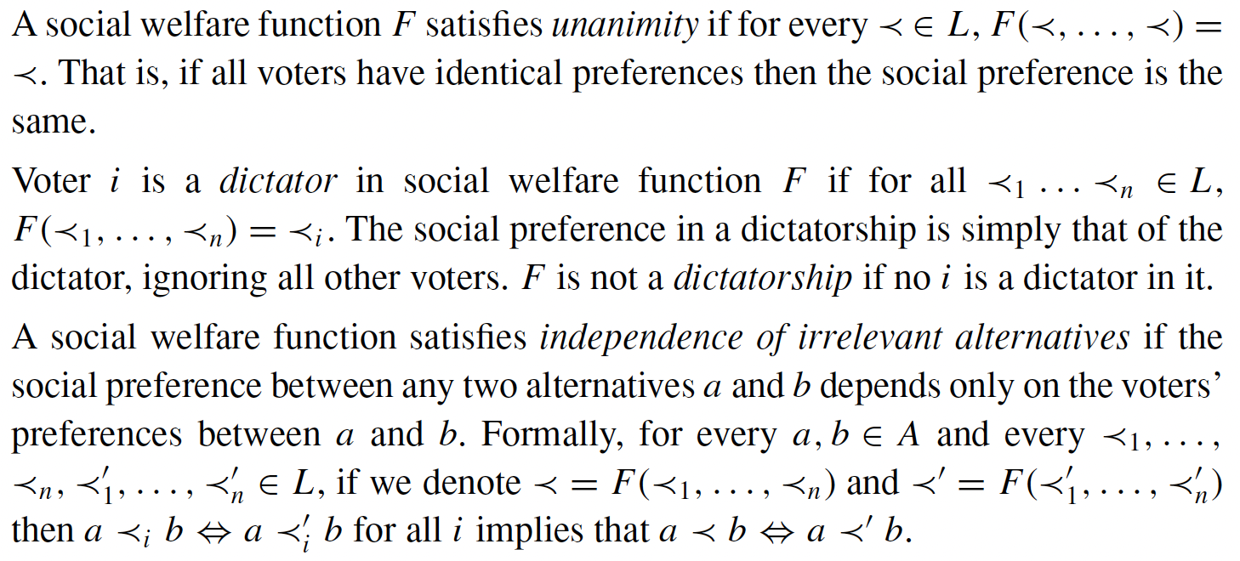

Arrow's Impossibility Theorem

Gibbard-Satterthwaite Theorem

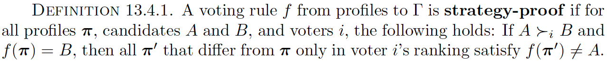

Desirable Properties

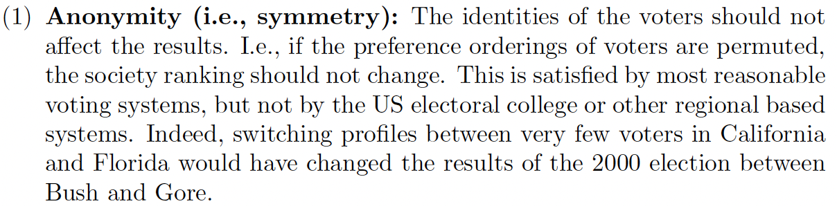
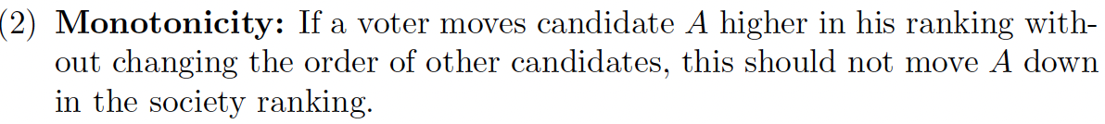
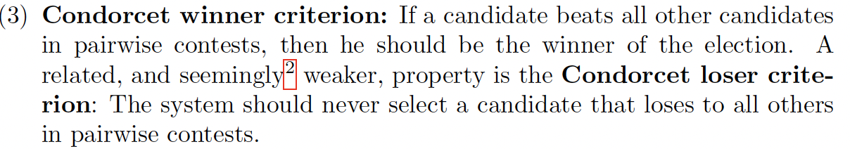
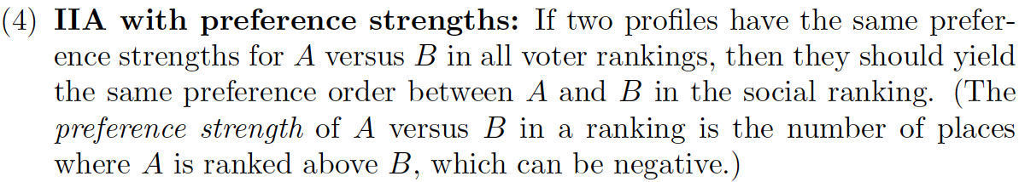

Analysis of Specific Voting Rules

Instant Runoff - remove candidate with fewest first-place votes after each round. Issues
with monotonicity, IIA with preference strengths, and Condorcet winner criterion.

Borda Count - m candidates gives descending weights m, m - 1, . . . , 1 for ranks. Issues with
Condorcet winner criterion, IIA, and strategic vulnerability.

Positional Voting - generalizes Borda count.

Approval Voting - vote for as many candidates as one wishes without ranking.

3.D. Auction Concepts (R p. 11)

Welfare-Maximizing Auction - maximizes the utilities(s) of the winner(s) (assuming truthfulness)

(expected) utility = (expected) value - (expected) payment

Single-Parameter Domain/Environment/Setting (N p. 228?; R p. 24)

Each agent i has a private value-per-unit v_{i} (distribution is assumed public)

(Terminology: k units are homogeneous / indistinguishable, k items are heterogeneous / distinguishable. Concept of substitutes complicates this.)

(Desired quantity)

Feasible set of allocation vectors

Examples (and allocation vectors) (R p. 24)

Single Item (basis vectors)

k Units (0-1 vectors)

Sponsored Search (click-through rates) (R 2.6)

Public Project (nobody-or-everybody)

Single Item Auctions and Independent Private Values (review of Notes 1.D; KP 14.1-14.2, Def. 14.1.1)

First-Price

Ascending - Dominant Strategy: stop bidding when price exceeds value

Sealed-Bid - Dominant Strategy: bid 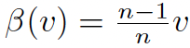 (KP p. 241)

Sealed-Bid Second-Price (R Theorem 2.4) - Dominant Strategy: bid value

Dominant-Strategy Incentive Compatible (DSIC; R p. 15)

Truthful bidding is always a dominant strategy

Truthful bidders obtain non-negative utility

Bayes-Nash Equilibrium - For every bidder i, utility is maximized by bidding β_{i}(V_{i})

Revenue in Single-Item Auctions (KP 14.3)

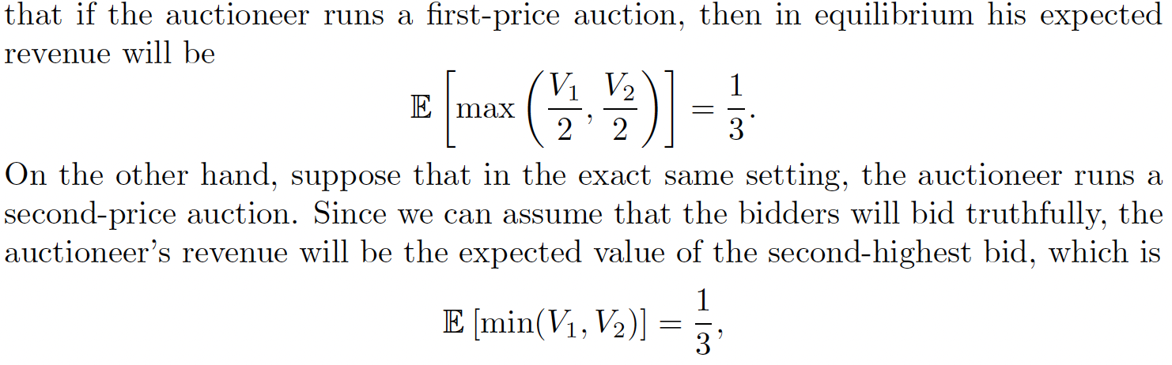

Revenue Equivalence (KP 14.4)

Arguably, the central result in single-object auction theory is the revenue equivalence theorem
. . . (Bichler, p. 61)

Perhaps the most remarkable theoretical result in auction theory is revenue equivalence, a principle which can be loosely expressed as follows: for a broad class of auctions, bidders, ideally, adjust their behavior to the rules in such a way that the expected revenue to the seller remains the same. (Steiglitz, p. 180)

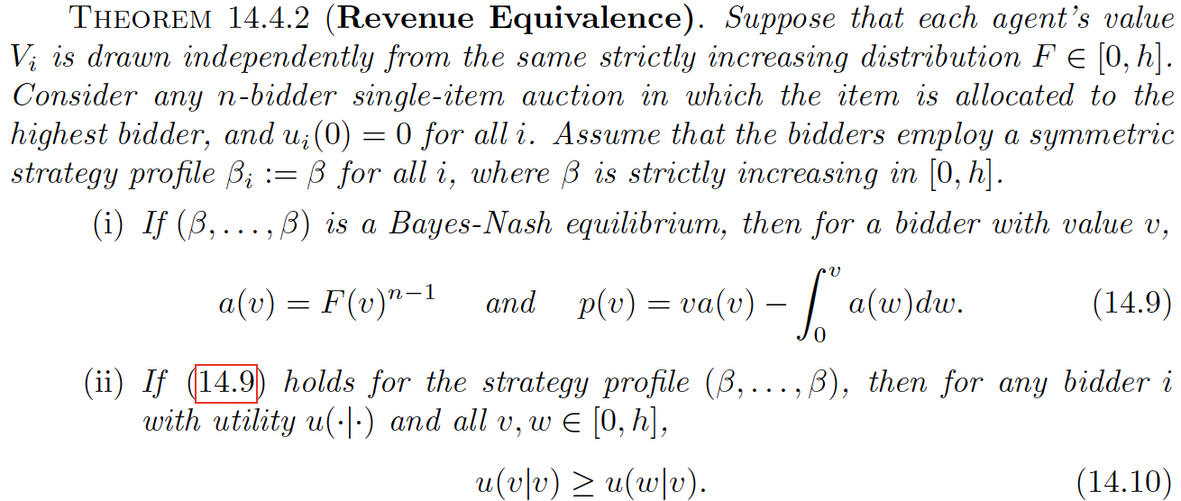

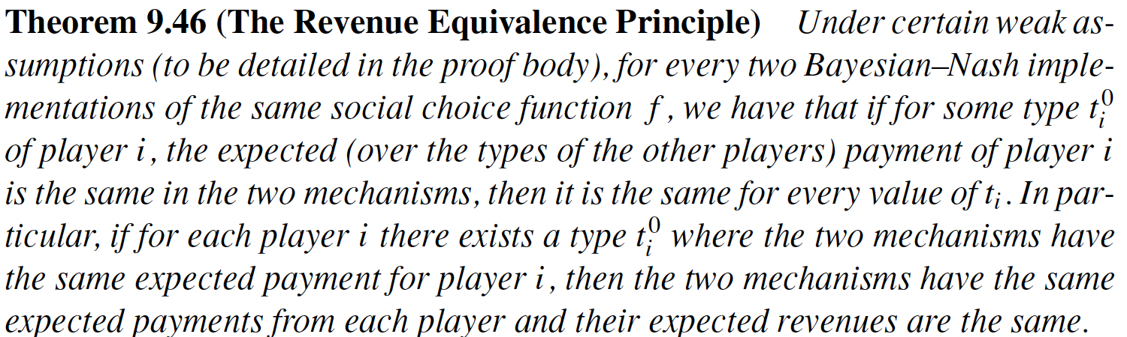

Ascending First-Price

Descending (Dutch)

Second-Price Sealed-Bid

First-Price Sealed-Bid

All-pay (Steiglitz, p. 203-205; KP p. 241)

War of attrition (second-price all-pay)

When i.i.d. valuations for n bidders are uniformly distributed over [0, 1], the expected revenue is (n - 1)/(n + 1) (Steiglitz, p. 190-192)

https://en.wikipedia.org/wiki/Winner's_curse

Reserve Prices

Vickrey Auction with a Reserve Price (KP p. 243; R exercise 5.1)

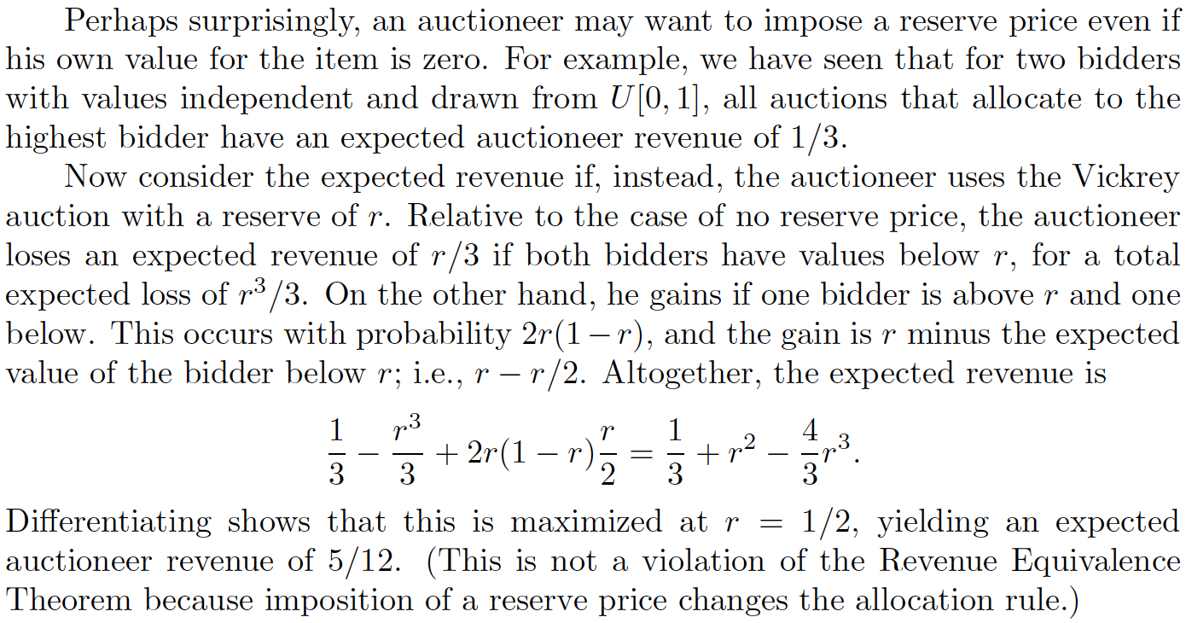

Bidder-Specific Reserve (R p. 78)

Revenue Equivalence Generalized (KP 14.5.1)

Entry Fee vs Reserve Price (KP 14.5.2)

Evaluation Fee (KP 14.5.3) - must pay fee to know your value (similarly eBay shipping)

Knapsack Auctions (R 4.1, 4.2; Chapters 1/2/3 of
https://www-degruyter-com.ezproxy.uta.edu/document/doi/10.7312/milg17598/html)

Seller has capacity w

Each bidder has public size w_{i} (≤ w) and private valuation v_{i} (which is also the bid b_{i})

Since knapsack is NP-hard, apply greedy heuristic of ordering bid-to-size ratios descending

Achieves at least 50% of the maximum social welfare . . .

From https://ranger.uta.edu/~weems/NOTES3318/notes06.pdf

Observe that applying fractional concept to 0/1 problem gives an upper bound on what may be
achieved optimally (OPT) for 0/1.

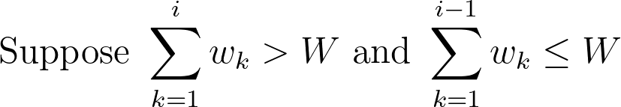

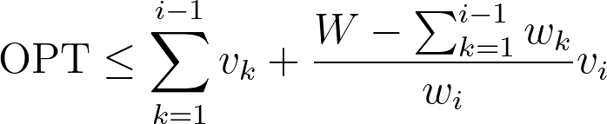

By taking the larger of the revenue for the first i - 1 units or the revenue for unit i, we will
achieve at least 1/2 of OPT. (Why?)

Aside: eBay

https://en.wikipedia.org/wiki/EBay#Bidding

3.E. Auction Concepts (continued)

Individually Rational (KP 14.5.4; N 9.4.1)

Each bidder’s expected utility is nonnegative (given a decision time for information)

Ex-ante - bidders know only the value distributions (evaluation fee)

Ex-interim - bidders know the value distributions and their own value (entry-fee)

Ex-post - bidders know their values after the auction (first-price and second-price)

Myerson’s Lemma (R 3)

Definition 3.5 (Implementable Allocation Rule) An allocation rule ... is implementable if there is a payment rule such that the direction-revelation mechanism is DSIC.

Definition 3.6 (Monotone Allocation Rule) An allocation rule ... is monotone if for every agent the allocation is nondecreasing in her bid.

Theorem 3.7 (Myerson’s Lemma) . . .

(a) Allocation rule is implementable if and only if it is monotone.

(b) Such a monotone allocation rule has a unique payment rule for which the direct-revelation mechanism is DSIC and the payment is zero whenever the bid is zero.

(c) The payment rule in (b) has an explicit formula.

Highlights of the proof: expressions (3.4) and (3.5/3.6), along with diagrams on (R p. 32).

Example: Knapsack Auction and critical bid (R p. 41)

Payment Rule:

For each winner in the greedy heuristic, replace v_{i} with the smallest value such that it’s
still a winner in the greedy heuristic.

That value is the payment . . .

W = 5

i 1 2 3 4 5 6 7

v_{i} 8 7 6 5 4 3 2

w_{i} 1 1 1 1 1 1 1

p_{i} 3 3 3 3 3

W = 7

i 1 2 3 4 5 6 7 8

v_{i} 9 4 7 3 4 2 3 1

w_{i} 2 1 2 1 2 1 2 1

p_{i} 4 2 4 2 1
2•4/2 1•4/2 2•4/2 1•4/2 1•1/1 ⇐ w_{i} • v_{j}/ w_{j}

W = 21

i 1 2 3 4 5 6 7 8 9 10 11 12 13 14 15

v_{i} 37 29 21 13 6 25 19 13 8 3 10 7 5 3 1

w_{i} 5 4 3 2 1 5 4 3 2 1 5 4 3 2 1

p_{i} 95/4 19 57/4 26/3 4 95/4 1
5•19/4 4•19/4 3•19/4 2•13/3 1•8/2 5•19/4 1•1/1

Characterization of Bayes-Nash Equilibrium (KP 14.6)

Myerson’s Lemma, but for distributions

KP proof and diagram (KP p. 247-248) mirror R proof and diagram (R p. 28-32)

POA in Auctions (KP 14.7)

See Roughgarden et.al, “The Price of Anarchy in Auctions” ( PAPERSTWO/auction.poa.pdf )

Revelation Principle

Theorem 4.3 (Revelation Principle for DSIC Mechanisms): For every mechanism in which every participant always has a dominant strategy, there is an equivalent direct-revelation DSIC mechanism. (R p. 47)

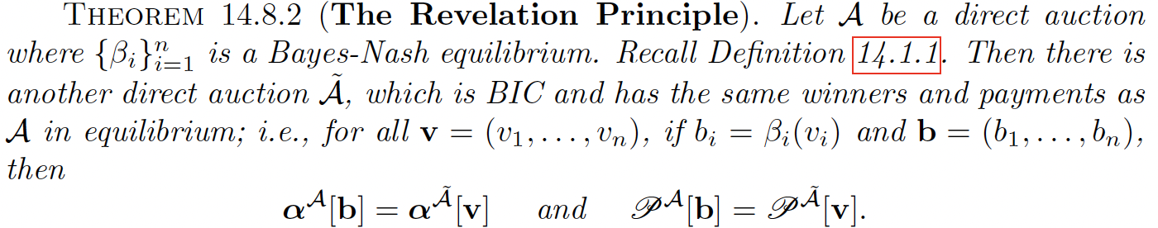

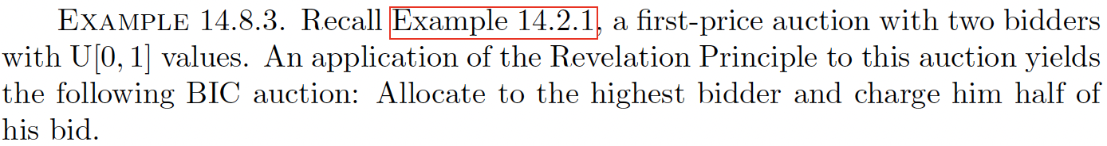

Myerson's Optimal Auction/Revenue Maximization (R 5; KP 14.9)

“Take it or leave it” by setting a reserve price r

One Bidder, One Item (Monopoly Price)

Expected Revenue: r • (1 - F(r)) (F is the distribution function, the probability that the
value is at most the argument. f is the density function, its derivative.)

Uniform distribution [0, 1] for buyer’s value - set r at 1/2 (F(x)=x, f(x)=1)

Virtual Valuation (“regular” if non-decreasing, R p. 62)

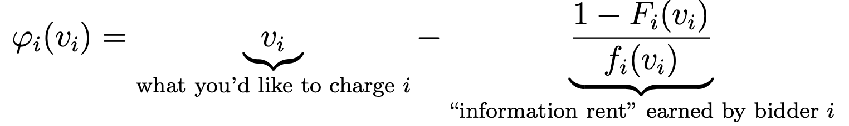
Expected Revenue = Expected Virtual Welfare

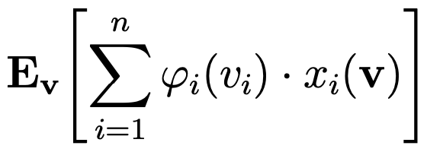

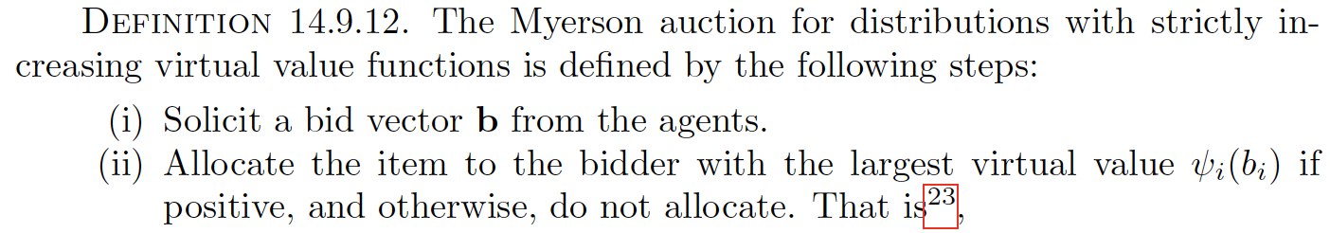
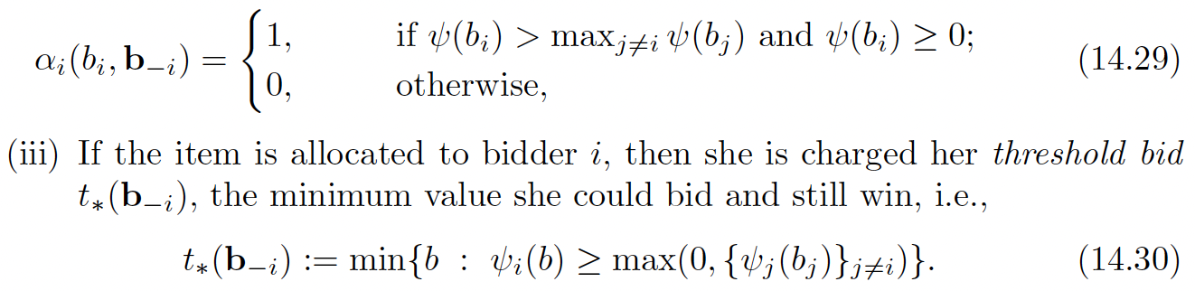

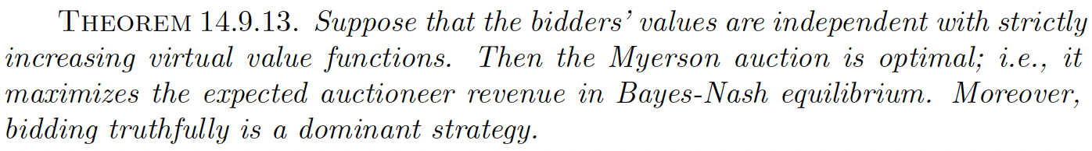

Also see R 5.2.6:

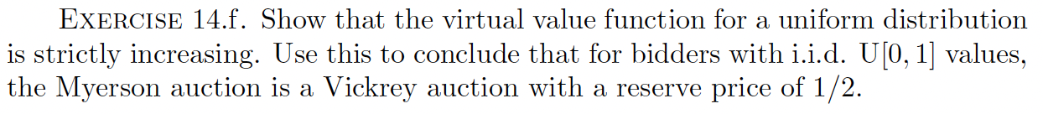

Approximately (Near-) Optimal Auctions

What if you don’t have the agents’ distributions?

Prophet Inequality (R 6.2) and Simple Single-Item Auction (R 6.3)

https://cacm.acm.org/magazines/2017/12/223050-lousy-advice-to-the-lovelorn

Bulow-Klemperer (KP 14.10.1; R 6.4)

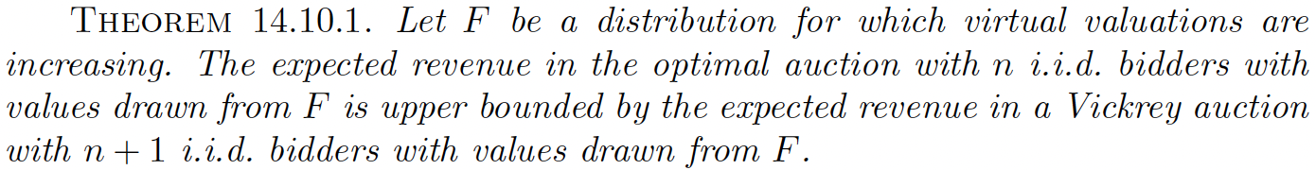

Lookahead Auction (KP 14.10.2)

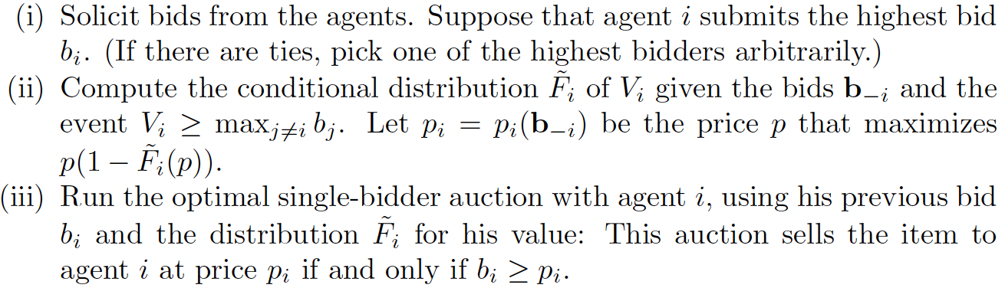

Lookahead Auction is Approximately Optimal (KP 14.10.3)



